CXBanking

OptiVault 10.1

User Reference Guide

**Build Number: 3131**

**January 2023**

Copyright and Trademark Information

If this guide is distributed with software that includes an end-user agreement, this guide, as well as the software described in it, is furnished under license, and may be used or copied only in accordance with the terms of such license. Except as permitted by any such license, no part of this guide may be reproduced, stored in a retrieval system, or transmitted, in any form or by any means, electronic, mechanical, recording, or otherwise, without the prior written permission of NCR Corporation. Please note that the content in this guide is protected under copyright law even if it is not distributed with software that includes an end-user license agreement.

The content of this guide is furnished for informational use only, is subject to change without notice, and should not be construed as a commitment by NCR Corporation. NCR Corporation assumes no responsibility or liability for any errors or inaccuracies that may appear in the informational content contained in this guide.

OptiCash, OptiNet, OptiVault, OptiCashMI, OptiVLM, OptimizeCF, OptiSuite, OptiRecon, and OptiBridge are trademarks of NCR Corporation.

Adobe Acrobat Reader is a registered trademark of Adobe Systems Incorporated. Microsoft, Windows, and Windows Vista, Internet Explorer (IE) are either registered trademarks or trademarks of Microsoft Corporation in the United States and/or other countries. Solaris is a Trademark or registered trademark of Sun Microsystems, Inc. in the United States and other countries. Oracle is a trademark of Oracle in the United States and other countries. Websphere is a trademark of IBM in the United States and other countries. UNIX is a trademark in the United States and other countries, licensed exclusively through X/Open Company, Ltd. All other trademarks are the property of their respective owners.

Copyright NCR Corporation.

All Rights Reserved

Revision Record

|  |  |  |
| --- | --- | --- |
| Date | Page No. | Description of Change |
| February 2023 | ALL | Formatting Changes |
|  |  |  |
|  |  |  |

Table of Contents

[CXBanking 1](#_Toc128021041)

[OptiVault 10.0 1](#_Toc128021042)

[User Reference Guide 1](#_Toc128021043)

[Copyright and Trademark Information 1](#_Toc128021044)

[Revision Record 1](#_Toc128021045)

[Table of Contents 1](#_Toc128021046)

[Preface 1](#_Toc128021047)

[Document Conventions 1](#_Toc128021048)

[1 Introduction to OptiVault 1](#_Toc128021049)

[1.1 Getting Started 1](#_Toc128021050)

[1.1.1 Screen Resolution 1](#_Toc128021051)

[1.1.2 Navigation Tips 1](#_Toc128021052)

[1.1.3 Accessing OptiVault 1](#_Toc128021053)

[1.1.4 Logging into OptiVault 1](#_Toc128021054)

[1.1.5 Logging Out Of OptiVault 1](#_Toc128021055)

[2 Introduction to the Interface 1](#_Toc128021056)

[2.1 General OptiVault Pages 1](#_Toc128021057)

[2.1.1 Main Menu Tabs 1](#_Toc128021058)

[2.1.2 Common OptiVault Icons 1](#_Toc128021059)

[2.1.3 Common OptiVault Buttons 1](#_Toc128021060)

[2.1.4 Date Selector 1](#_Toc128021061)

[2.1.5 Cashpoint Search 1](#_Toc128021062)

[2.1.6 Cashpoint Selector 1](#_Toc128021063)

[2.1.7 Language Selector 1](#_Toc128021064)

[2.1.8 Cashpoints 1](#_Toc128021065)

[2.1.9 Cashpoint Types 1](#_Toc128021066)

[2.1.10 Vault 1](#_Toc128021067)

[2.1.11 ATMs and Branches 1](#_Toc128021068)

[2.1.12 Commercial 1](#_Toc128021069)

[2.1.13 Custodial Inventory 1](#_Toc128021070)

[2.1.14 External Funding Source 1](#_Toc128021071)

[2.2 Cashpoint Pages 1](#_Toc128021072)

[2.2.1 Cashpoint→Basic→Definition 1](#_Toc128021073)

[2.2.2 Cashpoint→Basic→Denominations 1](#_Toc128021074)

[2.2.3 Cashpoint→Basic→Requirements 1](#_Toc128021075)

[2.2.4 Cashpoint→Basic→Service Days 1](#_Toc128021077)

[2.2.5 Cashpoint→Basic→Cashpoints 1](#_Toc128021078)

[2.2.6 Cashpoint→Basic→Balance Entry 1](#_Toc128021079)

[2.2.7 Cashpoint→Basic→Provisional Credit 1](#_Toc128021080)

[2.2.8 Cashpoint→Advanced→Costs 1](#_Toc128021081)

[2.2.9 Cashpoint→Advanced→Teller Verification 1](#_Toc128021082)

[2.2.10 Cashpoint→Advanced→Denomination Yield 1](#_Toc128021083)

[2.2.11 Cashpoint→Advanced→Denomination Yield→Edit 1](#_Toc128021084)

[2.2.12 Cashpoint→Advanced→Sorting 1](#_Toc128021085)

[2.2.13 Cashpoint→Advanced→Sorter Utilization 1](#_Toc128021086)

[2.2.14 Cashpoint→Advanced→Quality Yield 1](#_Toc128021087)

[2.2.15 Cashpoint→Advanced→Cross-Ship Fit Split 1](#_Toc128021088)

[2.2.16 Cashpoint→Orders→Recommendations 1](#_Toc128021089)

[2.2.17 Cashpoint→Orders→Orders 1](#_Toc128021090)

[2.2.18 Cashpoint→Orders→Orders workflow 1](#_Toc128021091)

[2.2.19 Cashpoint→Orders→Order Overview 1](#_Toc128021092)

[2.2.20 Vault Orders 1](#_Toc128021093)

[2.2.21 Vault Recommendations 1](#_Toc128021094)

[2.2.22 Override Vault Recommendations 1](#_Toc128021095)

[2.2.23 Manual Orders 1](#_Toc128021096)

[2.2.24 Order Details Page 1](#_Toc128021097)

[2.2.25 Cashpoint→Forecast→View Forecast 1](#_Toc128021098)

[2.2.26 Cashpoint→Forecast→Exclude History 1](#_Toc128021099)

[2.2.27 Cashpoint→Forecast→Generate Forecasts 1](#_Toc128021100)

[2.2.28 Cashpoint→Forecast→Analysis 1](#_Toc128021101)

[2.2.29 Cashpoint→Forecast→ATM/BRANCH Forecast 1](#_Toc128021102)

[2.2.30 Cashpoint→Reports 1](#_Toc128021103)

[3 Today Tab 1](#_Toc128021104)

[3.1.1 Today→Snapshot Page 1](#_Toc128021105)

[3.1.2 Snapshot→To Do List 1](#_Toc128021106)

[3.1.3 Today→Vault Status 1](#_Toc128021107)

[3.1.4 Today→Vault Orders 1](#_Toc128021108)

[3.1.5 Today→Orders Workflow 1](#_Toc128021109)

[4 Processing Tab 1](#_Toc128021110)

[4.1.1 Processing→Process Status 1](#_Toc128021111)

[4.1.2 Processing→Load Balances 1](#_Toc128021112)

[4.1.3 Processing→Load Orders 1](#_Toc128021113)

[4.1.4 Processing→Recommendations 1](#_Toc128021114)

[4.1.5 Processing→Forecast 1](#_Toc128021115)

[4.1.6 Processing→Order Output 1](#_Toc128021116)

[4.1.7 Processing→CI Constraints 1](#_Toc128021117)

[4.1.8 Processing→Cost Calculation 1](#_Toc128021118)

[4.1.9 Processing→Custom Jobs 1](#_Toc128021119)

[5 Network Tab 1](#_Toc128021120)

[5.1.1 Network→Cashpoints 1](#_Toc128021121)

[5.1.2 Network→Create New 1](#_Toc128021122)

[5.1.3 Network→Mass Assign 1](#_Toc128021123)

[5.1.4 Network→Carrier 1](#_Toc128021124)

[5.1.5 Network→Groups 1](#_Toc128021125)

[5.1.6 Network→Sorters 1](#_Toc128021126)

[5.1.7 Network→Cross Shipping 1](#_Toc128021127)

[5.1.8 Network→Trading Market 1](#_Toc128021128)

[6 Events Tab 1](#_Toc128021129)

[6.1.1 Events→Calendar Page 1](#_Toc128021130)

[6.1.2 Events→Event Collisions 1](#_Toc128021131)

[6.1.3 Events→Events Page 1](#_Toc128021132)

[7 Settings Tab 1](#_Toc128021133)

[7.1.1 Settings→Institution 1](#_Toc128021134)

[7.1.2 Settings→Override Reasons 1](#_Toc128021135)

[7.1.3 Settings→Privileges 1](#_Toc128021136)

[7.1.4 Settings→Currencies/Denominations 1](#_Toc128021137)

[7.1.5 Settings→Order Settings 1](#_Toc128021138)

[7.1.6 Settings→Calendar Refresh 1](#_Toc128021139)

[8 Maintenance 1](#_Toc128021140)

[8.1.2 Maintenance→Cashpoint Synchronization 1](#_Toc128021141)

[8.1.3 Maintenance→Audit Log Browser 1](#_Toc128021142)

[8.1.4 System→View Logs 1](#_Toc128021143)

[8.1.5 System→About 1](#_Toc128021144)

[9 Reports Tab 1](#_Toc128021145)

[9.1.1 Reports Overview 1](#_Toc128021146)

[9.1.2 Report Basics 1](#_Toc128021147)

[9.1.3 Processing Reports 1](#_Toc128021148)

[9.1.4 History Reports 1](#_Toc128021149)

[9.1.5 Planning Reports 1](#_Toc128021150)

[9.1.6 Management Information Reports 1](#_Toc128021151)

[9.1.7 Cashpoint Reports 1](#_Toc128021152)

[10 Table of Figures 1](#_Toc128021153)

Preface

The conventions used in this help documentation are shown in the table below.

## Document Conventions

Table 1: Conventions

| Convention | Use |
| --- | --- |
| [**Green**](#_Conventions_Used_in) **Text** | Indicates a link to the top of the current section. These links can be clicked to quickly navigate through this document. (In some cases, you may need to hold the CTRL key to click the link) |
| **Blue Text** | Indicates a link to a different topic or section. These links can be clicked to quickly navigate through this document. (In some cases, you may need to hold the CTRL key to click the link) |
| **à** | The “arrow” sign indicates a menu choice. For example, "**Choose File à Open**" means "click the File menu, and then click Open." |
| MCj04338830000[1] | Used to warn users of potential problems or to take caution when making changes to settings and parameters. |
|  | Tips or information that may help use the functionality. |

Return To: Introduction to OptiVault

# Introduction to OptiVault

OptiVault is the solution to lower costs through more effective currency management. This software application is a comprehensive system designed to optimize currency ordering and clearing for financial institutions with Vaults, Custodial Inventory, Commercial customers, and External Funding Sources known as Cashpoints. Based on historical cash-demand data, OptiVault will forecast future currency needs, considering important factors such as seasonality, holidays, special events, and trends.

Forecasted currency and denomination requirements are evaluated against various cost components associated with ordering, holding, and delivering currency to a Cashpoint.

**The overriding objective:** calculate the optimal amount of cash required for Cashpoints and reduce operating costs.

* Conventions Used in this Help Documentation
* Getting Started
* Screen Resolution
* Navigation Tips
* Accessing OptiVault
* Logging into OptiVault
* Logging Out Of OptiVault

|  |  |
| --- | --- |
| MCj04338830000[1] | **Caution:** OptiVault is a live application. Changes that are made in the application are permanent and can affect the operation of the system. There are limited undo capabilities for the users; therefore be sure to consult this manual before deleting or changing system parameters. |

## Getting Started

OptiVault is a web-based application, operating in a multi-user environment to produce daily recommendations for the amount and frequency of currency orders. Daily order recommendations are distributed from a central location. The recommendations are updated by the OptiVault analyst to confirm the recommendations into orders. Resulting orders are then that can then be printed or passed electronically to the cash provider. NCR will assist in getting the application properly configured.

Return To: Introduction to OptiVault

### Screen Resolution

Because OptiVault runs in a browser, the user may choose any valid desktop resolution, and OptiVault will resize automatically. However, we recommend using at least 1024x768 resolution and larger is preferred to minimize scrolling on some of the screens containing large amounts of information.

Return To: Introduction to OptiVault

### Navigation Tips

When using OptiVault, avoid using the Back and Forward buttons  in the browser. All navigation should occur within the application via the menu or icons, thereby ensuring the successful processing of the OptiVault system.

Return To: Introduction to OptiVault

### Accessing OptiVault

To begin using the application, enter the required EPSS Application URL in the browser.

|  |  |
| --- | --- |
|  | **Suggestion:** save the EPSS Application URL in the Favorites folder for easier future access. |

Return To: Introduction to OptiVault

### Opening OptiVault

Once EPSS Application has been launched, the login screen will appear, as shown below. To login, enter your Username and Password, and click the **‘Login’** button.



Figure 1: OptiVault Login Page

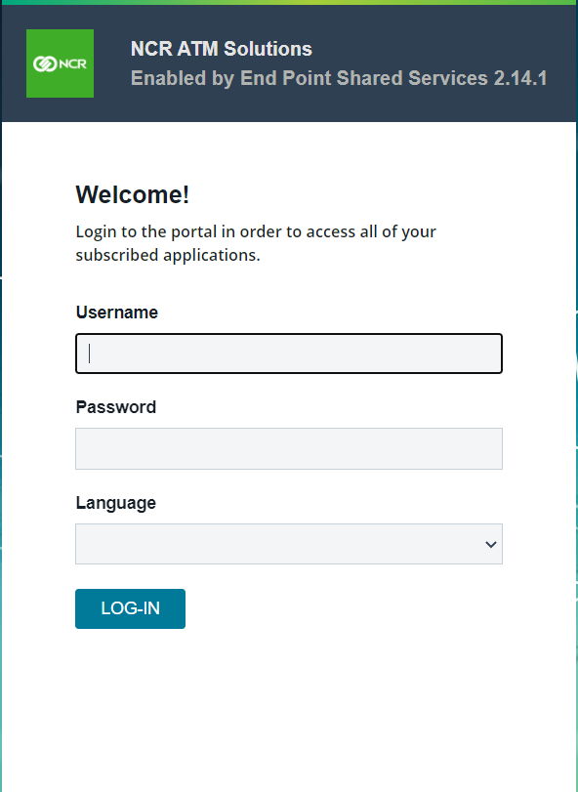

After a successful login, users will be directed to the Cash Management Dashboard Screen, as displayed below. To access OptiVault, go to the App Launcher and click on the ‘OV’ button.

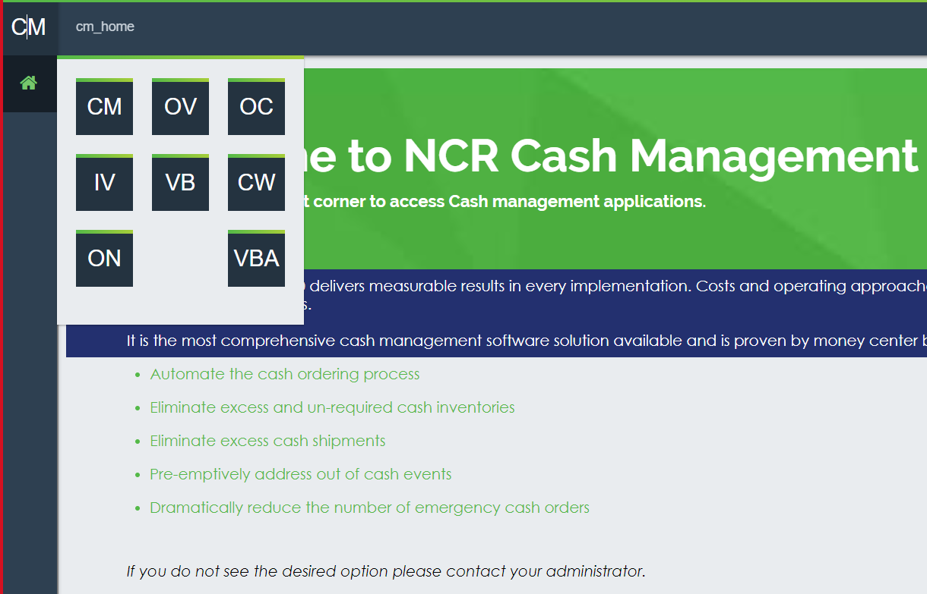

Return To: Introduction to OptiVault

### Log out Of EPSS

To log out, Simply click on the User menu icon  located in the bottom left menu option of the screen

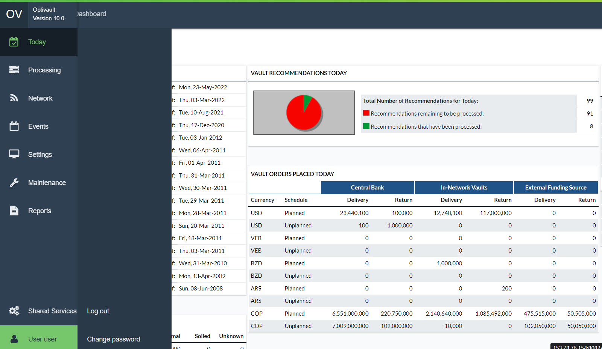

|  |  |
| --- | --- |
|  | **Note:**  To ensure the successful processing of the OptiVault system, do not use the **Close** button in the browser; always use the EPSS Application Logout icon instead. |

Return To: Introduction to OptiVault

# Introduction to the Interface

The following section will illustrate examples of most of the OptiVault interface pages and explain the functionality, purpose, or use of each page. This section is to be used as a reference guide when working with the application regularly.

In order to keep this manual as succinct as possible, the user interface is described in detail in this section. Other chapters throughout the manual will then refer to the appropriate section of the user interface to avoid having duplicate screen images and text.

This chapter has been broken out into different sections to make it easier for the readers to find the information they are seeking. The General topics are broken out by the main Tabs or functions with all associated information contained beneath those sections. The following is a summary of the information that will be covered along with hyperlinks to each topic.

* General OptiVault Pages
* Processing Tab
* Network Tab
* Events Tab
* Settings Tab
* Maintenance Tab
* Reports Tab

## General OptiVault Pages

Users of OptiVault will encounter several pages that are commonly used throughout the application. The user should become familiar with these pages as they are used frequently when working in OptiVault.

The following is a summary of the information that will be covered along with hyperlinks to each topic:

* Main Menu Tabs
* Common OptiVault Icons
* Common OptiVault Buttons
* Date Selector
* Cashpoint Search
* [Cashpoint Selector](#_Cashpoint_Selector)
* [Language Selector](#_Language_Selector)

Return To: Introduction to the Interface

### Main Menu Tabs

The users can control the OptiVault operations through the main menu tabs displayed in the picture below. After selecting the menu items, additional options are displayed, until a final menu option is reached, allowing full access to all functions of OptiVault.

Figure 2: Navigation Tabs

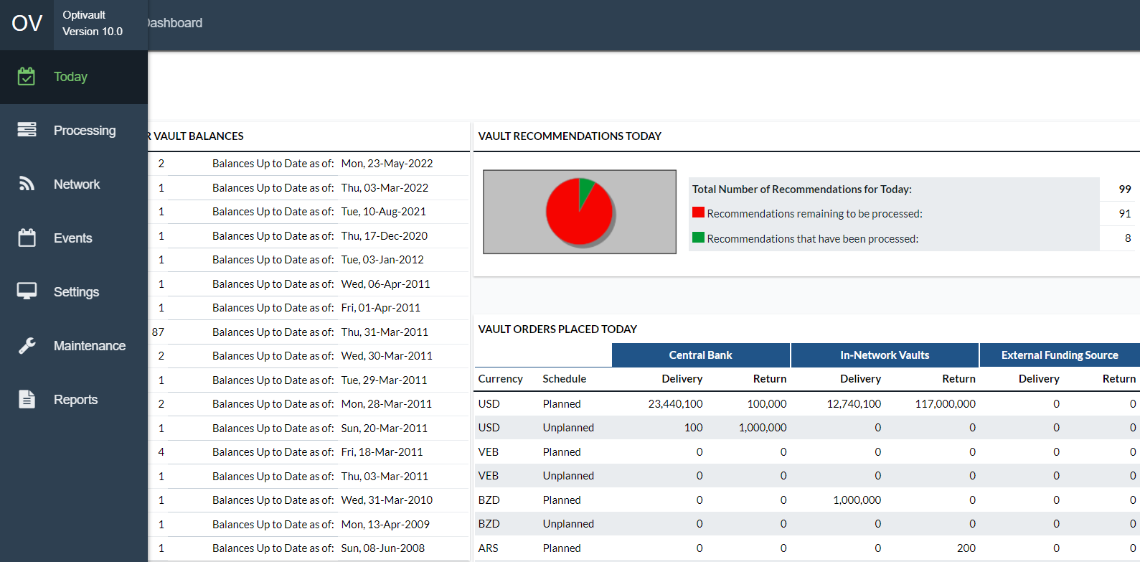

Table 2: Main Menu Tabs

| Tabs | Description |
| --- | --- |
| **Today** | Shows daily Cashpoint, order status and lists the processes or tasks to be executed on a daily basis by users. |
| **Processing** | **Contains main OptiVault processes:** balance load, recommendations, forecast, etc. |
| **Network** | Organizing Cashpoints. |
| **Events** | Calendars and event definition. |
|  |  |
| **Reports** | OptiVault reports. |
| **Settings** | System Privileges and institutional setup. |
| **Maintenance** | Maintenance and View Logs |

Return To: General OptiVault Pages

### Common OptiVault Icons

Some common icons are used throughout the application with which the user should become familiar. Table 3: OptiVault Icons gives an overview of these icons and their functions.

Table 3: OptiVault Icons

| Icon | Description |
| --- | --- |
|  | **Search Icon:** provides access to search for Cashpoints by ID, Name, and type. |
|  | **Help Icon**: Displays OptiVault On-line help. |
|  | **Print Icon:** Print from any of the screens. This function will only print what is currently displayed in the browser. Any text that is not visible will not be printed. |
|  |  |
|  | **Home Icon:** Return to the main OptiVault screen. |
| Description: C:\Sun\SDK\domains\domain1\applications\j2ee-apps\ov1\OptiVault_war\images\download.gif | **Download icon:** Allows the user to download the file to the local system. |
| Description: C:\Sun\SDK\domains\domain1\applications\j2ee-apps\ov1\OptiVault_war\images\view.gif | **View icon:** Allows the user to view a file that is hosted on the server. |
|  | **Exit icon:** Closes the Cashpoint window. |
| Description: C:\Sun\SDK\domains\domain1\applications\j2ee-apps\ov1\OptiVault_war\images\icon_holiday.gif | **Purple Ball:** Holiday Indicator to denote days that have holiday events |
| Description: C:\Sun\SDK\domains\domain1\applications\j2ee-apps\ov1\OptiVault_war\images\icon_event.gif | **Orange Ball:** Event indicator to denote days that have normal events |
| Description: C:\Sun\SDK\domains\domain1\applications\j2ee-apps\ov1\OptiVault_war\images\red.gif | **Red Ball:** Indicator that the process or action is incomplete |
| Description: C:\Sun\SDK\domains\domain1\applications\j2ee-apps\ov1\OptiVault_war\images\green.gif | **Green Ball:** Indicator that the process or action is complete |
| Description: C:\Sun\SDK\domains\domain1\applications\j2ee-apps\ov1\OptiVault_war\images\amber.gif | **Yellow Ball:** Indicates that the process has been completed but there still may be actions that need to be completed |
| Description: C:\Sun\SDK\domains\domain1\applications\j2ee-apps\ov1\OptiVault_war\images\alert_icon.gif | **Alert Indicator:** Informs the user that there is a problem with the action or process |
|  | **Question Mark Icon**: Help tips and information for each field in the application (to close it, click on the top right corner of the note). |
|  | **Radio button:** Used for selecting items. |
|  | **Check box:** Used for selecting items. |
| Description: C:\Sun\SDK\domains\domain1\applications\j2ee-apps\ov1\OptiVault_war\images\previous.gifDescription: C:\Sun\SDK\domains\domain1\applications\j2ee-apps\ov1\OptiVault_war\images\next.gif | **Single Arrow Icon:** Move to the next page of the list. |
| Description: C:\Sun\SDK\domains\domain1\applications\j2ee-apps\ov1\OptiVault_war\images\first.gifDescription: C:\Sun\SDK\domains\domain1\applications\j2ee-apps\ov1\OptiVault_war\images\last.gif | **Double Arrow Icon:** Move to the first or last page of the list. |
|  | **Date Selector Icon:** Used to select a date from a calendar box. This option will allow you to enter the date in “YYYY-MM-DD” format. |
|  | **Calculator Icon: A**utomatically calculates certain values using the history data. |

Return To: General OptiVault Pages

### Common OptiVault Buttons

The buttons in the following table will appear in most of the windows when executing daily or weekly tasks:

Table 4: OptiVault Buttons

| Button | Description |
| --- | --- |
|  | Exit the window. |
|  | Save the changes made in the fields. |
|  | Exit without saving changes. |
|  | Update the changes made in the fields. |
|  | Select all the items listed on the screen. |
|  | Display the default values in the fields. |
|  | Submits the request for the function on the current screen to be processed |
|  | Finalizes the selection of Cashpoints or functions to allow the user to move to the next step in the process |

Return To: General OptiVault Pages

### Date Selector

In several areas of the application, it may be necessary to select or change a date for reports, orders, etc. Date fields can only be changed by accessing a Date Selector by clicking the Date Selector icon 

Figure 3: Date Selector

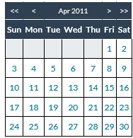

Table 5: Date Selector Description

| Field | Description |
| --- | --- |
| **<<** | Moves the Calendar 1 Year in the past |
| **>>** | Moves the Calendar 1 Year forward |
| **<** | Moves the Calendar 1 Month in the past |
| **>** | Moves the Calendar 1 Month forward |
| **Dates** | Hyperlinks will denote which dates can be selected. In some cases, dates will not be available (i.e. The date being selected is for a delivery day and Sunday is a non-delivery day; Sunday would not be available for selection) |
| **yyyy-MM-dd** | Specifies the currently selected date. If the user would like to type in the date, then it is possible to do so in this field, but it must conform to the format of Year(yyyy)-Month(MM)-Day(dd). |
| **Clear** | Clears the date completely from the field that was originally selected |
| **Cancel** | Cancels the date selection without changing any values. |

Return To: General OptiVault Pages

### Cashpoint Search

Many times, a user will want to find a particular Cashpoint for different reasons. An easy way to search for Cashpoints is by using the Cashpoint Search Function. The Search window can be accessed by clicking on the Search Icon Description: C:\Sun\SDK\domains\domain1\applications\j2ee-apps\ov1\OptiVault_war\images\search.gif on most OptiVault screens.

Figure 4: Cashpoint Search Page

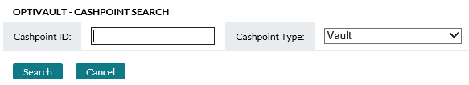

Table 6: Cashpoint Search Description

| Field Name | Description |
| --- | --- |
| **Cashpoint ID** | Unique alphanumeric code that identifies the Cashpoint. |
| **Cashpoint Type** | Allows the user to select the type of Cashpoints that OptiVault will search. The following Cashpoint types are available:   * Vault (Default) – Cash Distribution Cashpoints * Commercial – Commercial Customer Cashpoints * Custodial Inventory – Custodial Inventory Cashpoints * External Funding Source – External Funding Source Cashpoints |
| **Search** | Submits the request to search for the Cashpoint. If nothing was entered in the search criteria field, then all Cashpoints will be returned for the Cashpoint type selected. |
| **Cancel** | Closes this window without processing any information. |

Return To: General OptiVault Pages

### Cashpoint Selector

The users are frequently asked to select one or several Cashpoints for reports. For these processes, the Cashpoint Selector is used. This window gives the user several different ways to search for Cashpoints by allowing the user to filter the selection results using different criteria.

Figure 5: Cashpoint Selector Window

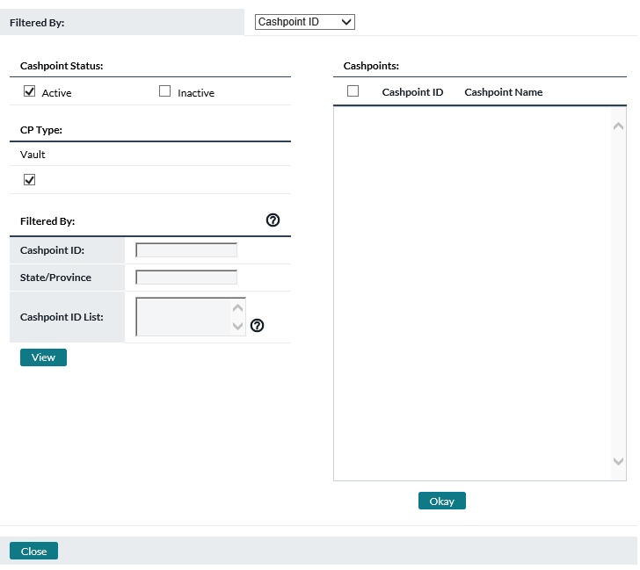

Table 7: Cashpoint Selector Description

|  |  |  |  |
| --- | --- | --- | --- |
| Field Name | | Description | |
| **Filtered By:** | | | | Allows the user to select how OptiVault will search for the Cashpoint. When a new selection is made, OptiVault will change the area in the bottom-left corner to allow the user to select or input criteria specific to that input type. The options available are:   * **Cashpoint ID (Default) –** With this option, the user can search for the Cashpoint using its unique identifier. Type the Cashpoint ID in the field marked **‘Cashpoint ID’**. * **Cashpoint Name –** With this option, the user can search for the Cashpoint using the name that is defined at the Cashpoint level. Type the Cashpoint name in the field marked **‘Cashpoint Name’**. * **Type –** Allows the user to select only a specific type of Cashpoint (Vault, Commercial, Custodial Inventory, or External Funding Source). * **Trading Market –** Association of cashpoints that can share currency between them at reduced costs relative to that of the Default Funding Sources | |
| **Cashpoint Status** | | Allows the user to choose Active/Inactive/All Cashpoint statuses when searching for Cashpoints. | |
| **Cashpoint Type** | | Allows the user to select one or several types of Cashpoints | |
| **Cashpoints** | | List the Cashpoints that the user is able to select from. The user needs to check the box on the Cashpoint(s) they would like to choose for their select. Pressing the **Okay** button will finalize the selection and return it to the page requesting the information. | |
| **View** | | Submits the request to search for the Cashpoint. If nothing was entered in the search criteria field, then all Cashpoints will be returned. The results of the search are shown in the Cashpoints box which the user can then select Cashpoints by clicking on the checkboxes and **‘**Okay’ to finalize the selection and return the information to the page requesting the Cashpoints. | |
| **Close** | | Closes this window without processing any information. | |
| **Page** | | Shows how many pages of Cashpoints have been returned. Each page contains 25 Cashpoints and the user can navigate between pages to select particular Cashpoints | |
| << < > >> Buttons | | These buttons allow the user to navigate between pages. The double arrows take the user to the beginning or end of the list, whereas the single arrows take the user to the next or previous pages respectively. | |
| **Select All Button** | | This button will select all Cashpoints that are in the Cashpoint list. If the list was filtered, then only those Cashpoints will be selected. | |
| **Okay Button** | | This button finalizes the transaction and returns the selected Cashpoints to the page requesting the Cashpoint selection. | |

Return To: General OptiVault Pages

### Language Selector

The Language Selector is located at the footer line. This allows each user to select their own language choice.

Figure 6: Language selector

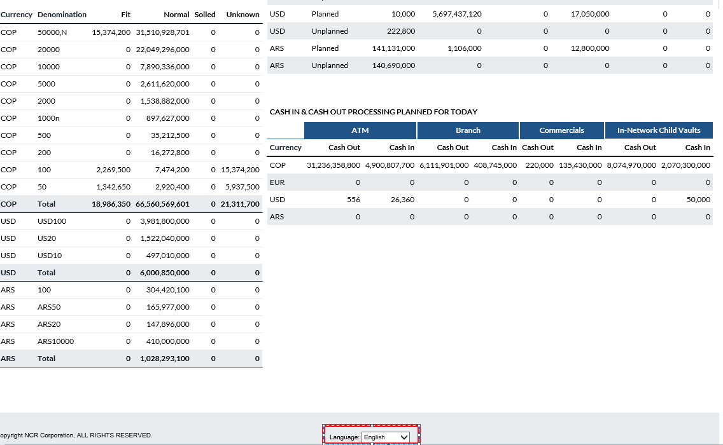

Return To: General OptiVault Pages

### Cashpoints

The Cashpoint is the core of OptiVault. Each one holds a piece of a large puzzle, which is the Cash Network. The Cashpoint holds all the History and Parameters that allows the system to create Forecasts and Recommendations at a granular level. The Cashpoint window contains all the information, parameters, reports, and functions that allow the user to define, manage, and execute processes for Cashpoint.

The following is a summary of the information that will be covered along with hyperlinks to each topic:

* Cashpoint Types
* Cashpoint→Basic→Definition
* Cashpoint→Basic→Denominations
* Cashpoint→Basic→Service Days
* Cashpoint→Basic→Cashpoints
* Cashpoint→Basic→Balance Entry
* Cashpoint→Basic→Provisional Credit
* Cashpoint→Advanced→Denomination Yield
* Cashpoint→Advanced→Sorting
* Cashpoint→Advanced→Sorter Utilization
* Cashpoint→Advanced→Quality Yield
* Cashpoint→Advanced→Cross-Ship Fit Split
* Cashpoint→Orders→Recommendations
* Cashpoint→Orders→Orders
* [Cashpoint→Orders→Orders Workflow](#_Cashpoint(Orders(Orders_workflow)
* Cashpoint→Forecast→View Forecast
* Cashpoint→Forecast→Generate Forecasts
* Cashpoint→Forecast→Exclude History
* Cashpoint→Forecast→Analysis
* Cashpoint→Forecast→ATM/BRANCH Forecast
* Cashpoint→Report

Return To: Introduction to the Interface

### Cashpoint Types

There are different types of Cashpoints in OptiVault that perform different functions based on their type. Figure 7 shows the basic relationship of the different Cashpoints and how they relate to each other.

Figure 7: Cashpoint Elements

Below is a description of each Cashpoint and the parameters that are associated with them.

The following is a summary of the information that will be covered along with hyperlinks to each topic:

* Vault
* ATMs and Branches
* Commercial
* Custodial Inventory
* External Funding Source

Return To: General OptiVault Pages

### Vault

The Vault Cashpoint is the main type of Cashpoint that is used to manage cash from its funding sources and to its child Cashpoints. Vaults are the central Cashpoint from which all transactions are performed.

Vaults can be independent of all other vaults or they can be dependent on one another; meaning that one vault can be the funding source for another. A vault has other Cashpoint types assigned to it such as ATMs, Branches, Commercial Cashpoints, or Custodial Inventory Cashpoints.

There are many different combinations that can be used to accommodate the needs of the institution.

The following Topics are related to Vault Cashpoints:

* Cashpoint→Basic→Definition
* Cashpoint→Basic→Denominations
* Cashpoint→Basic→Service Days
* Cashpoint→Basic→Cashpoints
* Cashpoint→Basic→Balance Entry
* Cashpoint→Basic→Provisional Credit
* Cashpoint→Advanced→Costs
* Cashpoint→Advanced→Teller Verification
* Cashpoint→Advanced→Denomination Yield
* Cashpoint→Advanced→Sorting
* Cashpoint→Advanced→Sorter Utilization
* Cashpoint→Advanced→Quality Yield
* Cashpoint→Advanced→Cross-Ship Fit Split
* Cashpoint→Orders→Recommendations
* Cashpoint→Orders→Orders
* Cashpoint→Forecast→View Forecast
* Cashpoint→Forecast→Generate Forecasts
* Cashpoint→Forecast→Exclude History
* Cashpoint→Forecast→Analysis
* Cashpoint→Forecast→ATM/BRANCH Forecast
* Cashpoint→Report

Return To: Cashpoint Types

### ATMs and Branches

ATMs and Branches are managed by OptiCash and are used in OptiVault to forecast the demand from these Cashpoints as demand on Vault Cashpoints in OptiVault. ATM and Branch Cashpoints are created in OptiCash and synchronized with OptiVault. It is not possible to create an ATM or Branch Cashpoint in OptiVault.

ATM and Branch Cashpoints can be assigned manually to a Vault at the Vault Cashpoint level or assigned through the Cashpoint synchronization process.

The following topics are related to ATM and Branch Cashpoints:

* Cashpoint→Basic→Cashpoints

See the following topics for information on assigning ATM and Branch Cashpoints to Vaults:

* Cashpoint→Basic→Cashpoints

Return To: Cashpoint Types

### Commercial

The Commercial Cashpoint is used to account for special customers that deposit large amounts of cash to the Vault. These can be grocery store chains, casinos, or any other institution that uses a lot of currency. These Cashpoints are important because they can contribute or demand large volumes of cash that are important to consider when ordering cash for a vault.

Commercial Cashpoints are created in OptiVault and manually assigned as a Cashpoint to a Vault. This is similar to the ATM and Branch Cashpoint assignment with the exception that Commercial Cashpoints cannot be automatically assigned during Cashpoint Synchronization.

The following topics are related to Commercial Cashpoints:

* Cashpoint→Basic→Definition
* Cashpoint→Basic→Service Days
* Cashpoint→Basic→Balance Entry
* Cashpoint→Basic→Denominations
* Cashpoint→Forecast→View Forecast
* Cashpoint→Forecast→Exclude History
* Cashpoint→Forecast→Generate Forecasts
* Cashpoint→Forecast→Analysis
* Cashpoint→Report

See the following topic for information on assigning Commercial Cashpoints to Vaults:

* Cashpoint→Basic→Cashpoints

Return To: Cashpoint Types

### Custodial Inventory

In certain countries, it is possible for a Vault to hold cash for the Central Bank in a designated area of the vault. Because the cash belongs to the Central Bank, it is off the books of the vault and therefore is not incurring balance costs.

A Custodial Inventory Cashpoint is a special type of Cashpoint that is used as a holding Vault for normal Vault Cashpoints. The purpose of the Custodial Inventory Cashpoint is to hold cash off the books of its parent vault. The Custodial Inventory Cashpoint cannot stand alone, it must be assigned to a vault in order to be used. For a Vault that is capable of using Custodial Inventory, it is an extremely efficient way to lower costs while keeping cash available to service the needs of customers.

The following topics are related to Custodial Inventory Cashpoints:

* Cashpoint→Basic→Definition
* Cashpoint→Basic→Denominations
* Cashpoint→Basic→Service Days
* Cashpoint→Basic→Balance Entry

See the following topic for information on assigning Custodial Inventory to Vaults:

Return To: Cashpoint Types

### External Funding Source

The External Funding Source Cashpoint is used to identify sources of cash in the Funding Chain. The External Funding Source is mainly for informational purposes and does not have much control over its child vaults. The only exception to this would be in the Denominations assigned to the External Funding Source. These denominations are funnelled down to the child vaults as the denominations they are able to order. If denominations are not defined for an External Funding Source Cashpoint, they will not be available to order for any of the child vaults, even if they are already assigned.

The following topics are related to Custodial Inventory Cashpoints:

* Cashpoint→Basic→Definition
* Cashpoint→Basic→Denominations

See the following topic for information on assigning Vaults to External Funding Sources:

Return To: Cashpoint Types

## Cashpoint Pages

### Cashpoint→Basic→Definition

This topic relates to the following Cashpoint types:

* Vault
* Commercial
* Custodial Inventory
* External Funding Source

The Definition page gives general information that describes Cashpoint’s name, location and contact information.

Figure 8: Vault Basic Definition Page

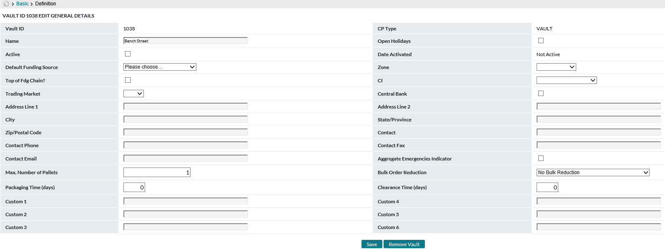

Table 8: Definition Description

| Field Name | Description |
| --- | --- |
| **Vault ID** | A unique 12-character alpha-numeric identifier that is used to identify the Cashpoint in OptiVault. The identifier is referred to differently in each Cashpoint type but is essentially the same thing:   * **Vault:** Vault ID * **Commercial:** Commercial Cashpoint ID * **Custodial Inventory:** CI ID * **External Funding Source:** External Funding Source Cashpoint ID |
| **CP Type** | This field is for informational purposes and shows the type of Cashpoint (Vault, CI, Commercial, External). This field cannot be edited. |
| **Name** | The name of the Cashpoint is used as a description of the Cashpoint. This description can be seen in many reports and processes to refer to the Cashpoint as opposed to the Cashpoint ID. |
| **Open Holidays** | Flag indicating whether or not the Cashpoint is open on Holidays. This is used to identify a Cashpoint as being able to send and receive cash on holidays. |
| **Active** | Flag indicating whether or not the Cashpoint is Active or not. |
| **Date Activated** | The date that the Cashpoint was put into service or activated. |
| **Default Funding Source** | The Funding Source by default, will deliver cash to the Vault or accept returns from the vault. |
| **Zone** | This refers only to Vault Cashpoints and is used to identify the area of the country or zone to which the Vault belongs. This is used to identify the Cashpoint’s location with respect to other Cashpoints and used for checking for Cross-Shipping charges when this functionality is used within OptiVault. See: Network→Cross Shipping |
| **Top of Fdg Chain** | Specifies that the Cashpoint is at the top of the funding chain. When this indicator is selected for a vault, the vault is designated as the ending point for aggregation. When the aggregation process runs for Second Level Aggregation, the aggregation process will stop at the Top of the Funding Chain based on this indicator. |
| **Trading Market** | Allows Users to associate cashpoints with a Trading Market. For more information on Trading Markets see Network→Trading Market |
| **CI** | The Custodial Inventory Cashpoint is associated with the vault. The user will specify the correct CI vault if this is a vault that will use Custodial Inventory. |
| **Address** | The address of the Cashpoint |
| **City** | The city location of the Cashpoint |
| **State/Province** | The state and province of the Cashpoint |
| **Zip code/Postal code** | The postal code of the Cashpoint |
| **Contact** | Contact information for the person who is responsible for the Cashpoint |
| **Contact Phone** | Contact phone number |
| **Contact Fax** | Contact Fax Number |
| **Contact Email** | Contact Email Address |
| **Aggregate Emergencies Indicator** | When this option is enabled, OptiVault will aggregate unplanned or emergency deliveries as well as normal or planned deliveries when performing aggregation during the recommendation process. |
| **Max Number of Pallets** | This represents the physical space available in the vault. See: System→Currencies/Denominations for pallet size definition |
| **Bulk Order Reduction** | This option is used to determine how incoming Vault Orders and incoming ATM residuals are handled in OptiVault. The available options are  **No Bulk Reduction** – This means that there is no reduction of Orders or ATM residuals  **Discount Bulk Cash Order –** The incoming orders are not available on the day they are due.  **Discount ATM Residuals –** The incoming ATM residuals are not available on the day they are due.  **Discount ATM Residuals and Bulk Cash Order –** Both Bulk orders and ATM residuals are not available on the day they are due.  **Bulk Orders -** Vaults have the responsibility to hold enough cash to service the needs of its Child Cashpoints (Vaults, ATMs, Branches, and Commercial Customers). The Vault is supplied with cash primarily from its Parent Vault (i.e., Central Bank or Parent Vault). A Vault receives Cash from its Parent by means of scheduled Deliveries or sends Cash back to the Parent by means of a scheduled Return. These Orders are used to keep the balance of the Vault at a level it can service its Child  In some situations, Bulk Orders are normally not received until the end of the business day. This means that even though the Vault is scheduled to receive a delivery, the funds that are delivered will not be able to be used during the business day. In these situations, the option to discount or deduct the Bulk Orders from the Available Balance is used. This **‘Discount Bulk Orders’** option is set on the Vault’s Parameters screen and is used to deduct the Order(s) on the next business day following the Last Load Date.  **ATM Residuals -** When an ATM uses a Replace Cash replenishment scenario, the ATM is replenished with cassettes filled with Cash that are swapped out for the old cassettes that were used to dispense cash. Normally these replaced cassettes contain residual cash that needs to be returned to the Vault to be processed and used as available cash for future deliveries. ATM Residuals are represented on the Forecast Report for a Vault as Cash In.  In some cases, ATM Residuals are received at the end of the business day. This means that even though the Vault is expecting to have residual cash from ATMs returned to the Vault, that cash is not available due to its late arrival. In these cases, the ATM Residual amounts should be deducted from the Available Cash. When ATM Residuals are received late in the day and are unavailable to be used for orders, the option to ‘Discount ATM Residuals’ is used.  The Discount ATM Residuals option is set on the Vault’s Parameters screen and is used to deduct the ATM Residuals amount for the first day following the Last Load Date. Whether or not there is a Gap between the Last Load Date and the current date, the ATM Residuals from the first day’s forecasted ATM Residuals are used. The ATM Residual amount is shown in the Forecast Report as Cash In. On days where there is no Gap between the Last Load Date and the current date, the ATM Residual amount is the current day’s Cash In. |
| **Packaging Time** | The number of days cash during which cash is intended for specific customer orders is in the vault preparing for delivery. This parameter is used to determine the available balance each day. Cash appears in the vault horizon in the **“Not Available”** column during this time. When using this parameter, there is an assumption that customer orders in history are recorded X days prior to actual arrival at ATM, Branch, or Commercial location (where X = Packaging Time). |
| **Clearance Time** | The number of days that cash takes to be processed when returned to the vault from child Cashpoints. This is used to indicate to the Recommendation process that cash that comes in will not be available right away. For example, the cash may need to be counted and verified prior to being available again for circulation. This appears as a shift in dates: ATM, Branch, and Commercial cash in appear in vault horizon X days later than it left the source, where X is the Clearance time entered here. |
| **Custom 1-6** | Text fields available for custom client-driven details to be stored relative to the cashpoint(s) |
| **Save Button** | Used to save any changes made on the page |
| **Remove Vault Button** | Used to delete the Cashpoint from the system. This deletes all references of the Cashpoint to other Cashpoints as well as any parameters, history, or reports. The Cashpoint must be inactive before it can be deleted. Be sure that the Cashpoint is no longer needed as the deletion is permanent and cannot be undone. |

[Return: OptiVault General Pages](#_General_OptiVault_Pages)

### Cashpoint→Basic→Denominations

This topic relates to the following Cashpoint types:

* Vault
* Commercial
* Custodial Inventory
* External Funding Source

The denominations page is used to assign denominations to a Cashpoint. The denominations and qualities that are assigned to Cashpoint allow Cashpoint to forecast, aggregate, recommend, order, and deliver these denominations. Without the assignment of denominations, the Vault will not be able to order the currencies and they will not be available for order by child or symbiont Cashpoints (Commercial, ATM, Branch, or Custodial Inventory).

Table 9: Denominations Description

| Field Name | Description |
| --- | --- |
| **Currency** | 3-character code of the currency and denomination being defined |
| **Denomination** | The denomination of the currency |
| **Quality** | The quality of the note. There are several that become available for each denomination defined.   * **Unknown –** Cash that has not been sorted or verified. * **Fit –** Cash that can be used by branches but is required for ATMs. * **Normal –** Cash that can be used by branches or commercials * **Soiled –** Unfit for circulation |
| **Max Balance** | The maximum balance of the denomination that can be held in the Cashpoint. |
| **Order Unit Amount** | The bundle size of the order for the denomination. This means that orders must be in multiples of the Order Unit Amount. |
| **Minimum Delivery Amount** | The minimum amount that must be ordered for each delivery |
| **Minimum Return Amount** | The minimum amount that must be ordered for each return |
| **Minimum Unplanned Delivery Amount** | The minimum amount that must be ordered for each unplanned delivery |
| **Recommend Flag** | Determines which denomination/quality combinations will be considered during the Forecast and Recommendations processes. Checked are processed while unchecked are not processed. |
| **Include in Sorting** | Determines if the denomination is included in the sorted process. By default, all unknown qualities assigned to a Vault are automatically included in the sorting process. |
| **Add New** | Allows the user to add new denominations to the Cashpoint. Once clicked, a pop-up screen will appear with the available currencies and qualities that can be added to the Cashpoint. |
| **Remove button** | Used to Remove a denomination from the vault.  Caution should be taken before removing denominations as the history will also be deleted and if Cashpoint has child vaults attached to it, they may no longer have the ability to order the denominations. |

[Return: OptiVault General Pages](#_General_OptiVault_Pages)

### Cashpoint→Basic→Requirements

This topic relates to the following Cashpoint types:

* Vault

Table 10: Requirements Description

| Field Name | Description |
| --- | --- |
| **Current Existing Vault Requirements** | A list of the denominations and qualities that have requirements defined. The list contains definitions for individual days of the week or **‘All Days’** which applies to every day. Clicking on the hyperlink will load the currently defined requirements in the Edit pane. This is the same as selecting the denomination/quality, the day, and selecting the Retrieve button. |
| **Vault ID** | The identifier of the vault. |
| **Denom. List** | A dropdown allows the user to specify the Denomination and quality for which the requirements will be defined. |
| **Day** | Lists the possible choices for requirements definition. The options available are:   * **All Days –** Means the requirements apply to every day of the week. * **Weekdays –** Sunday Thru Saturday meaning the requirements refer to that day of the week, every week. * **Specific Day –** The requirements apply to only 1 specific day. Selecting this option will show a list of all currently defined Specific day requirements and allow the user to either edit existing or create new requirements. |
| **Retrieve Button** | Retrieves the requirements for the Denomination/Quality and Day selected. If the requirements have not yet been defined, a new record will be displayed that will allow the user to define and save the requirements. |
| **Edit Existing Requirements** | A list of all the denomination requirements for the Vault ID, Currency, Denomination, Day, and Quality selected. These will all be fields that will be defined at the top of this pane. |
| **Cycle** | Indicates the cycle for which cash is delivered to the Vault.  The available options are:   * Weekly * Bi-Weekly * Tri-Weekly * 4th Week * Monthly Week 1 * Monthly Week 2 * Monthly Week 3 * Monthly Week 4 |
| **Specific Date** | When used with a specific date option, this is the date for which the parameters will apply.  When a cycle is chosen for Bi-Weekly, Tri-Weekly, or 4th Week, the Specific date indicates that starting date of the cycle. |
| **Max Holding** | The maximum holding amount for a given denomination. |
| **Minimum Operating Balance** | Sets the minimum balance for the Vault. This is also known as safety stock and is used to ensure that enough cash is available at the Vault to avoid a shortfall situation. This amount is included as part of the required balance |
| **E-Cash Holding Amount** | Emergency Cash Holding amount is used as an amount that is held in the Vault for emergency purposes. This amount is included as part of the required balance |
| **Percent of Withdrawals to Cover** | The percentage of forecasted withdrawals that should be covered by cash balances in the branch at the start of the day. If 100% is input, the branch should have enough cash at the start of the day to satisfy 100% of the expected day’s withdrawals. |
| **Percent of Deposits Available for Withdrawal** | The percentage of daily cash deposits used or recycled to cover cash withdrawals. |
| **Percent of Deposits Held Until End Of Day** | The percentage of all deposits that are held in the balance until the end of the day. This amount is used to determine the recyclability of incoming deposits. |
| **Percent Adjustment to Forecasted Demand** | An adjustment that can be applied to the Forecasted demand to increase the forecasted amount. This field only accepts positive numbers from 0 to 100 |
| **Percent Adjustment to Forecasted Deposits** | An adjustment that can be applied to the Forecasted deposits to increase the forecasted amount. This field only accepts positive numbers from 0 to 100 |
| **Percent Adjustment to Generated Returns** | An adjustment that can be applied to the Recommendation for returns is to increase the amount of cash returned. This field only accepts positive numbers from 0 to 100 |
| **Percent Adjustment to Total Requirements** | An adjustment that can be applied to the Total Requirements to increase the requirements for the Vault. This parameter results in the Cashpoint holding more cash and should only be used when Cashpoint has a poor forecast. |
| **Exception Threshold Amount** | The Exception Amount is used to allow some flexibility to the Required Balance.  When the Exception Amount is set, the recommendation will not trigger an emergency delivery until the Exception amount is exceeded.  **Example,** Tuesday’s Required balance is $100,000, and the opening balance for Tuesday is $98,000 meaning the Cashpoint will fall short $2,000. If the exception amount were set to $5,000, the opening balance for Tuesday could fall to $95,000 without generating and Emergency Delivery.  **Note:** The Exception Amount is an exception based on the Required Balance. Therefore, the Exception Amount cannot exceed the Required Balance value. |
| **Exception Threshold Percent** | An alternative to the Exception Amount is the Exception % of Holdings. Similar in function to the Exception Amount, the Exception Percentage will allow the minimum balance to fall below the Required Balance by the Percentage set.  **Example,** if the Required Balance were set to $10,000 and the Exception Percent to 20%, then the opening balance could fall $2,000 below the requirements before generating an Emergency Delivery. |
| **Save Button** | Saves the currently selected Requirements. |
| **Delete Button** | Deletes the currently selected Requirements |

[Return: OptiVault General Pages](#_General_OptiVault_Pages)

### Cashpoint→Basic→Service Days

This topic relates to the following Cashpoint types:

* Vault
* Commercial
* Custodial Inventory

Table 11: Service Days Description

| Field Name | Description |
| --- | --- |
| **Calendar** | Shows the available calendars and highlights the one(s) that the cashpoint is currently associated with |
| **Business Days** | Business days are defined for every Cashpoint to tell the Forecast and Recommendation process which days the Cashpoint will service customers. This should be the normal work schedule of the Cashpoint. |
| **Required Service Days** | When selected for a given day, this option tells the Recommendation process that it is required to make a delivery on this day. As a result, OptiVault will attempt to maximize the required day to make the most of the delivery costs.  **Note:** Optional Days must also be checked when Required Service Days are specified. |
| **Optional Service Days** | When selected for a given day (without a Required Service Day), this option tells the Recommendation process that it is possible to delivery cash on this day, but not required. In this case, OptiVault has the choice if cash will be delivered. This allows the system to be flexible and order cash only when needed. This is also referred to as an On Demand Scenario.  **Note:** This option is overridden if Required Days is selected for the same day. |
| **Cycle** | The frequency that the Cashpoint is normally serviced. It is not always the case that a Cashpoint is serviced every week; this is the purpose of this parameter. It allows the user to specify one of the following methods:   * **Weekly –** Service is done every week * **Bi-Weekly –** Service is done every 2 weeks * **Tri-Weekly –** Service is done every 3 weeks * **Fourth Week –** Service is done every 4 weeks * **Monthly Week 1 –** Service is done only the first week of the month * **Monthly Week 2 –** Service is done only the second week of the month * **Monthly Week 3 –** Service is done only the third week of the month * **Split Week –** Service alternates on different schedules from one week to the next. |
| **Lead Time** | The Lead Time is the time required by the carrier, in advance of delivery, that an order must be placed.  **Example,** If an order placed today can be delivered tomorrow, then the Lead Time is defined as 1. |
| **Lead Time** | The Lead Time is the time required by the carrier, in advance of a return of cash, that a return order must be placed.  **Example,** if a Return Order is placed today and will be picked up tomorrow, then the Lead Time is 1. |
| **EOD Return Time** | Indicates that the branch generally has its cash picked up by the servicer at the end of the business day. Therefore, the demand on the day of return must be included in the calculation of the return recommendation. If not indicated, a beginning-of-the-day (BOD) return time is assumed. This includes one less day of demand in the calculation of the return recommendation. |
| **Lead Time**  (Unplanned Orders) | The Lead Time is the time required by the carrier, in advance of an emergency order of cash, that an emergency order must be placed.  **Example**, if an Emergency Order is placed today and will be delivered today, then the Lead Time is 0. |
| **Unplanned Service Days** | An Unplanned or Emergency delivery falls outside the Lead Time for normal deliveries.  An Unplanned Delivery is a movement of cash to a Cashpoint that can be initiated on short notice. As a result, these types of services are generally more expensive and are avoided at all costs. It is, however, the goal of OptiVault to keep Cashpoints running at all costs and therefore emergencies will be generated to protect a Cashpoint from falling short.  In some instances, institutions choose not to use emergencies or limit them to specific days.  The following scenarios for unplanned deliveries are supported:  NYYYYYN, where Mon-Fri are the available days for emergency deliveries.  NYYYYYY, where Mon-Sat are the available days for emergency deliveries.  YYYYYYY, where Sun-Sat are the available days for emergency deliveries.  NNNNNNN, when there are no days selected for emergency deliveries. In this scenario, all services days for unplanned services are unchecked, and OptiVault will never generate an emergency. If customers choose to use this scenario, it is essential that users use pre-emptive alerts report to warn of any Cashpoints running low on cash.  Taking the decision to avoid emergencies in OptiVault may be a dangerous practice since the user disables the only way OptiVault can alert the user when Cashpoints are running low on cash. |
| **Save Button** | Saves the Service Days parameters. |

### 

### Cashpoint→Basic→Cashpoints

This topic relates to the following Cashpoint types:

* Vault
* Commercial

Table 12: Cashpoints Description

| Field Name | Description |
| --- | --- |
| **Add Cashpoint Vault** | This field allows the user to type in the Cashpoint ID that will be added to the Vault. This can be done by entering a valid Cashpoint ID and clicking the **‘Add’** button. The analyst can also click the Browse button to search for a Cashpoint. |
| **Add Button** | Adds a new Cashpoint to the Vault by entering a valid Cashpoint ID into the field adjacent to this button. |
| **Browse Button** | Allows analysts to browse all the available Cashpoints on the system to add to the Vault.  After clicking this button, the analyst will be prompted with a search page where they can search by:   * Cashpoint ID * Name * Depot * Center * Region   The user can also enter the default Delivery and Return Transit times that will apply once the Cashpoints are selected and added.  Once the user has searched for a Cashpoint, they can check the desired Cashpoints and click the ‘Add’ button at the bottom of the page to add the selected Cashpoints to the Vault.  **Note:** A Cashpoint ID can only belong to one Vault, therefore it is possible that if a particular Cashpoint is not found while browsing that the Cashpoint has already been assigned to another Cashpoint. |
| **ID** | Unique alpha-numeric Cashpoint ID that is currently assigned to the selected Vault |
| **Name** | Name of the Cashpoint |
| **Type** | Type of Cashpoint corresponding to the Cashpoint ID. |
| **Return Transit Time** | The time (in days) that it takes to return cash from the Cashpoint. This is read from OptiCash and is read-only in OptiVault. |
| **Delivery Transit Time** | The time (in days) that it takes to deliver cash to the Cashpoint. This is read from OptiCash and is read-only in OptiVault. |
| **Remove Button** | Removes the corresponding Cashpoint from the Vault |
| **Save Button** | Saves changes made to the Return and Delivery transit times. |

Return To: General OptiVault Pages

Cashpoints

### Cashpoint→Basic→Balance Entry

This page allows the user to manually enter or edit balances for the selected Cashpoint.

This topic relates to the following Cashpoint types:

* Vault
* Commercial
* Custodial Inventory

Table 13: balance Entry Description

| Field Name | Description |
| --- | --- |
| **Cashpoint ID** | The Cashpoint ID for the vault that has been selected |
| **Date** | The date of the entry will be changed. This can be changed by clicking on the calendar icon and selecting a new date. |
| **Submit button** | Submits the request to change the balances for the Cashpoint ID and date selected. |
| **Vault Cashpoints** | The following fields are available for the Vault Balance entry:   * **Load –** This checkmark is used to indicate that the denomination will be loaded or saved upon clicking the save button. * **Denomination –** Lists the denomination and quality to be loaded * **Closing Balance –** The actual closing balance of the vault. * **Not Available –** The balance that is not available for withdrawal for the selected day. * **Branch/ATM Orders –** The number of orders for the day to be delivered to the vault’s Branch and ATM Cashpoints. * **Branch/ATM Returns –** The number of returns for the day from the vault’s Branch/ATM Cashpoints. * **Central Bank/Vault/Other Source Cash In –** Cash coming in from the Funding Sources * **Central Bank/Vault/Other Source Cash Out –** Cash going out to the Funding Sources |
| **Commercial Cashpoints** | The following fields are available for the Commercial Balance entry:   * **Load –** This checkmark is used to indicate that the denomination will be loaded or saved upon clicking the save button. * **Denomination –** Lists the denomination and quality to be loaded. * **Deposits –** Deposits into the Vault from the Commercial Customer * **Withdrawals –** Cash deliveries to the Commercial Customer from the Vault. |
| **Custodial Inventory Cashpoints** | The following fields are available for the Commercial Balance entry:   * **Load –** This checkmark is used to indicate that the denomination will be loaded or saved upon clicking the save button. * **Denomination –** Lists the denomination and quality to be loaded. * **Opening Balance –** The balance at the start of the day for the Custodial Inventory Cashpoint * **Cash In –** Cash transferred into the Custodial Inventory from the Vault * **Cash Out –** Cash taken out of the Custodial Inventory to the Vault * **Closing Balance –** The balance at the end of the day for the Custodial Inventory Cashpoint |
| **Check All Link** | Checks all denominations and qualities listed on the Balance Entry page. |
| **Clear All Link** | Clears all checkmarks for all denominations and qualities listed on the Balance Entry page. |
| **Save Button** | Saves the changes to the selected denominations and qualities on the page. |
| **Cancel Button** | Cancels any changes made and reverts to the previous menu. |

Return To: General OptiVault Pages

Cashpoints

### Cashpoint→Basic→Provisional Credit

The Provisional Credit is used in cases where cash is in the Vault but for some reason is not included in the balance information of the Vault. A provisional credit can then be entered for a particular day so that the On Book Minimum Holding Custodial Inventory Capacity amount (OBMH/CI Cap) is calculated correctly.

This topic relates to the following Cashpoint types:

* Vault

Table 14: Provisional Credit Description

| Field Name | Description |
| --- | --- |
| **Vault ID** | The Cashpoint ID for the vault that will have the Provisional Credit added |
| **Date** | The date of the provisional credit. This date can be selected by clicking on the Date icon. |
| **Amount** | The amount, in local currency, that will be added to the vault on the selected date to be added as a provisional credit |
| **Save** | Saves the entry to the Vault as a provisional credit for the date and Cashpoint ID selected. |

Return To: General OptiVault Pages

Cashpoints

### Cashpoint→Advanced→Costs

The cost elements that are assigned to the Cashpoint are used for both the optimization and reporting of the Cashpoint. It is important to have the correct cost settings to ensure the best optimization possible for the Cashpoint.

This topic relates to the following Cashpoint types:

* Vault

Table 15: Costs Description

| Field Name | Description |
| --- | --- |
| **Effective Date** | The date that the currently defined rates are applicable. The date can be selected by clicking on the Date icon and will be saved with the new values upon clicking the **‘Save’** button. |
| **Carrier** | The carrier that is assigned to the vault for the delivery and return of cash from the vault’s funding source. |
| **Range Button** | Clicking this button allows the analyst to define ranges for either Fixed or Per $ Cost elements. The range is used when the costs are different based on the amount of cash that is being delivered/returned.  The analyst can specify one or several cost elements by selecting the checkbox and entering the Cost per trip and the upper and lower bounds of the cost range.  **Note:** There should be no gaps in the cost ranges otherwise there could be inaccurate cost calculations. |
| **Remove Button** | Removes the corresponding cost element from the Cashpoint. |
| **Add New Button** | Allows the analyst to add new cost elements to the Cashpoint. Clicking on this button will pop-up a page with the currently available cost elements that are not currently assigned to the Cashpoint. The analyst can select the items to add by checking the boxes next to the cost element and clicking the **submit** button. |
| **Costs** | A vault can be assigned a variety of cost elements that are applicable to the type of service the Cashpoint receives. All cost elements that are performed at the Cashpoints should be added to the vault to ensure the correct calculations for both Recommendations as well as the Cost Calculation process.  The different Service types are:   * **Normal Delivery/Return –** Delivery or return of cash to the Cashpoint within the predefined lead times for normal deliveries * **Combined Service –** Delivery costs for normal services when a Delivery and return occur on the same day. * **Emergency Delivery/Return –** Deliveries or returns that occur outside the normal lead time.   The Available Cost elements are:   * **Fixed Costs (Normal/Emergency/Combined Delivery and Returns) –** The fixed prices for service to the Cashpoint. Fixed implies that the cost will occur every time a service is placed for that category regardless of the value of the service. * **Per Unit Costs (Normal/Emergency/Combined Delivery and Returns) –**In addition to the fixed cost defined above, some carriers may charge a fixed cost perdefined unit of delivery (**Example,** a bag or box of money transported). In this case, set the unit size, and the cost per unit size.   + Formula for total delivery cost:   + Total Delivery Cost = Fixed Cost per Delivery + (Delivery Amount / Unit Size) x Fixed Cost per Defined Unit.   + **Example:** Fixed delivery cost = 50, defined unit size = 5000, cost per defined unit = 20. When the delivery = 45000, the total cost of delivery will be: 50 + (45000 / 5000) \* 20 = 230. * **Unit Size –** The size that is charged based on the Per Unit Costs * **Per $ Cost –** The cost for each unit of currency. |
| **Save Button** | Saves the changes made to the cost page. |

Table 16: Costs (by Currency) Description

| Field Name | Description |
| --- | --- |
| **Max Holding Amount** | This is the maximum total amount that will be recommended to hold in a vault for the total of all denominations and qualities. This generally applies to insurance or capacity limitations of a vault.  Additionally, the denomination maximum capacities ensure that a single denomination does not exceed the maximum capacity during the recommendation process. |
| **Currency Insurance Rate %** | The annual insurance rate that is used to calculate the insurance cost for the vault |
| **Delivery Handling Cost** | The additional cost associated with the delivery of cash. |
| **Return Handling Cost** | The additional cost associated with the return of cash. |

[Return: OptiVault General Pages](#_General_OptiVault_Pages)

### Cashpoint→Advanced→Teller Verification

Cash that is returned to a vault from a Branch/ATM/Commercial Customer is normally not able to be used immediately. The vault must first process the incoming cash to ensure that the amounts are correct before sorting and making it available for withdrawal. Teller verification is an optional process that is used by some banks to capture the true availability of cash in the Vault. This functionality is used in conjunction with sorting to account for delays in the processing of incoming cash. Cash that comes into the Vault as unavailable is processed based on the settings on the Teller Verification page and made available to the sorter process, which then clears the cash to be used by the vault for upcoming demand.

This topic relates to the following Cashpoint types:

* Vault

Table 17: Teller Verification Description

| Field Name | Description |
| --- | --- |
| **% of Unavailable to be Processed** | This value indicates the percentage of the balances of quality **‘Unavailable’** that are processed each day.  Cash that is reported in the balances as **‘Unavailable’** is normally reported on a daily basis in the nightly balance file. This amount usually includes the previous day’s deposits that were not able to be processed on the day they came in. |
| **% of Daily Deposits to be Processed** | This value indicates the percentage of incoming deposits from Branches/ATMs/Commercial customers that are processed on a given day. Any amount less than 100 indicates to OptiVault that the remainder will be ‘Unavailable’. The Unavailable balances will be processed on the next day that ‘Unavailable’ cash is processed based on the ‘% of Unavailable to be Processed’ setting. |
| **Expected Yield of Unverified Balance** | These fields allow the analysts to set up the expected yield of the Teller Verification process. These are used when the sort functionality is not used and allow the software to estimate the expected quality outcome of the Teller Verification process.  If the Sorting functionality is used by the Cashpoint, then the Expected Yield of Unverified Balance should be set to 100 for Unknown and the other elements should be zero.  **Note**: The sum of the Expected Yield of the Unverified Balance should equal 100% |
| **Save Button** | Saves the changes made to the Teller Verification settings |
| **Cancel Button** | Cancels any changes made to the Teller Verification settings and reloads the page with the currently saved settings. |

Return To: General OptiVault Pages

Cashpoints

### Cashpoint→Advanced→Denomination Yield

The Denomination Yield applies to the Teller Verification process and is used to indicate the Yield of the Teller Verification process by denomination. This is used in conjunction with the Expected Yield of Unverified Balance setting on the Teller Verification page to determine the expected denominations and qualities of the Teller Verification process. The page is automatically populated with each of the denominations that are assigned to the Cashpoint and the analyst must enter the percentage of each denomination (equal to a total of 100%) for each day that processing is performed.

This topic relates to the following Cashpoint types:

* Vault

Figure 9: Denomination Yield Page

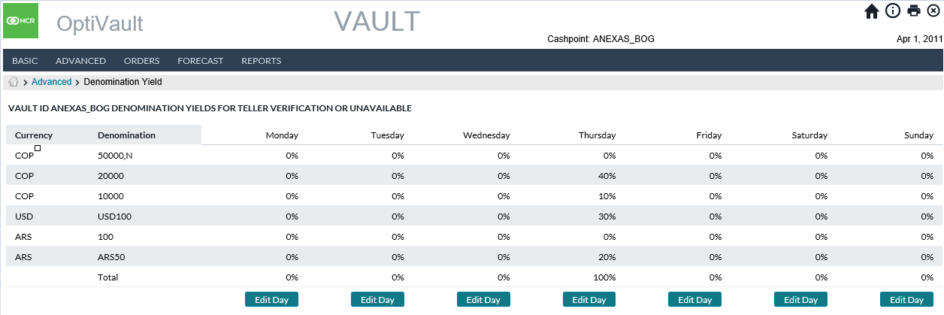

Table 18: Denomination Yield Description

| Field Name | Description |
| --- | --- |
| **Currency** | Gives the currency ISO code for the currency/denomination being defined. |
| **Denomination** | The denomination ID that is assigned to the Cashpoint. |
| **Edit Day Button** | Displays a pop-up corresponding to the day of the week where the denomination yield percentages can be entered or changed. |
| **Save Button** | Saves the denomination yield percentages for the vault |
| **Cancel Button** | Cancels all changes made to the yield percentages and exits the screen without making any changes. |

[Return: OptiVault General Pages](#_General_OptiVault_Pages)

### Cashpoint→Advanced→Denomination Yield→Edit

By selecting the Edit button on the Denomination Yield page, the user will receive a pop-up where they can define the denomination yield expected from the Teller Verification process.

Figure 10: Edit Denomination Yield Page

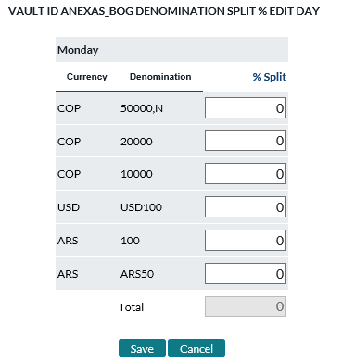

[Return: OptiVault General Pages](#_General_OptiVault_Pages)

### Cashpoint→Advanced→Sorting

The Sorting page allows the analyst to assign sorters that are used in the Cashpoint to process incoming cash of the quality **‘Unknown’**. Unknown cash is then processed and made available for use by the vault based on the Sorter’s Quality Yield percentages. Sorters are defined on the Network tab; for more information, See: Network→Sorters

By default, the sorter includes balances of **‘Unknown’** quality. It is possible to include additional qualities in the sorting process by selecting the **‘Include in Sorting’** option for the denomination and quality on the Denominations page; see: Cashpoint→Basic→Denominations

This topic relates to the following Cashpoint types:

* Vault

Table 19: Sorting Description

| Field Name | Description |
| --- | --- |
| **Sorter Name** | The Name of the sorter that is assigned to the Cashpoint. This value is defined on the Sorter definition page: See: Network→Sorters |
| **Notes Per Hour** | The Number of notes per hour that can be processed by the sorter. This value is defined on the Sorter definition page. See: Network→Sorters |
| **Remove Button** | Removes the corresponding sorter from the Cashpoint. The Remove function only removes the vault from the Cashpoint; the sorter will still be defined in the system. |
| **Edit Day Button** | Allows the analyst to specify the hours of operation for the sorter. |
| **Hours** | Number of hours that the sorter runs on a particular day. |
| **Notes** | This field is for informational purposes only and is used to indicate to the analyst the number of notes that are processed based on the number of hours the sorter runs and the Notes per hour that it can process. |
| **Add New Button** | Allows the analyst to add a new Sorter to the Cashpoint.  Upon clicking the button, the analyst must select the sorter to be added by clicking the **‘Select’** button corresponding to the sorter that is in use in the Cashpoint. |

[Return: OptiVault General Pages](#_General_OptiVault_Pages)

### Cashpoint→Advanced→Sorter Utilization

The Sorter Utilization page is used to define how the sorter will be utilized each day. In some cases, banks will process certain notes on specific days and therefore can set the percentages of each denomination that will be processed for each denomination on a given day. The combined split percentage must equal 100% or zero.

This topic relates to the following Cashpoint types:

* Vault

Table 20: Sorter Utilization Description

| Field Name | Description |
| --- | --- |
| **Currency** | Shows the various currencies that are assigned to the cashpoint. |
| **Denomination** | The denomination ID of the denomination that is assigned to the Cashpoint. |
| **Edit Day Button** | Allows the user to edit the Capacity splits for the selected sorter for the corresponding day. |
| **Sorter** | The drop-down List box at the top of the page allows the analyst to select the sorter for which the capacity splits will be set. Choosing a sorter from the list will load the values associated with that sorter. |

[Return: OptiVault General Pages](#_General_OptiVault_Pages)

### Cashpoint→Advanced→Quality Yield

The Quality Yield is used to indicate the percentage of each quality that will result from the notes processed. Based on the output of the sorting process, the sorter will process the notes and determine the yield of the sorting process based on the Sorter Utilization settings (See: Cashpoint→Advanced→Sorter Utilization). The results of the sorting will further be split into the note quality based on the Quality Yield settings.

This topic relates to the following Cashpoint types:

* Vault

Table 21: Quality Yield Description

| Field Name | Description |
| --- | --- |
| **Currency** | Shows the various currencies that are assigned to the cashpoint. |
| **Denomination** | The denomination ID of the denomination assigned to the Cashpoint |
| **Quality** | The quality of the denomination that will be output by the sorter.  The only options available are:   * **Fit –** Used for ATM and is the highest quality * **Normal –** Used for branches and commercial customers * **Soiled –** Unusable cash that must be returned to the central bank. |
| **Edit Day Button** | Displays a pop-up window to allow the analyst to define the quality percentage for each denomination. The total split should equal 100% or zero for each denomination in the list. Click on the **‘Submit’** button at the bottom of the page to save the changes. |

[Return: OptiVault General Pages](#_General_OptiVault_Pages)

### Cashpoint→Advanced→Cross-Ship Fit Split

Cross-shipping happens when Fit denominations are ordered and returned at the same time. In certain countries, this is not allowed by the central bank and if it occurs, the bank must pay a penalty for the error. This can become extremely costly and therefore OptiVault attempts to eliminate the possibilities of such costs.

Though the Cross-Shipping penalties apply to Fit cash, it is possible that Normal cash will also contain some Fit cash. Because of this, it is necessary to define an average percentage for each denomination that will be considered fit. In this way, OptiVault can manage the deliveries and return of cash to the Central Bank without having penalties while still maintaining enough cash to service customers.

To define the Cross-Ship Fit Split for denominations, a Zone must be assigned to the Vault and the Normal denomination must have the Cross-Ship option enabled to access the Cross-Ship Fit Split page. See the following topics for more information:

* Cashpoint→Basic→Denominations

This topic relates to the following Cashpoint types:

* Vault

Table 22: Cross-Ship Fit Split Description

| Field Name | Description |
| --- | --- |
| **Denomination** | The denomination ID for the denomination assigned to the Cashpoint that has the **‘Cross Ship’** option enabled.  **Note**: Cross Shipping can only apply to ‘**Normal’** quality cash. |
| **Edit Day button** | Indicates the percentage of fit cash to Normal cash that can be Cross shipped in on a particular day.  Clicking on this button will produce a pop-up window where the analyst can set the Fit percentage for each denomination. Clicking on the **‘Submit’** button will save the changes for the selected entry. |

[Return: OptiVault General Pages](#_General_OptiVault_Pages)

Return To: General OptiVault Pages

Cashpoints

### Cashpoint→Orders→Recommendations

This topic relates to the following Cashpoint types:

* Vault

Table 23: Recommendations Description

| Field | Description |
| --- | --- |
| **View Button** | Allows the user to view the recommendation and invoke the appropriate action to Accept, Deny, or Override the order.  If the order has already been placed, the analyst will see an overview of the order and will have the ability to edit the order. |
| **Action** | The type of service that will take place for the corresponding recommendation. The possible Actions would be:   * Planned Delivery * Planned Return * Emergency Delivery * Emergency Return |
| **Due Date** | The date the order is due to be performed. |
| **Funding Source** | The source Cashpoint that will send/receive the order |
| **Funding Source Type** | The type of funding source corresponding to the Funding Source column |
| **Status** | The status of the recommendation. This indicates if the recommendation has been completed or if it is still open |
| **Total Amount** | The total amount of the recommendation or order. |
| **View Order Button** | The View Order button is visible when viewing a recommendation that has already been committed into an order. Clicking on this View Order button will allow the analyst to see the order and delete or edit it. |
| **Denomination** | Lists the denomination and quality of the denominations that are assigned to the Cashpoint that can be ordered. |
| **Amount** | The recommendation amount of the order for the denomination. |
| **Unit Size** | The Unit Size refers to the size of the order units. Orders must be placed in multiples of the unit size. For instance, if the unit size is 100,000, the order must be 100,000, 200,000, 300,000 etc. |
| **Reason** | When an order is set up as a manual order or an overridden recommendation, the analyst must select an override reason to allow the analysts to later understand why the recommendations were not followed and take corrective action so future recommendations are correct. |
| **Submit Button** | Submits the changes made to the recommendation and converts the recommendation into an order. |
| **Cancel Button** | Cancels the changes made on the page and returns to the previous menu. |
| **View Horizon link** | Changes the view to the Horizon Report for the selected Cashpoint to allow the analyst to see the future horizon for the Cashpoint. This is helpful to allow the analyst to understand the recommendations |
| **Accept Button** | Accepts the recommendation into an order without making changes to the recommended amounts |
| **Override Button** | Allows the analyst to change the recommended amounts and commit the recommendation into an order.  **Note:** When overriding a recommendation, the analyst must select an override reason. This allows the analyst to understand why the recommendation is being overridden and make corrective action to avoid overrides in the future. |

[Return: OptiVault General Pages](#_General_OptiVault_Pages)

### Cashpoint→Orders→Orders

The Orders page allows the analyst to see all the orders that have been created for the current day and view and take corrective action if necessary. This page also allows the analyst to create new Orders once all recommendations have been processed.

Most of the descriptions for the orders are covered in the Cashpoint→Orders→Recommendations

This topic relates to the following Cashpoint types:

* Vault

Table 24: Orders Description

| Field Name | Description |
| --- | --- |
| **Process New Order Button** | Creates a new order for the Cashpoint.  To place a new order, the recommendations for the Cashpoint should first be completed.  Upon entering the order page, the user must first select the Due Date, Funding Source, Action, and Override Reason. Once the options are selected, the order may then be placed for the desired denominations. |
| **Submit Button** | Submits the changes made to the order and saves the completed order. |
| **Cancel Button** | Cancels the changes made to on the page and returns to the previous menu. |
| **Currency** | Filters in which currencies are displayed. Checked currencies are visible while unchecked are hidden.  **NOTE**: Hidden currencies are still part of the order. If you uncheck a currency and then select Save, the order will be saved including any hidden amounts. |

Figure 11: Vault Order

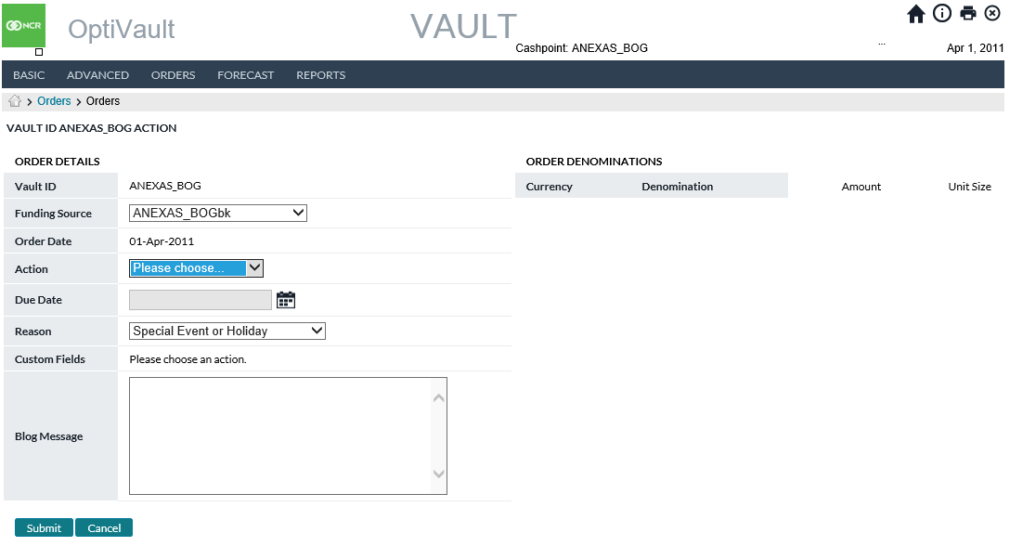

[Return: OptiVault General Pages](#_General_OptiVault_Pages)

### Cashpoint→Orders→Orders workflow

Order Workflow is a separately licensed functionality that is used to help analysts manage the State of an order from the time it is created until the time it is delivered. Workflow rules can be set up by an administrator to manage the different States of an order. Additionally, analysts can keep a Blog history of notes about the order to be able to share information about the orders and improve communication between analysts and users.

Figure 12: Order Workflow Page

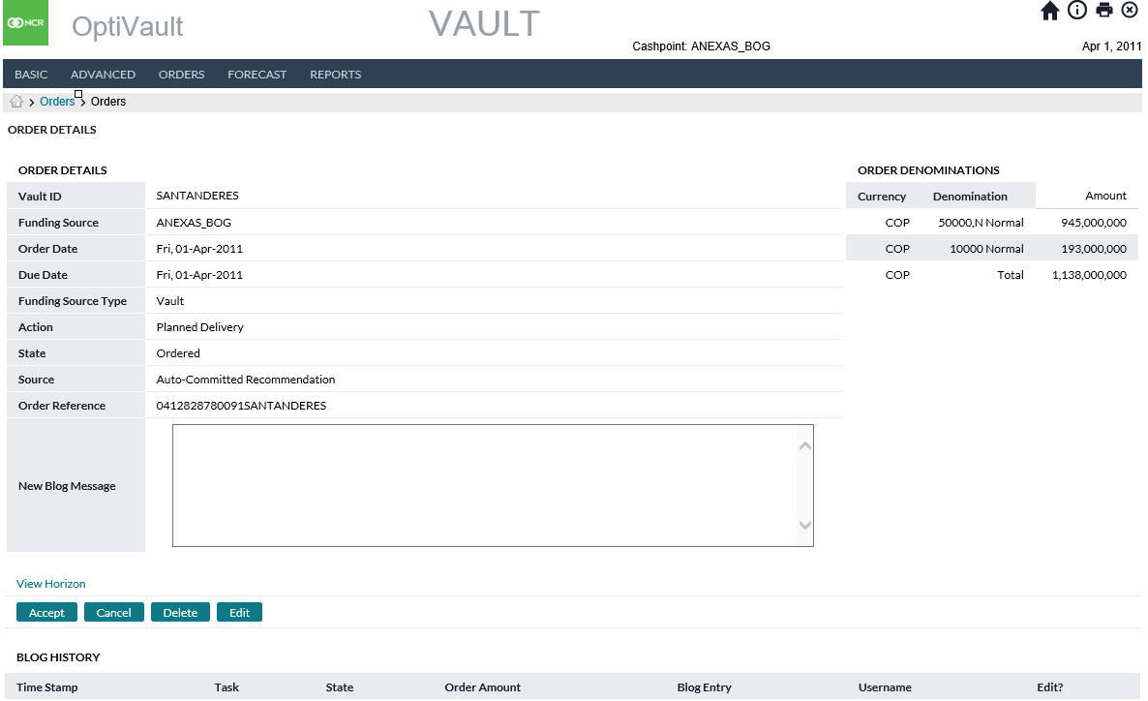

Table 25: Order Workflow Description

| Fields | Description |
| --- | --- |
| **Vault ID** | Unique alphanumeric code that identifies the Vault. |
| **Order Date** | Typically represents today’s date or the date the cash is being ordered. |
| **Due Date** | Due date indicates the date when the order will be completed. Normally, the due date considers the lead-time of the Cashpoint, the service days available, the holiday and other constraints defined in the application. |
| **Funding Source** | Indicates the source of the currency to fill this Order such as the parent vault |
| **Funding Source Type** | Indicates the type of source such as External Vault, Central Bank, Vault |
| **Action** | Describes the type of service that will be performed (Planned Delivery/Planned Return/Emergency Delivery/Emergency Return) |
| **State** | Indicates the current state of the order. The State of the order is determined by the workflow setup at the System →Order Settings level. For more information see: |
| **Source** | Indicates an action that led to the order such as Manual Order or System Recommendation |
| **Reason**  **(if applicable)** | This field is required when the order is a manual order or an overridden recommendation. The override reason is a status indicator that is used to describe the reason for changing a recommendation or creating a manual order. See System→Override Reasons |
| **Total Amount**  **(Ordered Denominations Panel)** | This entry must be performed on the right side of the window, in the Ordered Denominations window.  Enter the amount of Cash by denomination and currency that need to be ordered. When amounts are entered the following validations are taken into consideration:  **Delivery Validation:**   1. Denomination Ordered Amount should not be less than Small or Large Order Unit Size for that denomination (Unit sizes are defined at System → Currencies/Denominations → Denominations; large or small order unit is assigned at the Cashpoint level Basic → Denominations). 2. The total ordered amount should not exceed the maximum capacity of the Cashpoint.   **Return Validation:**   1. Denomination Ordered Amount should not be less than Small or Large Order Unit Size for that denomination (Unit sizes are defined at System → Currencies/Denominations → Denominations; large or small unit size is assigned at the Cashpoint level Basic → Denominations).   **Note:** In OptiNet, the Return Increment feature (defined in OptiNet by an Administrator) can be used to validate the Ordered Amount for each denomination instead of Unit Sizes. However, Return Increments will only apply to the OptiNet Branch Order screens for validation, while OptiCash will validate against unit sizes only. |
| **Blog History** | Details the History of Blog Notes placed for the order |
| **New Blog Message** | Users can enter a new message for the order that will be placed in the Blog History. Analysts can review these notes so all analysts can view them when reviewing the order. |

### Cashpoint→Orders→Order Overview

The Order Overview page gives detailed information about the status of the orders as well as the ability to view all information relating to orders. This section also reviews the following pages that are accessible from the Order Overview page:

* Vault Orders
* Vault Recommendations
* Override Vault Recommendations
* Manual Order Page
* Order Confirmation

### Vault Orders

The Vault Orders page gives detailed information about the status of the orders as well as the ability to view all information relating to the orders. Additionally, the Orders page shows OptiVault Recommendations as well as Child Vault Orders. The detail fields in each of the three sections report the same information for each order/recommendation type.

Figure 13: Orders Overview Page

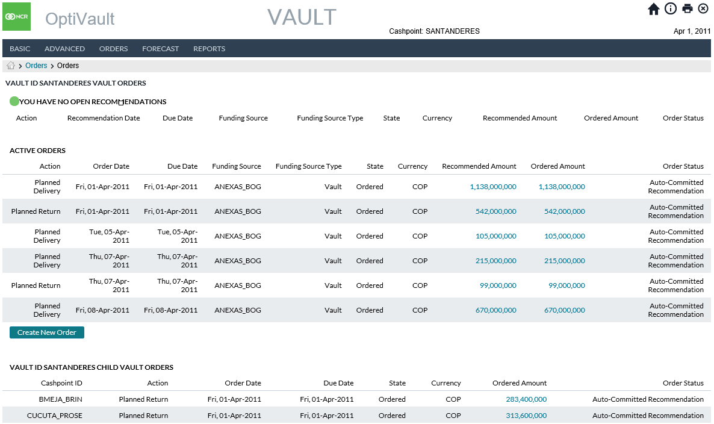

[Return to: Cashpoint Orders](#_Cashpoint→Orders→Order_Overview)

Table 26: Order Details Description

| Field | Description |
| --- | --- |
| **Vault ID**  (only used for Child Vault section) | A unique Vault ID |
| **Action**  (not used for Child Vault section) | Indicates if this is a cash delivery or return from the branch. |
| **Due Date** | Due date indicates the date when the ordered cash will be delivered considering the lead time. |
| **Funding Source** | Displays the Funding Source that has been selected to send cash to or receive cash from the cashpoint in question |
| **Funding Source Type**  (not used for Child Vault section) | Displays the type of funding source options being Vault, External Funding Source, or Custodial Inventory. |
| **Order State** | Gives the current state of the order which is referring to Orders Workflow. Examples include Ordered, Approved, In Transit, et al. |
| **Currency** | Displays the currency for which the Order is for |
| **Recommended Amount**  (not used for Child Vault section) | The amount recommended by OptiVault |
| **Ordered Amount** | The current total amount of the Order |
| **Order Status** | Refers to the current status of the Order. (Open Recommendation, Overridden, Manual Order, Declined, et al). |

[Return to: Cashpoint Orders](#_Cashpoint→Orders→Order_Overview)

### Vault Recommendations

Vault Recommendations provides the user with detail about cash order/shipment recommendations made by OptiVault.

Figure 14: Vault Recommendations Page

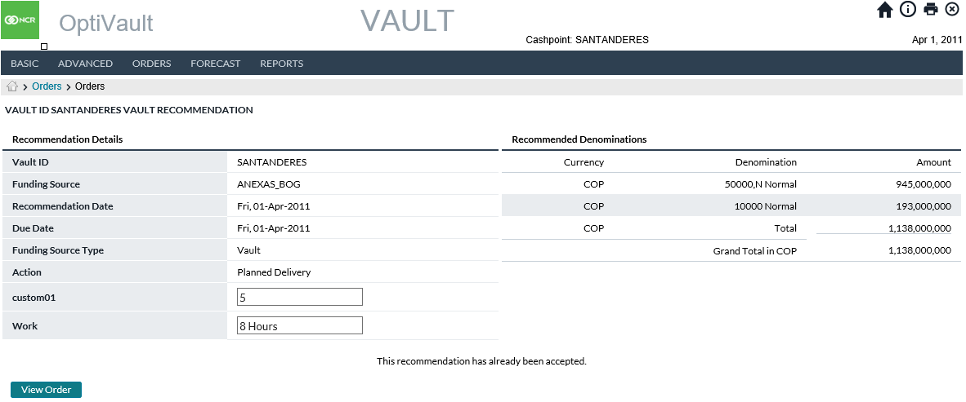

[Return to: Cashpoint Orders](#_Cashpoint→Orders→Order_Overview)

Table 27: Vault Recommendation Description

| Field | Description |
| --- | --- |
| **Vault ID** | A unique alpha-numeric code that identifies the Vault |
| **Funding Source** | The default will be to Default Funding Source |
| **Recommendation Date** | Date the recommendation generated by OptiVault |
| **Due Date** | Due date indicates the date when the ordered cash will be available. Normally, the due date considers the lead time of the Cashpoint, the service days available, the holiday and other constraints defined in the application.  OptiVault uses the smart calendar to control the dates. Only those dates viable for delivery/return under the Vault definition will be allowed. As an example, if a Cashpoint has a service lead time of 1 day, and the only available days for delivery are Tuesday or Thursday, the order for this Cashpoint could only be made on Mondays or Wednesdays due to the lead time defined at the Cashpoint level. The picture below shows the calendar with the hyperlinked dates that are available for making an order. |
| **Funding Source Type** | Refers to the type of cash source. The funding source options are Vault, Commercial, Custodial Inventory, and External Funding Source |
| **Action** | Shows the action recommended by OptiVault. |
| **Custom 1-10** | 1 – 10 Custom fields are available as Optional or Required to provide more information (at the customer’s definition) regarding the order. Only when activated as Optional or Required will the fields appear in the Orders screen |
| **Amount** (Recommended Denominations Panel) | OptiVault shows the Currency, Denomination, and Amount being recommended for inclusion in the action. |
| **Accept Button** | Users can select this to convert the Recommendation to an Order as OptiVault has recommended it |
| **Override** | The user selects to advance to the Override Recommendations screen to alter the system-generated recommendation (see below) |
| **Cancel Button** | Cancels the transaction and no information is saved. |

[Return to: Cashpoint Orders](#_Cashpoint→Orders→Order_Overview)

### Override Vault Recommendations

Users can accept OptiVault-recommended deliveries and shipments via the Vault Recommendations. They can also edit the recommendations via the Override Vault Recommendations page.

Figure 15: Override Vault Recommendations Page

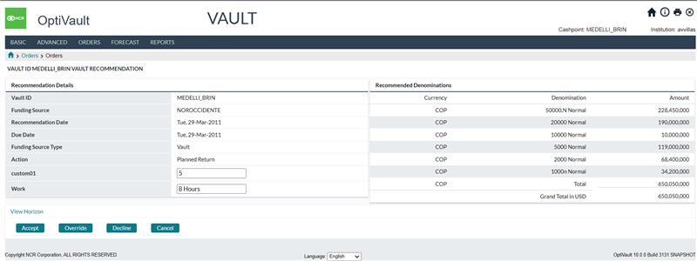

[Return to: Cashpoint Orders](#_Cashpoint→Orders→Order_Overview)

Table 28: Override Vault Recommendation Description

| Field | Description |
| --- | --- |
| **Vault ID** | A unique alpha-numeric code that identifies the Vault |
| **Funding Source** | The default will be to Default Funding Source |
| **Recommendation Date** | Date the recommendation generated by OptiVault |
| **Due Date** | Due date indicates the date when the ordered cash will be available. Normally, the due date considers the lead time of the Cashpoint, the service days available, the holiday and other constraints defined in the application.  OptiVault uses the smart calendar to control the dates. Only those dates viable for delivery/return under the Vault definition will be allowed. As an example, if a Cashpoint has a service lead time of 1 day, and the only available dates for delivery are Tuesday or Thursday, the order for this Cashpoint could only be made on Mondays or Wednesdays due to the lead time defined at the Cashpoint level. The picture below shows the calendar with the hyperlinked dates that are available for making an order. |
| **Funding Source Type** | Refers to the type of cash source. The funding source options are Vault, Commercial, Custodial Inventory, and External Funding Source |
| **Action** | Shows the action recommended by OptiVault. |
| **Reason** | Users select the reason the recommendation is being overridden from a pre-defined list of reasons. |
| **Custom 1-10** | 1 – 10 Custom fields are available as Optional or Required to provide more information (at the customer’s definition) regarding the order. Only when activated as Optional or Required will the fields appear in the Orders screen |
| **Amount (Recommended Denominations Panel)** | Users can enter new amounts by the denomination to alter the recommended total, denomination split, or both. |
| **Unit Size** | Shows the increments by which each denomination is required to be ordered |
| **Submit** | Once the user has made the necessary updates to the recommendation, they can click Submit to convert it to an order. |
| **Cancel Button** | Cancels the transaction and no information is saved. |

[Return to: Cashpoint Orders](#_Cashpoint→Orders→Order_Overview)

### Manual Orders

The Manual Orders page provides the ability to enter a Vault order for either cash delivery or cash return when an Open system-generated Recommendation does not exist.

Figure 16: Cashpoint manual Orders Page

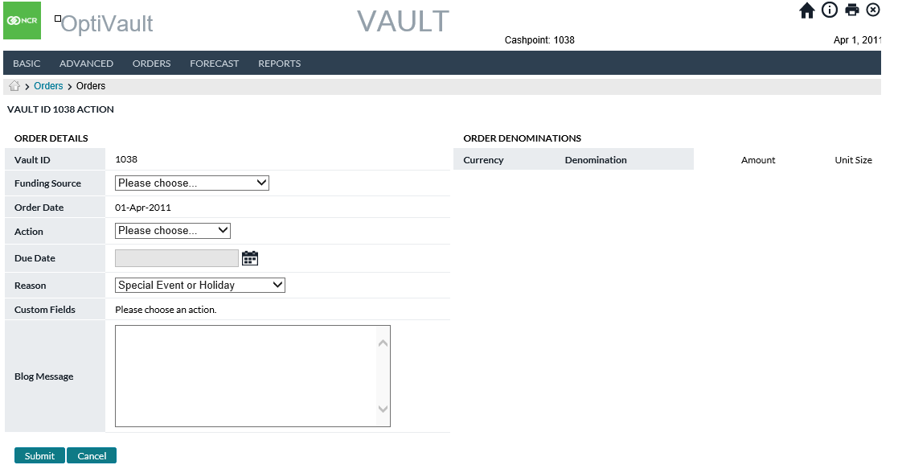

[Return to: Cashpoint Orders](#_Cashpoint→Orders→Order_Overview)

Table 29: Manual Order Description

| Field | Description |
| --- | --- |
| **Vault ID** | A unique alpha-numeric code that identifies the Vault |
| **Funding Source** | Users can select the source for the order being placed. Will default to the Default Funding Source |
| **Order Date** | Typically represents today’s date or the date when the cash is being ordered. |
| **Action** | Shows the action that has been selected in the previous window. |
| **Due Date** | Due date indicates the date when the ordered cash will be available. Normally, the due date considers the lead time of the Cashpoint, the service days available, the holiday and other constraints defined in the application.  OptiVault uses the smart calendar to control the dates. Only those dates viable for delivery/return under the Vault definition will be allowed. As an example, if a Cashpoint has a service lead time of 1 day, and the only available dates for delivery are Tuesday or Thursday, the order for this Cashpoint could only be made on Mondays or Wednesdays due to the lead time defined at the Cashpoint level. The picture below shows the calendar with the hyperlinked dates that are available for making an order. |
| **Reason** | This option is required when the order is new or overridden. The Reasons are created at the **Institution** level under the **System** tab. |
| **Custom 1-10** | 1 – 10 Custom fields are available as Optional or Required to provide more information (at the customer’s definition) regarding the order. Only when activated as Optional or Required will the fields appear in the Orders screen |
| **Total Amount** | This field is an auto-generated field showing the total of the amounts-by-denomination which are input via the Order Denominations panel |
| **Blog Message** | Users can enter a new message for the order that will be placed in the Blog History. Analysts can review these notes so all analysts can view them when reviewing the order. |
| **Amount** (Order Denominations Panel) | This entry must be performed on the right side of the window, in the Order Denominations window.  Enter the amount of Cash by denomination, condition (Fit, Normal, Soiled) and currency that needs to be ordered. When amounts are entered the following validations are taken into consideration:  **Delivery Validation**:   1. Denomination Ordered Amount should not be less than Small or Large Order Unit Size for that denomination (Unit sizes are defined at System → Currencies/Denominations → Denominations; large or small order unit is assigned at the Cashpoint level Basic → Denominations). 2. The total ordered amount should not exceed the maximum capacity of the Cashpoint.   **Return Validation:**   1. Denomination Ordered Amount should not be less than Small or Large Order Unit Size for that denomination (Unit sizes are defined at System → Currencies/Denominations → Denominations; large or small unit size is assigned at the Cashpoint level Basic → Denominations). |
| **Submit Button** | Commits the order provided all information was entered correctly. If there are errors or missing information, the user will be prompted for the correct information prior to committing the order. |
| **Cancel Button** | Cancels the transaction and no information is saved. |

[Return to: Cashpoint Orders](#_Cashpoint→Orders→Order_Overview)

### Order Details Page

The Order Details page provides an opportunity to review, edit, override, and delete an order prior to final placement. If utilized, it also provides the ability to add additional BLOG messages and review existing BLOGs.

The Order Details page applies to both vault and child-vault orders.

Figure 17: Cashpoint Order Confirmation Page

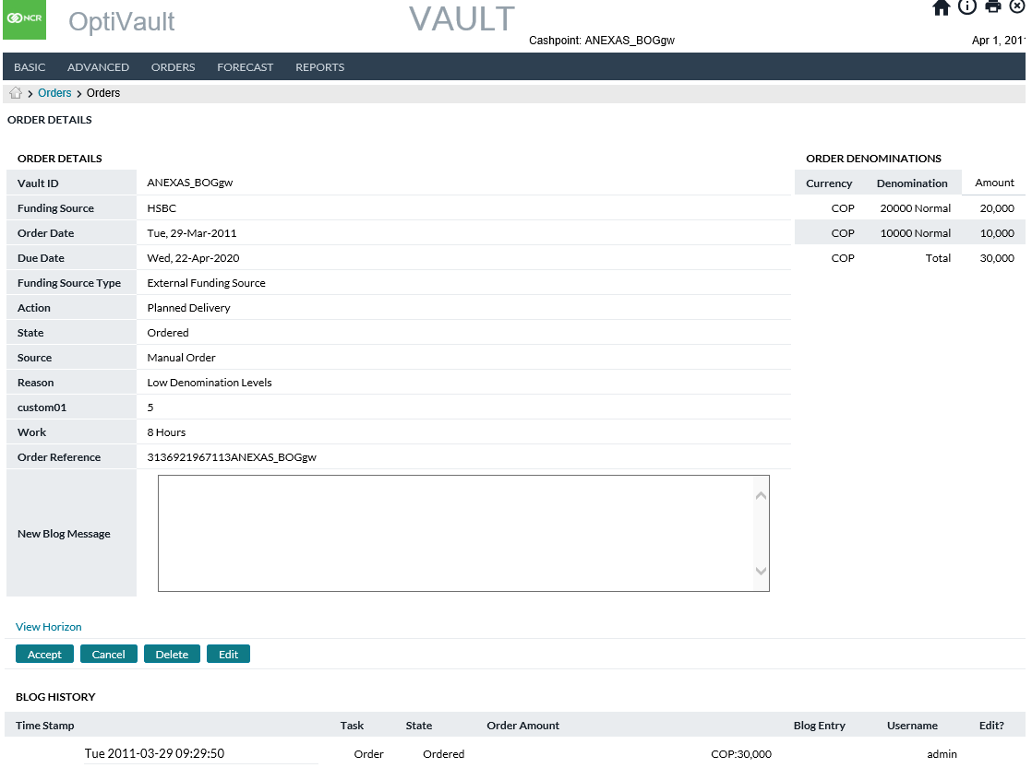

Table : Order Confirmation Page

| Field | Description |
| --- | --- |
| **Vault ID** | A unique alpha-numeric code that identifies the Vault |
| **Funding Source** | Displays the Funding Source that has been selected to send cash to or receive cash from the cashpoint in question |
| **Order Date** | Typically represents today’s date or the date when the cash is being ordered. |
| **Due Date** | Due date indicates the date when the ordered cash will be delivered considering the lead time. |
| **Funding Source Type** | Displays the type of funding source options being Vault, External Funding Source, or Custodial Inventory. |
| **Action** | Shows the action that has been selected in the previous window. |
| **Status** | Status or source of order options being Manual Order, Overridden Order, Accepted Recommendation |
| **State** | Indicates the current state of the order. The State of the order is determined by the workflow setup at the System →Order Settings level. |
| **Source** | Indicates the status of the order: auto-committed, accepted recommendation, overridden recommendation, manual order or centrally overridden. |
| **Reason** | The Reason indicates why a particular recommendation from OptiVault was not used. The override reasons are created at the **Institution** level under the **System** tab. |
| **Custom 01-10** | 1 – 10 Custom fields are available as Optional or Required to provide more information (at the customer’s definition) regarding the order. Only when activated as Optional or Required will the fields appear in the Orders screen |
| **Total Amount** | The current total amount of the Order |
| **Blog History** | Display of all Blog records entered in connection with the order |
| **New Blog Message** | User can enter a new blog message in connection with the order being reviewed |
| **Accept** | Accept button books order as recommended or manually ordered |
| **Cancel** | Approve and book order for changes made |
| **Edit** | Allows the user to Edit an existing order that has not yet reached its Due Date |

[Return to: Cashpoint Orders](#_Cashpoint→Orders→Order_Overview)

### Cashpoint→Forecast→View Forecast

The View Forecast page shows an overview of the forecast in a graphical representation so the analyst can see the variances between the forecasted and actual amounts.

This topic relates to the following Cashpoint types:

* Vault
* Commercial

Table 31: View Forecast Description

| Field Name | Description |
| --- | --- |
| **Start Date** | The date the Forecast graph will start.  **Note:** The graph will only show the date for which Forecast records were created. |
| **End Date** | The date the Forecast graph will end.  **Note:** The graph will only show the date for which Forecast records were created. |
| **Forecast Listbox** | Allows the user to change to the different forecast types. The user must select a forecast type and click on the Submit Button.  Possible selections are:   * Withdrawals * Deposits * Net Demand |
| **Denomination Listbox** | Allows the analyst to change to a different denomination(s). To change the view, the analyst must select the desired options and click the **‘Submit’** button  **Note:** Selecting **‘All’** gives a summary of all forecasts for all denominations for the selected qualities. |
| **Quality Listbox** | Allows the analyst to change to a different quality/qualities to change the view, the analyst must select the desired options and click the **‘Submit’** button.  **Note:** Selecting **‘All’** gives a summary of all the forecasts for the qualities of the selected denomination. |
| **Graph Type** | Allows the user to select between a line or bar graph.  To change the view, the user must select the desired options and click the **Submit** button |
| **Time Period** | Allows the analyst to select specific time periods. Choices are:   * Daily * Weekly * Monthly * Mondays * Tuesday * Wednesdays * Thursdays * Fridays * Saturdays   To change the view, the analyst must select the desired options and click the **Submit** button |
| **Forecast and History Graphs** | Each data point is a specific date. Two values are plotted:  **The Blue line (actual data)** represents the historical data loaded in daily files.  **The Red line (prediction)** represents the forecast data and is based on historical demand, cost, and future events.  Clicking on any data point loads the information in the Forecast Details Pane. |
| **Date** | The date currently selected (by clicking a data point on the graph). |
| **Data Type** | The type of data that is plotted: Withdrawal, Deposit or Net Demand. |
| **Base Forecast** | The value originally forecasted for the day without any adjustments. This figure is for informational purposes only. The Forecasted figure that will be enforced for the Cashpoint is the **‘Forecast’** number. |
| **Forecast** | The value of the Forecast is currently set for the selected day. Forecasts can be adjusted higher or lower due to rounding or Forecast Adjustments applied by an Analyst. |
| **Actual** | The value of Actual Historical data for the selected data point. |
| **Event** | If an Event is in force for the selected day, the name of that event will be listed in this field. |
| **Variance** | The Variance will show the difference between the Forecast and the Actual numbers. |
| **Holiday** | Indicates a non-working day for the Cashpoint and forecast demand will be zero, provided the Cashpoint is flagged as **“closed”** on Holidays. |
| **Exclude** | Indicates if the selected day is excluded in the next forecast generation process. Exclusions are usually necessary when an error in the data load has occurred or extraordinary activity occurs that is unlikely to be repeated. |
| **Forecast Health** | The value indicates the degree of correlation between the forecast and actual data. Generally, any value above 70 indicates a good correlation. The closer the value gets to 100, the higher the correlation. |
| **Events Tab** | Shows a list of the Events and dates assigned to the Cashpoint. |
| **Adjustments Tab** | This tab shows a list of Forecast Adjustments assigned to this Cashpoint.  Forecast Adjustments are used to change the Forecast due to additional trends that may not be captured by the initial forecast. For example, if there is a certain demand trend that is affecting Mondays, the user may adjust the forecast specifically for that day of the week using a percentage.  The Forecast Adjustment can be a positive or negative number. |
| **Create New Adjustment Link** | Above the **‘Adjust’** button is a link that allows the user to specify new Forecast adjustments. Forecast adjustments can be applied to the following days:   * All Days (Default for every Cashpoint) * Sundays * Mondays * Tuesdays * Wednesdays * Thursdays * Fridays * Saturdays * Specific Date   **Note:** The **‘All Days’** Adjustment is overwritten by any day of the week or specific date. The Forecast adjustments are not cumulative. |
| **Adjust Button** | Updates any values changed for the corresponding Forecast Adjustment. |
| **Delete Button** | Deletes the corresponding Forecast Adjustment from the Cashpoint.  **Note:** The **All Days** adjustment is required for every Cashpoint. Setting it to zero means it will not affect the Cashpoint forecast. |

[Return: OptiVault General Pages](#_General_OptiVault_Pages)

### Cashpoint→Forecast→Exclude History

The View Forecast page shows an overview of the forecast in a graphical representation so the analyst can see the variances between the forecasted and actual amounts.

This topic relates to the following Cashpoint types:

* Vault
* Commercial

The Vault History report shows the analyst the historical data that has been loaded into the system for the selected vault. The analyst can exclude data from the forecast from this page.

Table 32: Vault History Description

| Field | Description |
| --- | --- |
| **Start Date** | Starting date of the report |
| **End Date** | Ending date of the report |
| **Submit Button** | Displays the report based on the dates selected |
| **Denomination** | Denomination and quality of for the date selected |
| **Closing Balance** | The closing balance on the date reported |
| **Date** | Date of the reporting day |
| **Not Available** | The cash not available for distribution by the vault |
| **Total Cash In** | The total amount of cash coming into the vault is based on the different Funding source elements |
| **Total Cash Out** | The total amount of the cash going out to the funding sources. |
| **Branch Orders/Returns** | Total orders and returns to branches |
| **ATM Orders/Returns** | Total orders and returns to ATMs |
| **Central Bank Deliveries** | Total deliveries into the Vault from the central bank |
| **Central Bank Returns** | Total returns to the central bank from the vault |
| **Vault Deliveries** | Total deliveries from other vaults |
| **Vault Returns** | Total returns to other vaults |
| **Other Source Deliveries** | Total deliveries from External Sources |
| **Other Source Returns** | Total returns to External Sources |
| **Exclude Button** | Excludes the history record for the date and quality thereby excluding it from being used in the forecast  Upon clicking the Exclude Button, the analyst can choose to exclude Deposits, Withdrawals, or both from the pop-up window.  **Note**: The exclusion entries must be saved for them to take effect in the database. This is done by clicking the **‘Save’** button at the bottom of the page. |
| **Save Exclusion Entries Button** | Saves the exclusion settings for the history records displayed. |
| **View Button** | Displays the report based on the dates selected. |

[Return: OptiVault General Pages](#_General_OptiVault_Pages)

### Cashpoint→Forecast→Generate Forecasts

The Generate Forecast page allows the user to generate a new Forecast for the current Cashpoint. The user can create new Forecast Definition IDs or use existing IDs to run the Forecast process. Denominations can be included during the recommendations and forecast process by simply selecting the **‘Recommend’** checkbox on the Vault > Basic > Denominations page. For more information on running Forecasts see: Forecast→Run Forecast

This topic relates to the following Cashpoint types:

* Vault
* Commercial

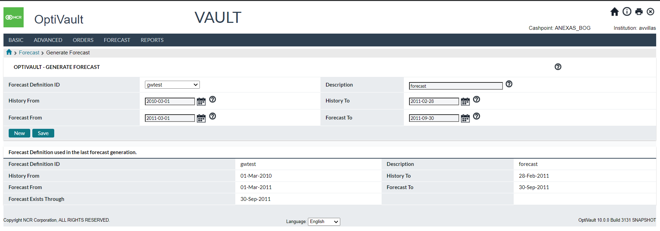

Return To: General OptiVault Pages

Cashpoints

### Cashpoint→Forecast→Analysis

The Forecast Analysis page gives a summary of the Forecast quality values with a visual indicator (Red, Yellow, Green) representing the quality level. This page is for Informational purposes only.

This topic relates to the following Cashpoint types:

* Vault
* Commercial

Table 33: forecast Analysis Description

| Field Name | Description |
| --- | --- |
| **Denomination ID** | The denomination ID of the forecast |
| **Quality** | The quality of the denomination of the forecast |
| **Withdrawals** | The forecast health of the withdrawals portion of the forecast |
| **Deposits** | The forecast health of the deposits portion of the forecast |
| **Net Demand** | The forecast health of the net demand portion of the forecast |

[Return: OptiVault General Pages](#_General_OptiVault_Pages)

### Cashpoint→Forecast→ATM/BRANCH Forecast

This page allows the analyst to determine how the Vault will handle forecasting ATM/Branch demand. Selecting the options on this page means that instead of aggregating the demand of the Cashpoints, it will forecast them as part of the vault’s forecast process.

This topic relates to the following Cashpoint types:

* Vault

Table 34: ATM/Branch Forecast Description

| Field Name | Description |
| --- | --- |
| **ATM Delivery** | When selected, OptiVault will forecast the ATM Deliveries instead of aggregating the future demand |
| **ATM Return** | When selected, OptiVault will forecast the ATM Returns instead of aggregating the future demand |
| **Branch Delivery** | When selected, OptiVault will forecast the Branch Deliveries instead of aggregating the future demand |
| **Branch Return** | When selected, OptiVault will forecast the Branch Returns instead of aggregating the future demand |

[Return: OptiVault General Pages](#_General_OptiVault_Pages)

### Cashpoint→Reports

The reports section of the Cashpoint screen gives the user Cashpoint specific reports to allow for faster access to critical reports used for analysis purposes. The reports are covered in the Reports Tab section of this document. Please refer to the following reports for additional information:

**Vault Cashpoints:**

* Vault Horizon Report
* Vault History Report
* Vault Forecast Report

**Commercial Cashpoints:**

* Commercial History Report
* Commercial Forecast Report

# Today Tab

Today tab represents the high-level summary information and daily highlights for users. The following is a summary of the information that will be covered, along with hyperlinks to each topic:

* [TodayàSnapshot](#_Today→Snapshot_Page)
* [TodayàVault Status](#_Today(Vault_Status)
* TodayàOrders Workflow

### Today→Snapshot Page

This page is the main screen users will log into when using the application. This is the starting point for OptiVault users to perform most of their daily and weekly tasks.

Figure 18: Today -> Snapshot Page

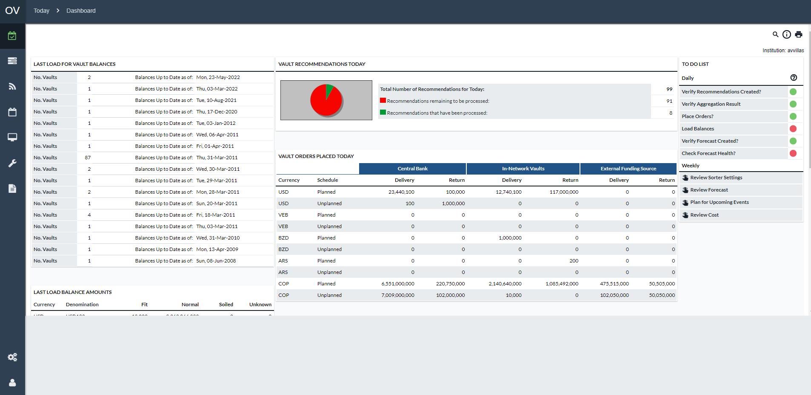

Table 35: Snapshot Page Descriptions

| Today Snapshot | Description |
| --- | --- |
| **Last Load for Vault Balances** | This section displays when balances were last loaded for the Cashpoints assigned to the current user. The list is organized by date and groups the Cashpoints by the last day they had balances loaded. Clicking on a link for a particular date will launch the last load snapshot report. |
| **Vault Recommendations Today** | The Ordering Status screen displays a graphical indicator of the status of the current day’s orders. (See: Vault Orders). The right side of this section shows:   * **Total Number of Recommendations for Today -** The Total Number of Cashpoints, assigned to this user, which has recommendations that were produced for the day. **For example,** if there was only one Cashpoint in the system and that one Cashpoint had 10 recommendations, then this field would display 1. * **Recommendations remaining to be processed –** This number is the number of Cashpoints, assigned to this user, which has recommendations that still need to be processed. If a Cashpoint has more than one recommendation and some or all of those recommendations are still open, then the indicator will still count that Cashpoint as **“remaining to be processed”**. * **Recommendations that have been ordered –** This number is the number of Cashpoints, assigned to this user, which has all their recommendations committed.   The graphic represents the total number of Cashpoints with recommendations. The Red area indicates Open Recommendations and the Green, committed recommendations. |
| **Last Load Balance Amounts** | Displays last loaded balance information by Currency, Denomination and Note Quality |
| **Vault Orders Placed Today** | This part informs about the orders already committed, overridden or manually created for Cashpoints.  The information shown in this section has details about the orders by Currency, Service Type, and Funding Source. The Service Types are as follows:   * **Planned –** Normal Deliveries and Returns * **Unplanned –** Deliveries that fall outside of the regular lead times for Normal Deliveries   **Funding Source options include:**   * Central Bank * In-Network Vaults * External Funding Source |
| **Cash In & Cash Out Processing Planned for Today** | Currency-total Detail of Cash-In and Cash-Out by Cashpoint Types ATM, Branch, Commercials, and In-Network Child Vaults. These are cashpoint types funded by and returning residual cash to Vaults managed by OptiVault |
| **To Do List** | The To-Do List is a daily checklist of the processes or tasks to be executed on a daily basis by the users. See Snapshot→To Do List in more detail. |

### Snapshot→To Do List

The To-Do List is used on a daily basis to help perform the processes necessary to complete the orders for all Cashpoints. The list helps users by providing indicators that show the state of the item to be completed as well as hyperlinks to pages and reports that are used to complete these tasks.

Figure 19: To Do List

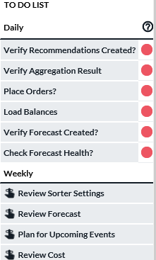

Table 36: To Do List Description

| To Do Item | Description |
| --- | --- |
| **Red Indicator** | Indicates there is an issue to be dealt with. For example, balances are too old, there are alerts, ordering for the Cashpoints has not been finished, etc. |
| **Yellow Indicator** | Indicates that the item has been checked but some items are still warnings that exist. |
| **Green Indicator** | Indicates that there are no warnings or no actions to be taken. For example - there are no alerts, no orders to be completed, etc. |
| **Verify Recommendations Created?** | **Red -** Indicates there was an error when running recommendations. This could apply to all Cashpoints or just one. **Green -** There are no errors in the recommendation process. |
| **Verify Aggregation Results?** | Aggregation is the OptiVault process of taking ATM/Branch cash demand from OptiCash and rolling it to the respective Vaults to drive the recommendation process.  **Red -** There are Cashpoints that failed the aggregation process. **Green -** There are no errors in the aggregation process.  Clicking on this indicator will direct the user to the Aggregation Results page. |
| **Place Orders?** | This indicator shows the status of recommendations that need to be processed for the day.  **Red -** There are open recommendations remaining to be dealt with today. **Green -** There are no open recommendations remaining to be dealt with today.  Clicking on this indicator will direct the user to the Orders Page. |
| **Load Balances?** | This indicator signals if balances have been recently loaded. Normally this is 7 days, but this parameter can be changed by the administrator to include more or less days depending on the preference.  **Red –** There are active Cashpoints, assigned to this user, with out-of-date balances.  **Green -** The balances are up to date for all Cashpoints assigned to this user.  Clicking on the link will redirect to the Today→Vault Status.  If a red legend is displayed, balances must be loaded for those Cashpoints with out-of-date balances. |
| **Verify Forecast Created?** | This indicator is a reminder to run forecasts for the Cashpoints assigned to the user.  **Red -** Indicates that forecasts have not yet been run or there was an error when running forecasts.  **Green –** All forecasts have been run and there are no errors from the forecasting process. |
| **Check Forecast Health?** | This indicator is used both as a reminder to verify and improve forecast quality as well as giving an overview of the overall forecast quality for the Cashpoints assigned to the current user.  **Red -** You have poor forecast health for some of your Cashpoints. **Yellow -** You have marginal forecast health for some of your Cashpoints. **Green -** You have good forecast health for your network.  Clicking on the indicator will bring up the Forecast Health Summary Report. |
| Weekly Processes | |
| **Review Sorter Settings** | Sorters can be configured by type, capacity, operating hours, and also denomination yield percentages can be set accordingly. User should ensure that settings and sorter usage planning have not changed thus impacting projected cash available from sorting |
| **Review Forecast** | It is recommended that the users review forecast quality on a weekly basis as the forecast quality has a direct impact on the quality of recommendations. |
| **Plan for Upcoming Events** | Event setup has a direct impact on the forecast process; therefore, it is important that analysts review events on a weekly basis. Refer to the section Events→Events Page**.**  for more details on how to review, analyze and maintain calendar and event setup. |
| **Review Cost** | To monitor the costs of the network, analysts have to make sure the cost settings are up to date and the actual cost calculation is being run on a weekly basis. For more information, see Processing→Cost Calculation Cashpoint→Advanced→Costs |

### Today→Vault Status

The Today Vault Status Tab shows the analyst a summary of the vaults that are assigned to the analyst based on the Group settings on the Privileges page. Each vault is listed on this page along with a summary of the recommendations, orders, errors, and last load dates.

Figure 20: Today Vault Status Page

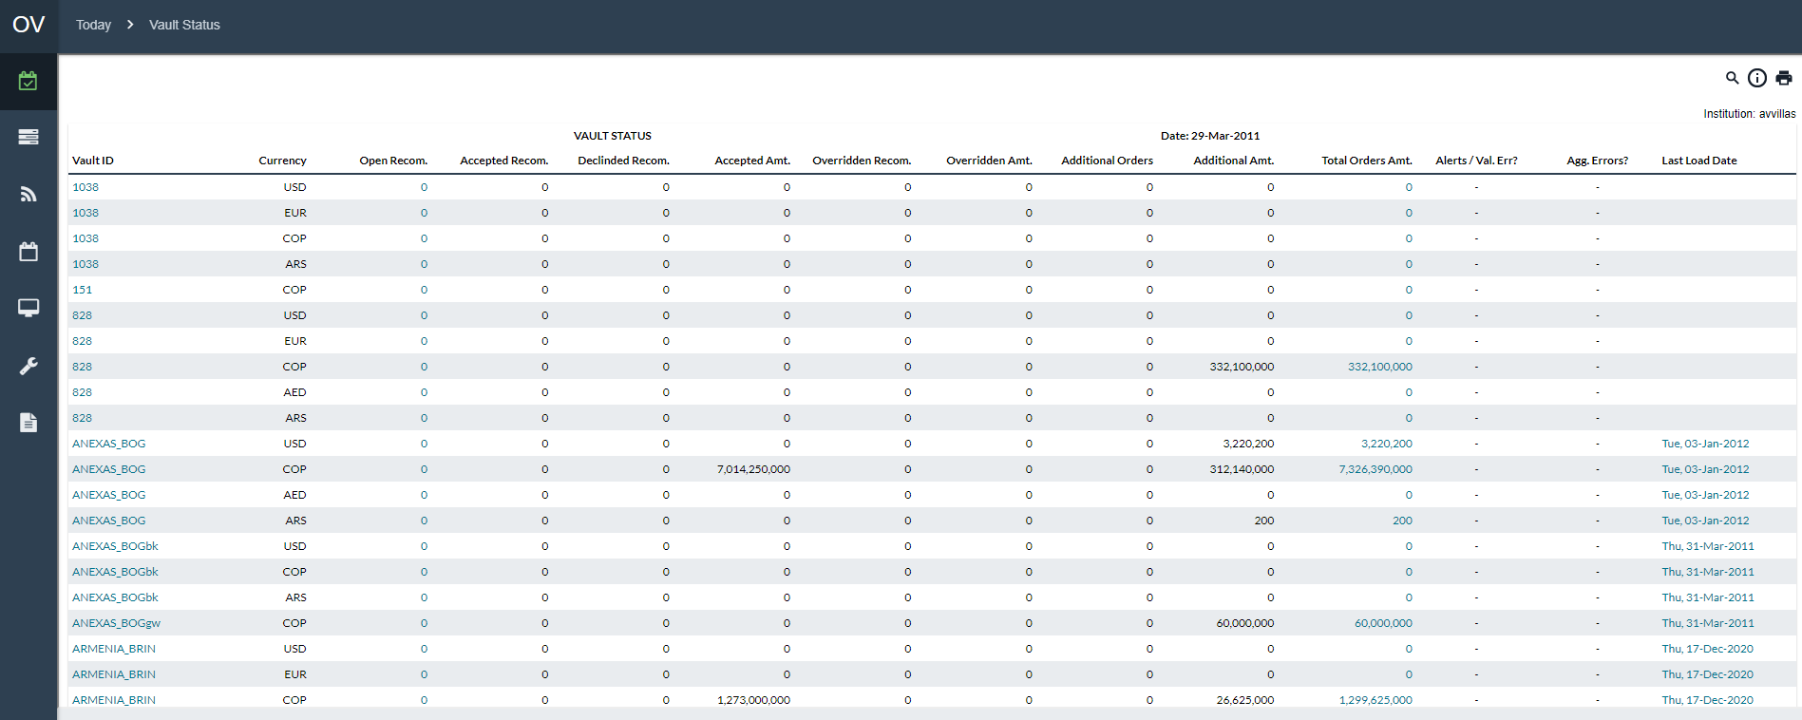

Table 37: Today Vault Status Page Description

| Field Name | Description |
| --- | --- |
| **Vault ID** | A unique 12-character alpha-numeric identifier is used to identify the Cashpoint in OptiVault.  Clicking on the hyperlink for a Vault will take the user to the Vault Cashpoint page where parameters can be reviewed and edited. |
| **Currency** | Each currency has an individual line. Each currency is designated by the currency code. |
| **Open Recommendation** | Shows the number of open recommendations for the vault.  Clicking on the hyperlink for a Recommendation will take the user to the open recommendation page at the Cashpoint level for the vault. From this page, recommendations can be viewed, edited, and committed into orders. If zero recommendations exist, the user can then click on the Orders tab to place a manual order. |
| **Accepted Recommendations** | Shows the number of recommendations that were accepted for the current day. |
| **Accepted Amount** | Shows the order amount of the recommendations that have been accepted. |
| **Overridden Recommendations** | Shows the number of recommendations that were overridden for the current day. |
| **Overridden Amount** | Shows the order amount of the recommendations that have been overridden. |
| **Additional Orders** | Shows the number of manual orders that were created for the current day. |
| **Additional Amount** | Shows the amount of manual orders that were created for the current day. |
| **Total Orders Amount** | Shows the total amount of orders placed for the current day for the Accepted, Overridden, and Additional orders.  Clicking on the hyperlink takes the user to the Vault Cashpoint Orders page to allow the user to view and edit all existing orders for the current day. |
| **Alerts/Validation Error?** | This field shows a warning icon for a vault that had any problems during the loading of data or the recommendation process.  Clicking on the hyperlink takes the user to the Recommendation Results Report. |
| **Last Load Date** | Shows the latest date for which data was loaded for the corresponding vault. |

### Today→Vault Orders

The Today Vault Orders page shows the analyst a listing of the orders and recommendations in the system. Numerous filters are available to assist in locating desired info. The user may also click into a record once located and use that path to reach more details.

Figure 21: Today Vault Orders Page

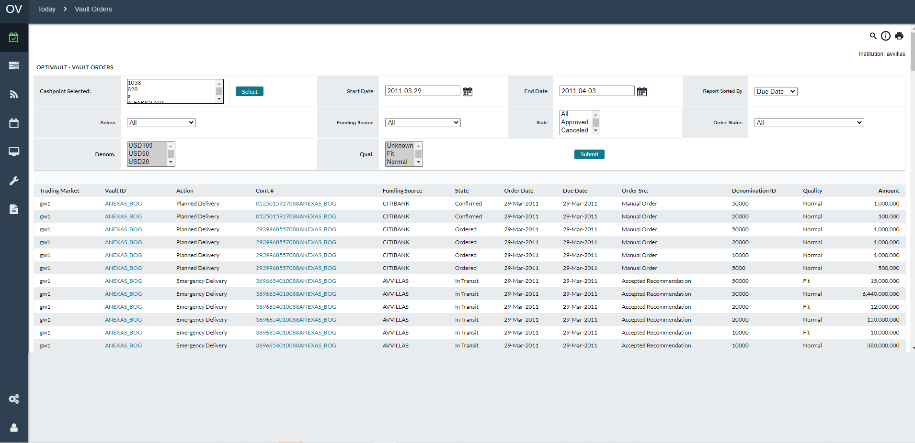

Table 38: Today Vault Orders Page Description

| Field Name | Description |
| --- | --- |
| **Trading Market** | The trading market, if any, to which this vault belongs. |
| **Vault ID** | A unique id that is used to identify the Cashpoint in OptiVault.  Clicking on the hyperlink will take the user to the Vault Cashpoint page where parameters can be reviewed and edited. |
| **Action** | Type of order. Delivery or Return. Planned or Emergency. |
| **Conf. #** | Reference number of the order or recommendation.  Clicking on the hyperlink will take the user to the Vault’s order or recommendation details page. |
| **Funding Source** | The other entity involved in this cash transfer: For delivery, this is the sender. For a return, this is the destination. |
| **State** | The current state of an order. Will be blank for open recommendations. |
| **Order Date** | The date on which the Order was placed into the system. For an open recommendation, this is the date when it is recommended to the user to place the order. |
| **Due Date** | The date on which the transfer is expected to execute. |
| **Order Src.** | Order source. Tracks where the order came from. Manual Order, recommendation, etc. |
| **Denomination ID** | Denomination identifier. |
| **Quality** | Quality identifier. Fit, Normal, Soiled, Unknown |
| **Amount** | The amount of cash to be transferred. |

### Today→Orders Workflow

The Orders Workflow page is used to review orders and quickly move orders from one state to another.

Figure 22: Today Orders Workflow Page

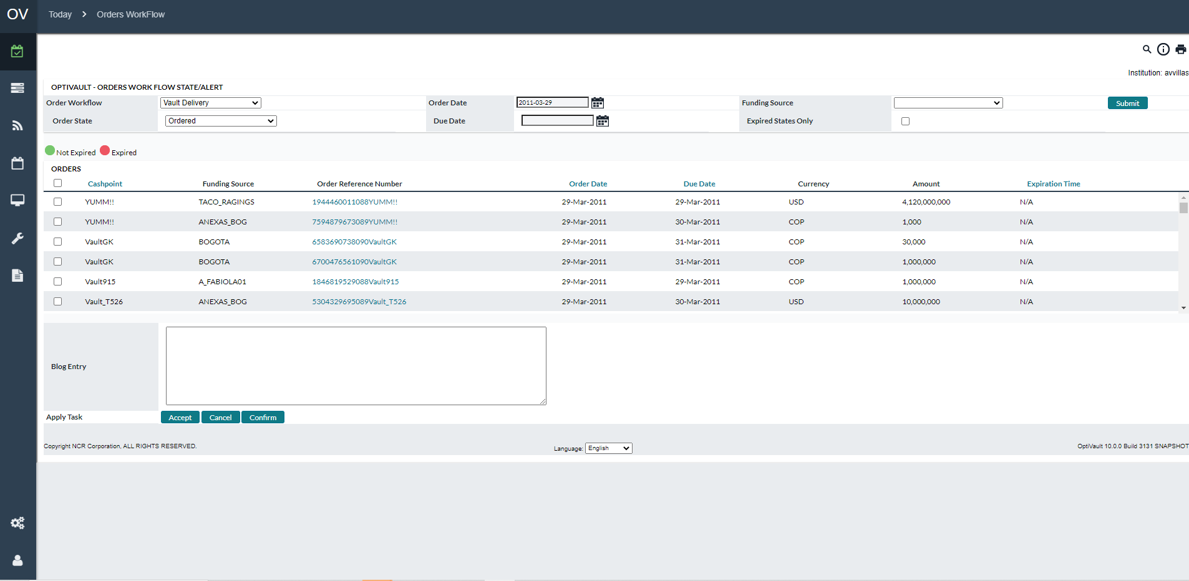

Table 39: Orders workflow Page Descriptions

| Function | Description |
| --- | --- |
| **Order Workflow** | Allows the user to select an order type |
| **Order State** | Allows the user to select an order state |
| **Order Date** | Allows the user to specify an order date |
| **Due Date** | Allows the user to specify an order due date |
| **Expired States Only** | Allows the user to view only those orders past the expiration time for their current state. |
| **Submit Button** | Executes the query to find the orders that pertain to the order parameters specified by the Order Workflow, Order State, Order Date, Due Date, and Expired States Flag. |
| **Checkbox** | Allows the user to select the cashpoints that will be processed for the **‘Apply Task’** |
| **Cashpoint ID** | Indicates the Cashpoint ID of the Cashpoint to be updated |
| **Order Reference Number** | Indicates the Reference number for the order |
| **Order Date** | The date that the order was placed |
| **Due Date** | The date that the order is to be delivered |
| **Currency** | Currency of the Order |
| **Amount** | The amount of the order |
| **Expiration Time** | Time and date that the state of the order is to expire   * Green indicator indicates the State has not expired * Red indicator indicates the State has already expired |
| **Blog Entry** | Allows users to enter information about the transaction in the Blog history |
| **Apply Task button** | Moves the selected orders to the next specified state. |

# Processing Tab

This Tab provides the user with tools to load, process, and export data. The user can Load historical data and orders; define forecast and recommendation parameters; run Forecast and Recommendation processes; output Order and Recommendation Reports; and Calculate the costs for transporting and holding cash.

All of the pages that are contained under the Processing Tab are explained below. The following is a summary of the information that will be covered in this section along with hyperlinks to each topic:

* Processing→Process Status
* Processing→Load
* Processing→Recommendations
* Processing→Forecast
* Processing→Order Output
* Processing→CI Constraints
* Processing→Cost Calculation

Return To: Introduction to the Interface

### Processing→Process Status

The Process Status page shows any system processes that are currently running on the server.

Figure 23: Process Status Page

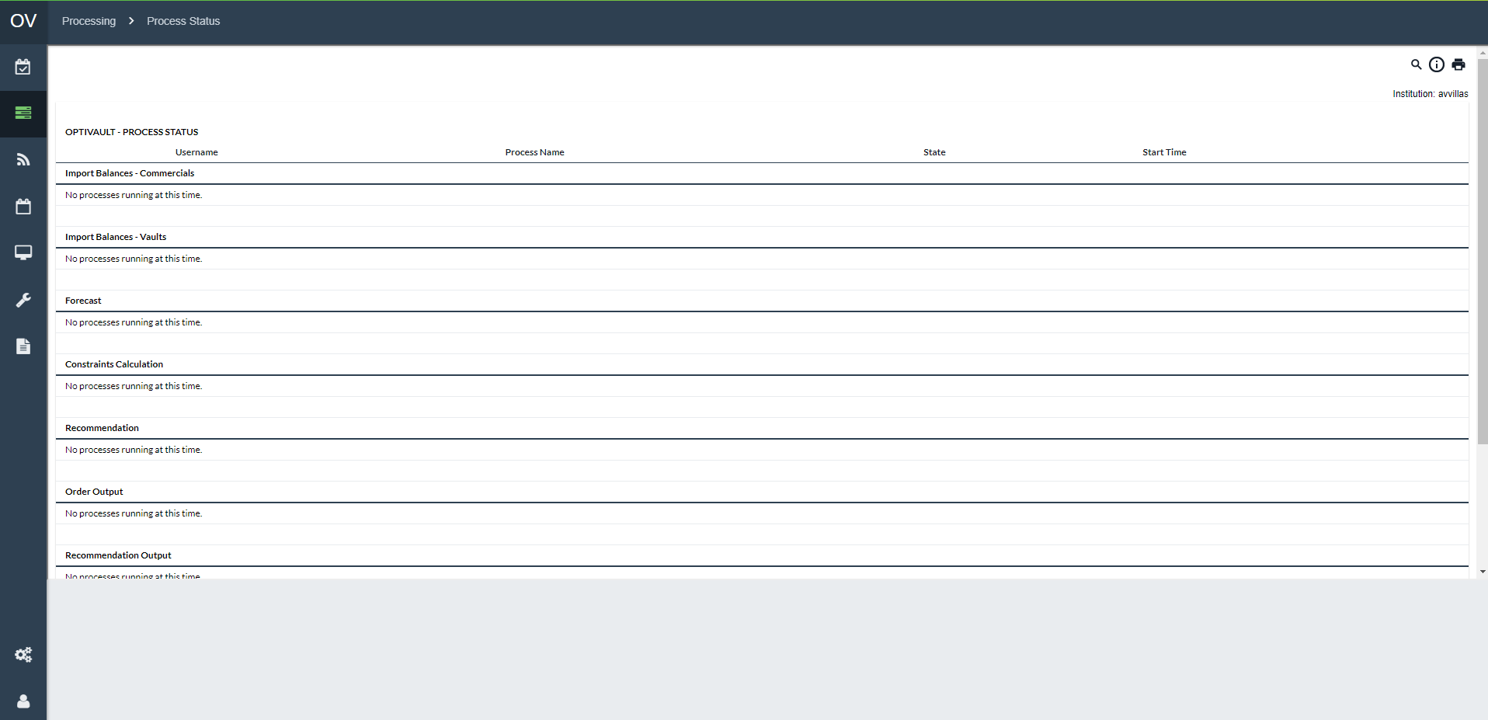

Table 40:Process Status Description

| Field | Description |
| --- | --- |
| **Username** | Name of the user that initiated the process |
| **Process Name** | Name of the process that is running |
| **State** | State of the process that is running (Active or Inactive) |
| **Start Time** | Time the process was started |
| **Import Balances – Commercials** | The daily import commercial balance load process is started through *ProcessingàLoadàLoad Commercial Balances* or as an automated batch process on the server. |
| **Import Balances – Vaults** | The daily import vault balance load process is started through *ProcessingàLoadàLoad Vault Balances* or as an automated batch process on the server. |
| **Forecast** | The forecasting process for Cashpoints is started at the Cashpoint level, through *ProcessingàForecasting*, or as an automated batch process on the server. |
| **Constraints Calculation** | The Constraint Calculations for Custodial Inventory Cashpoints are started through the *ProcessingàCI Constraints* page. |
| **Recommendation** | The recommendation process for Cashpoints is started at the Cashpoint level, through ProcessingàRecommendations, or as an automated batch process on the server. |
| **Orders Output** | The Orders Output process for Cashpoints is started through *ProcessingàOrder Output*, or as an automated batch process on the server. |
| **Recommendation Output** | The Recommendation Output process for Cashpoints is started through *ProcessingàRecommendation Output*, or as an automated batch process on the server. |
| **Commercial Consolidation** | The Commercial Consolidation process for Commercial Cashpoints is started through *ProcessingàForecastàCommercial Consolidation*, or as an automated batch process on the server. |
| **Delete Job** | The **‘Delete Job’** button in the OptiVault interface can be used to delete any of the processes in the queue but **will not delete the process already submitted to the server**.  **Example,** when a forecast process is submitted, it is put into the queue on the processing screen. Then the web browser sends a message to the server to initiate the process for the first one in the queue. Once started on the application server, the process itself cannot be stopped without a system administrator's intervention.  If a job becomes hung up on the application server, it is necessary to delete the process from the OptiVault interface or else the job will be kicked off again as soon as the application server is restarted. |

Return To: Processing Tab

### Processing→Load Balances

The Load process is used to load balances for Vaults and Commercial Cashpoints into OptiVault. This function is only necessary when the batch processes failed to work as expected.

Figure 24: Load Balances Page

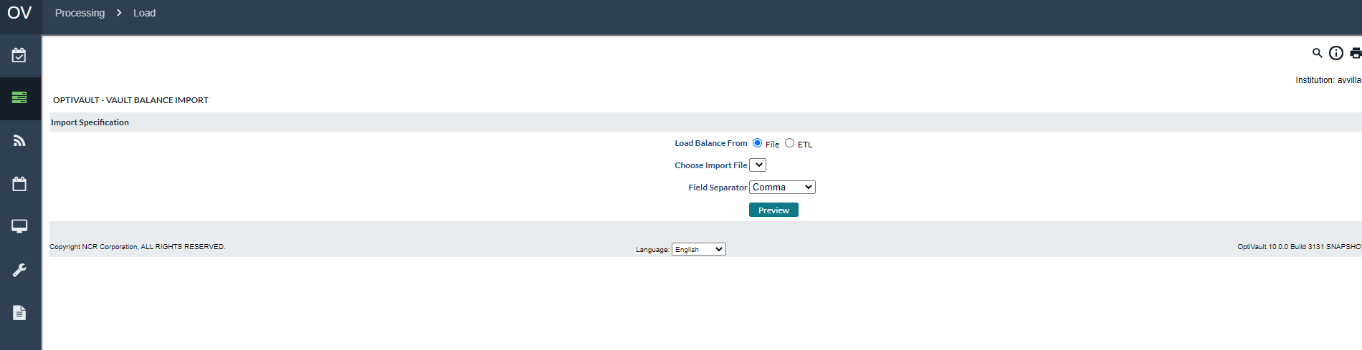

Table 41: Load Balances Description

| Field | Description |
| --- | --- |
| **Type** | Allows the analyst to select the type of balance files that will be loaded into OptiVault.  The available options are:   * Load Commercial Balances * Load Vault Balances |
| **Select button** | Selects the load type selected in the Type field to load balances into OptiVault |
| **Load Balance From**  (only available for Vaults. Not for Commercial Clients) | OptiVault allows files to be imported from two sources:  **File**: Users can save a file in the appropriate OptiVault format in the input directory. Users select the appropriate file name from the **“Choose Import File”** dropdown.  **ETL:** ETL load comes from a table instead of a file supplied by the user. The customer institution has an outside system that drops the data into one specific table in OptiVault. The ETL load process copies from the table into the Vault history. |
| **Choose Import File** | A list of available files that can be loaded into OptiVault. The list is populated based on the files that are already saved on the server in the import directory. The import directory is defined on the maint/setup.jsp page. |
| **Field Separator** | Defines the separator that is used to separate fields in the import file.  The available options are:   * Comma * Space |

Return To: Processing Tab

### ProcessingàLoad Orders

The Load Orders process is used to load Vault Cashpoints into OptiVault. This function is only necessary when the batch processes failed to work as expected.

Figure 25: Load Orders Page

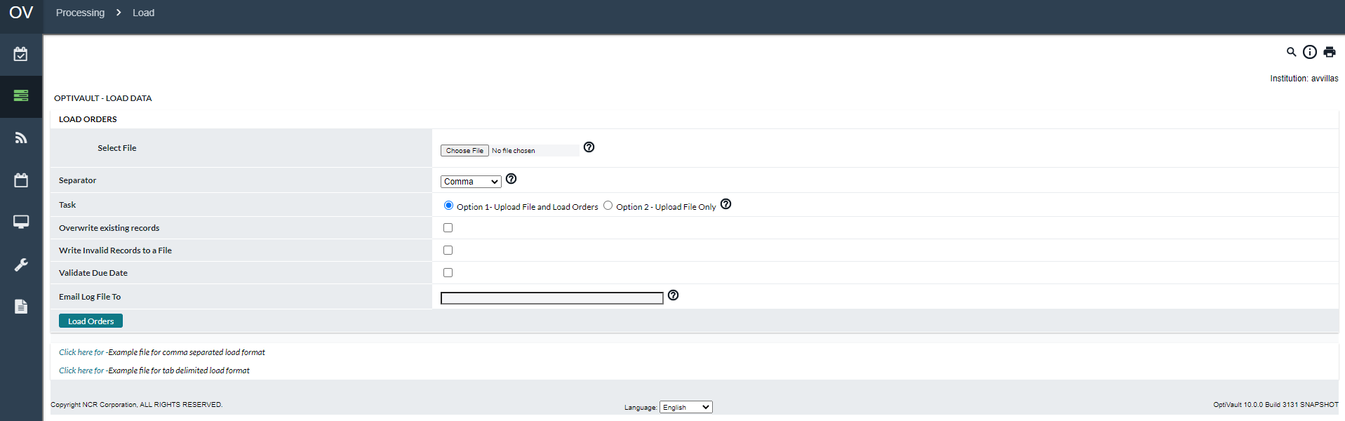

Table 42: Load Orders Description

| Field | Description |
| --- | --- |
| **Select File** | Click on the Browse button to select the file containing orders to upload. The file should follow the OptiVault order load format. |
| **Separator** | Select the type of field separator used in the file. Options available: comma or tab. |
| **Task** | Select whether you would like to just upload the file to the server or upload the file to the server and process the file to load orders into OptiVault.  If **Option 1** is selected, the load process is scheduled for execution immediately. But the process could take some time to complete. The status of the load process is emailed to the email addresses entered below.  **Option 2** should be used if the process of loading orders is to be scheduled for a later time. Contact the system administrator for detailed information about scheduling the process of loading orders. |
| **Overwrite Exiting Records** | In situations where the order files were loaded, found to be in error and then reloaded, you have to use this option. With this option, the order load process will overwrite any previously existing records for the same date and Cashpoint. |
| **Write Invalid Records to a File** | When order file records cannot be loaded, they will be rejected by the system. If the checkbox is checked, invalid records will be written to a file so that they can be reviewed, corrected, and successfully loaded later. |
| **Validate Due Date** | If checked, the order load process will validate the order date and due date based on the Cashpoint lead time defined in the system. Incorrect records will be rejected and written to the log file. |
| **E-mail Log File to** | Enter the email addresses of the people who should receive notification of the status of the load process when the load is completed successfully or unsuccessfully. Multiple addresses should be separated by semicolons. |

Return To: Processing Tab

### Processing→Recommendations

The Recommendations page is used to define recommendation profiles, run, and validate the recommendation process for Cashpoints, and output the recommendation report.

The following options are available to be run on this page:

* Recommendations→Run Recommendation
* Recommendations→Run Validation for Recommendation
* Recommendations→Run Recommendation Output

Table 43: Recommendations Description

| Field | Description |
| --- | --- |
| **Type** | Allows the analyst to select the type of balance files that will be loaded into OptiVault.  The available options are:   * Load Commercial Balances * Load Vault Balances |
| **Select button** | Selects the Recommendation option selected in the Type field to load balances into OptiVault |

Return To: Processing Tab

#### Recommendations→Run Recommendation

The Run Recommendations process is used to define Recommendation profiles and/or run the process to produce recommendations.

Figure 26: Run Recommendations Page

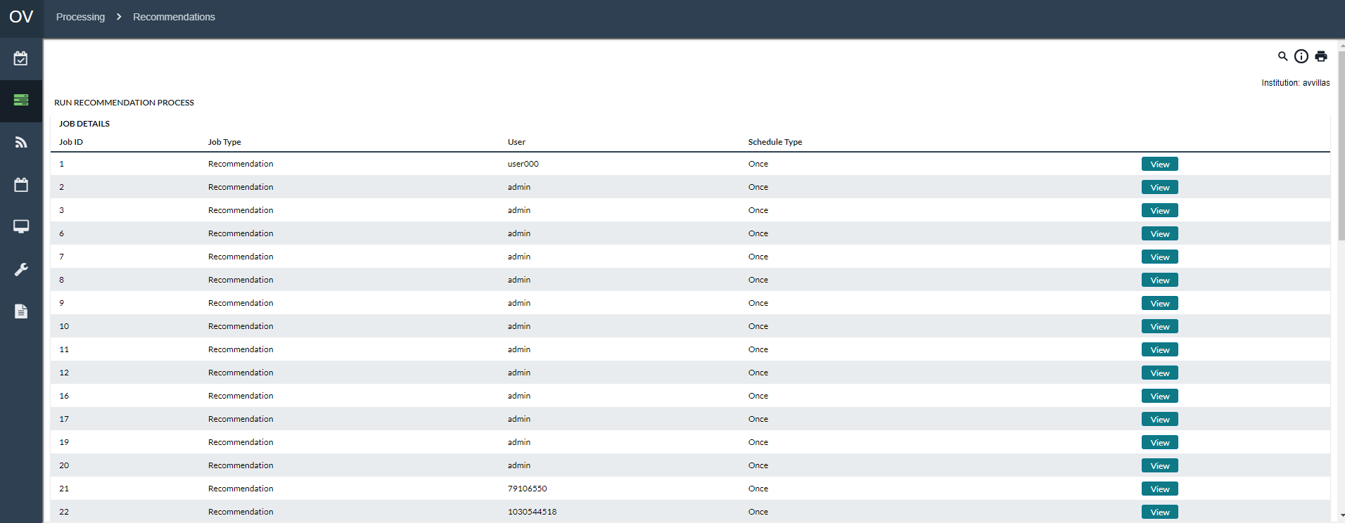

Table 44: Run Recommendations Description

| Field | Description |
| --- | --- |
| **Job Id** | A number indicating the Identifier for the Recommendation profile. This number is automatically assigned at the time of creation. |
| **Job Type** | Describes the type of profile that is created |
| **User** | Indicates the user name of the person who created the Job profile |
| **Schedule Type** | Indicates the type of profile that is being created. This is used for informational purposed to identify to users how the profile is to be used. This helps to prevent the deletion of system profiles that are used for batch processes. |
| **View Button** | Allows the user to view or edit the Recommendation profile as well as run the recommendation process. |
| **Type Selector** | Located next to the ‘New’ button, is used to select the type for a new Job Profile.  The available options are:   * **Recommendation –** Used for the recommendation process * **Recommendation Output –** Used for batch process recommendations output. This only applies to batch processes. Manual processing uses the Recommendation Output Process from the main Recommendations menu. |
| **New Button** | Used to create a new recommendation profile. |
| **Cancel Button** | Cancels the process and returns to the previous menu. |

Table 45: New or Edit Recommendation Description

|  |  |
| --- | --- |
| **Field** | Description |
| **Start Date** | The Starting Date of the recommendation process |
| **End Date** | The ending date of the recommendation process |
| **Auto Accept Recs** | When Yes is selected, all normal delivery and return recommendations will automatically be turned into orders. All Emergency recommendations will remain open. |
| **Schedule Type** | Indicates the type of profile that is being created. This is used for informational purposed to identify to users how the profile is to be used. This helps to prevent the deletion of system profiles that are used for batch processes. |
| **Cash Point** | The Cashpoint will be run during the recommendation process. Child Cashpoints will only be run if the Aggregation options are selected. |
| **Aggregate Entire Chain** | Runs the recommendation processes and aggregates the results to the selected Cashpoint. |
| **Horizon Length** | This field allows the analyst to define the number of days that will be produced for the horizon. 45 days should be the minimum setting for this option. |
| **Run First Level Aggregation** | Runs the first level aggregation process which takes the demand for Branch and ATMs in OptiCash and loads them as future demand for the select Cashpoint. |
| **Default Recommendation Dates** | Uses the default recommendation dates meaning the current date plus 7 days into the future. |
| **Separate Note vs Coin Recommendations** | Selecting Yes will cause OptiVault to generate separate recommendations for notes and coins. Selecting No will cause OptiVault to generate a single recommendation for notes and coins together. |
| **Run Recommendation Process Button** | Starts the recommendation process based on the profile settings and parameters. |
| **Save Button** | Saves the changes to the profile. |
| **Cancel Button** | Cancels the process and returns to the previous menu. |
| **Delete Button** | Only viewable when the entry is being edited; this button will delete the profile from the system. The user should be prompted to confirm the deletion before it is made permanent. |

Table 46: Recommendation Output Description

| Field | Description |
| --- | --- |
| **Start Date** | Starting date of the Recommendation Process |
| **End Date** | Ending date of the Recommendation Process |
| **Rec Output File** | The name that the file will be called once it is produced. |
| **Schedule Type** | Indicates the type of profile that is being created. This is used for informational purposed to identify to users how the profile is to be used. This helps to prevent the deletion of system profiles that are used for batch processes. |
| **Save Button** | Saves the changes made to the selected profile. |
| **Cancel Button** | Cancels the process and returns to the previous menu. |
| **Delete Button** | Only viewable when the entry is being edited; this button will delete the profile from the system. The user should be prompted to confirm the deletion before it is made permanent. |

Return to: Processing→Recommendations

#### Recommendations→Run Validation for Recommendation

The Run Validation for Recommendations process runs a validation process to determine if any errors will prevent the recommendation process from completing successfully.

Figure 27: Run Recommendation Validation Page

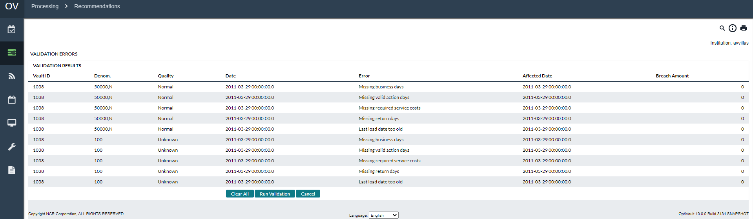

Table 47: Run Validation for Recommendation Description

| Field | Description |
| --- | --- |
| **Vault ID** | A unique alpha-numeric value identifies the vault. |
| **Denomination** | The denomination ID for the Cashpoint |
| **Quality** | Quality of the denomination |
| **Date** | The date that the validation was run |
| **Error** | The error message for the Vault, Denomination, Quality and Affected date |
| **Affected Date** | The date of history to which the error applies |
| **Breach Amount** | This applies only to Custodial Inventory and shows the amount that was exceeded in the CI. |
| **Clear All Button** | Deletes all the error history entries. |
| **Run Validation** | Runs the validation for all selected vaults |
| **Check All Link** | Checks all entries in the list |
| **Clear All Link** | Clears all checked entries in the list. |
| **Cancel Button** | Cancels the process and returns to the previous menu. |

Return to: Processing→Recommendations

#### Recommendations→Run Recommendation Output

The Run Recommendation Output process is used to output the completed recommendations to a file that can be used by analysts or to load into external reporting systems.

Figure 28: Run Recommendation Output Page

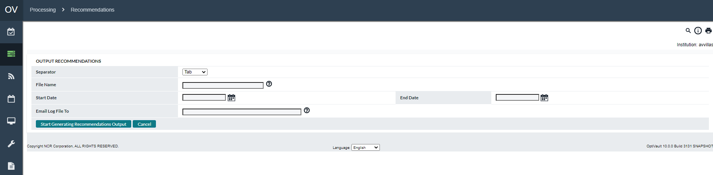

Table 48: Run Recommendation Output Description

| Field | Description |
| --- | --- |
| **Separator** | Indicates how the report fields will be separated.  The available options are:   * Tab * Comma |
| **File Name** | The name that the file will be called once it is produced. |
| **Start Date** | Starting date of the Recommendation Process |
| **End Date** | Ending date of the Recommendation Process |
| **E-mail Log File to** | Enter the email addresses of the people who should receive notification of the status of the load process when the load is completed successfully or unsuccessfully. Multiple addresses should be separated by semicolons. |
| **Cancel Button** | Cancels the process and returns to the previous menu. |
| **Delete Button** | Only viewable when the entry is being edited; this button will delete the profile from the system. The user should be prompted to confirm the deletion before it is made permanent. |

Return to: Processing→Recommendations

### Processing→Forecast

The Forecast page is used to define Forecast profiles, run forecasts for vaults and commercial Cashpoints, and run commercial consolidation for one or many Cashpoints.

The following options are available to be run on this page:

* Forecast→Run Forecast
* Forecast→Commercial Consolidation
* Forecast→Commercial Consolidation for Individual Vault
* Forecast→Forecast Settings

Table 49: Forecast Description

| Field | Description |
| --- | --- |
| **Type** | Allows the analyst to select the type of process to run.  The available options are:   * Run Forecasts * Commercial Consolidation * Commercial Consolidation for an Individual Vault |
| **Select button** | Selects the process selected in the Type field to access that function. |

Return To: Processing Tab

#### Forecast→Run Forecast

The Run Forecast process is used to define or run forecast profiles for one or many Vault or Commercial Cashpoints.

Figure 29: Run Forecast Page

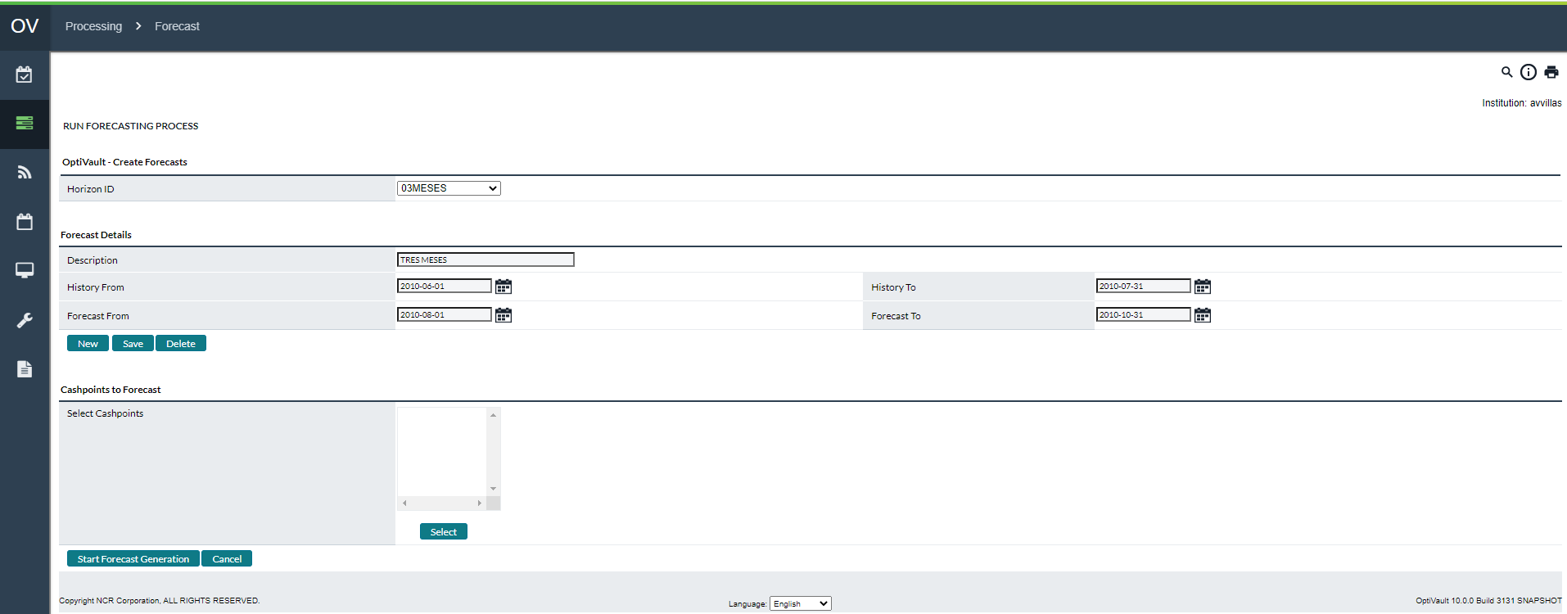

Table 50: Run Forecast Description

| Field | Description |
| --- | --- |
| **Horizon ID** | When defining a **‘New’** profile, the Horizon ID is defined to uniquely identify the Forecast profile. This should be a unique alphanumeric identifier.Otherwise, this is a selection box which is used to select the desired profile to run forecasts. |
| **Description** | The description of the forecast process. |
| **History From Date** | The starting date of the history used for the forecast. |
| **History To Date** | The ending date of the history used for the forecast. |
| **Forecast From Date** | Forecast starting date |
| **Forecast To Date** | Forecast ending date |
| **New Button** | Creates a new forecast profile. |
| **Save Button** | Saves the changes to the current forecast profile. |
| **Delete Button** | Deletes the selected forecast profile.  **Note:** The forecasts are not deleted when the forecast profile is deleted. |
| **Select Button** | Prompts the user to select Cashpoints that will be forecasted using the currently selected forecast profile.  **Note:** If the user changes the forecast profile after selecting Cashpoints that the Cashpoints will need to be selected again. |
| **Start Forecast Generation Button** | Starts the forecast generation process for the Cashpoints and forecast Horizon ID selected. |
| **Cancel Button** | Cancels the process and returns to the previous menu. |
| **Note** | The forecast process runs for the Denomination/Quality combinations as configured in your cashpoint’s Denominations setup screen. If after running the process some are missing, please check your Denominations screen and make sure that the “Recommend?” option is enabled for them. |

Return To: Processing Tab

#### Forecast→Commercial Consolidation

The Commercial Consolidation process is used to define or run commercial consolidation profiles.

Figure 30: Run Commercial Consolidation Page

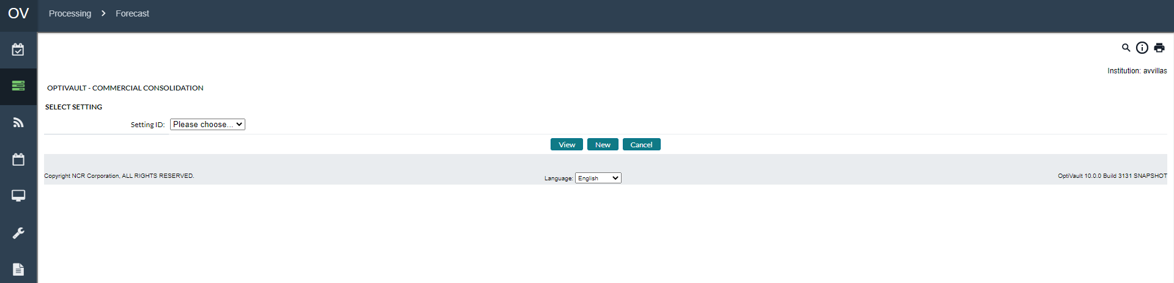

Table 51: Commercial Consolidation Description

| Field | Description |
| --- | --- |
| **Setting ID** | A unique identifier that is used to save and identify the Consolidation profile |
| **View Button** | Allows the analyst to view, edit, and run the Commercial Consolidation process |
| **New Button** | Creates a new Commercial Consolidation profile. |
| **Cancel Button** | Cancels the process and returns to the previous menu. |
| **Start Date** | Sets the starting date of the Commercial Consolidation profile. |
| **End Date** | Sets the ending date of the Commercial Consolidation profile |
| **All Date** | Indicates that all dates will be consolidated. Note that this option will delete the selected Start/End dates. |
| **Selected Vaults** | Allows the analyst to select the vaults for which commercial consolidation will be run. |
| **All Vaults** | Specifies that all vaults will be run for the Commercial Consolidation process.  **Note:** This option will remove any existing vaults that have been selected from the Select Vaults list. |
| **Save and Start Consolidation** | Saves the changes made to the currently selected profile and runs the Commercial Consolidation process using the currently selected parameters. |
| **Save Button** | Saves the parameters for the currently selected Commercial Consolidation profile. |
| **Delete Button** | Deletes the currently selected profile from the system. The user should be prompted to confirm the deletion before it is permanently deleted from the system. The deletion does not delete the commercial consolidations that have already been performed, only the profile is deleted. |

Return To: Processing Tab

#### Forecast→Commercial Consolidation for Individual Vault

The Commercial Consolidation is used to generate the Commercial Consolidation process for a single vault so a profile does not have to be created.

Table 52: Commercial consolidation for an Individual Vault Description

| Field | Description |
| --- | --- |
| **Vault** | Allows the user to select the vault that will be run for Commercial Consolidation. |
| **Use As Default** | This checkmark is used to indicate that the selected vault is to be the default Cashpoint used in the system. This will then be used for all processes which allow for a default Cashpoint to be used. |
| **Select Button** | Used to select the currently displayed vault as the vault to be run for Commercial Consolidation. Clicking this button will move to the next page where the user can select the denomination and submit the process to be run. |
| **Denomination** | Allows the user to select the denomination that will be run for the selected vault during the Commercial Consolidation process. |
| **Submit Button** | Submits the job to be run for Commercial Consolidation based on the Vault and denomination selected. |
| **Cancel Button** | Cancels the process and returns to the previous menu. |

Return To: Processing Tab

#### Forecast→Forecast Settings

The forecast settings can be modified on a system wide basis to allow the analyst to decide how the forecasts will be calculated for seasonality and event adjustments.

Figure 31: Forecast Settings Page

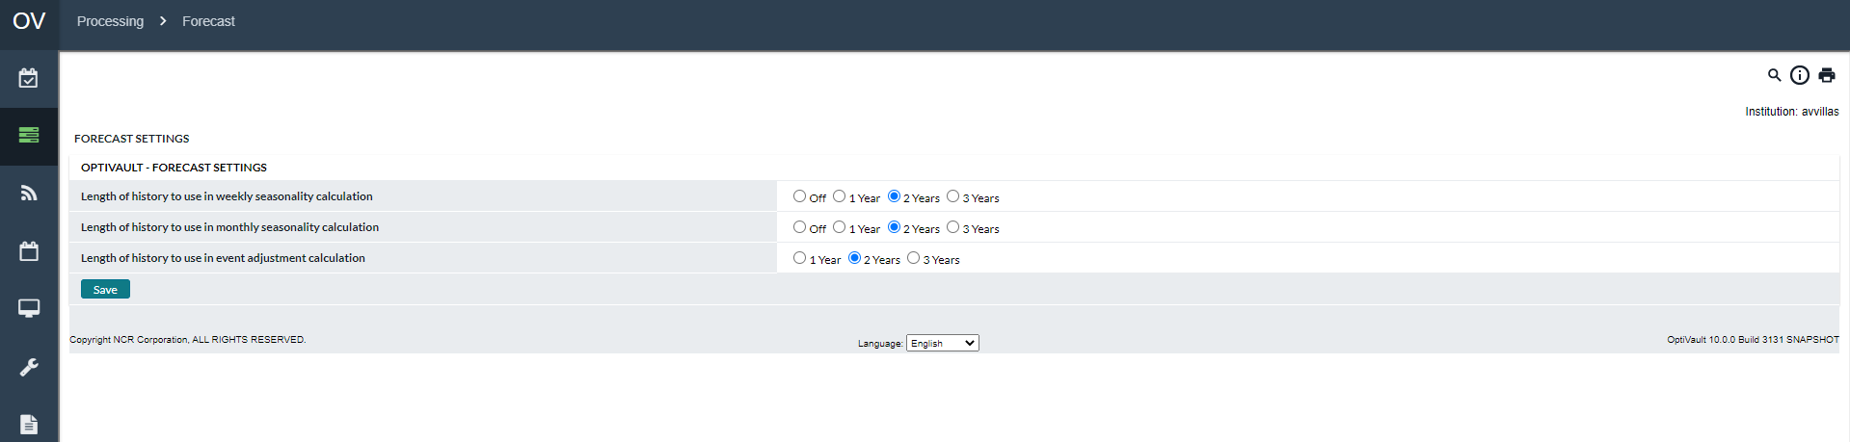

Table 53: Forecast Settings Description

| Field | Description |
| --- | --- |
| **Length of History to Use in Weekly Seasonality Calculation** | Used for calculation of the Weekly Seasonality  Available options are   * **N/A –** Weekly Seasonality calculations are turned off and not applied to the forecast * **1 Year –** The previous year will be considered for Seasonality calculations * **2 Years –** The previous 2 years will be considered for Seasonality Calculations * **3 Years –** The previous 3 years will be considered for Seasonality Calculations |
| **Length of History to Use in Monthly Seasonality Calculation** | Used for calculation of the Monthly Seasonality  Available options are   * **N/A –** Monthly Seasonality calculations are turned off and not applied to the forecast * **1 Year –** The previous year will be considered for Seasonality calculations * **2 Years –** The previous 2 years will be considered for Seasonality Calculations * **3 Years –** The previous 3 years will be considered for Seasonality Calculations |
| **Length of History to Use in Event Adjustment Calculation** | Used for calculations of the Event adjustments  Available options are   * **1 Year –** The previous year will be considered for Seasonality calculations * **2 Years –** The previous 2 years will be considered for Seasonality Calculations * **3 Years –** The previous 3 years will be considered for Seasonality Calculations |
| **Save Button** | Saves the settings to apply to all future forecasts. |

Return To: Processing Tab

### Processing→Order Output

The Order Output page allows analysts to define order output profiles and run them to create the order output file. The profiles can be run from the interface or used for the batch process to be run automatically from the server.

Figure 32: Orders Output Page

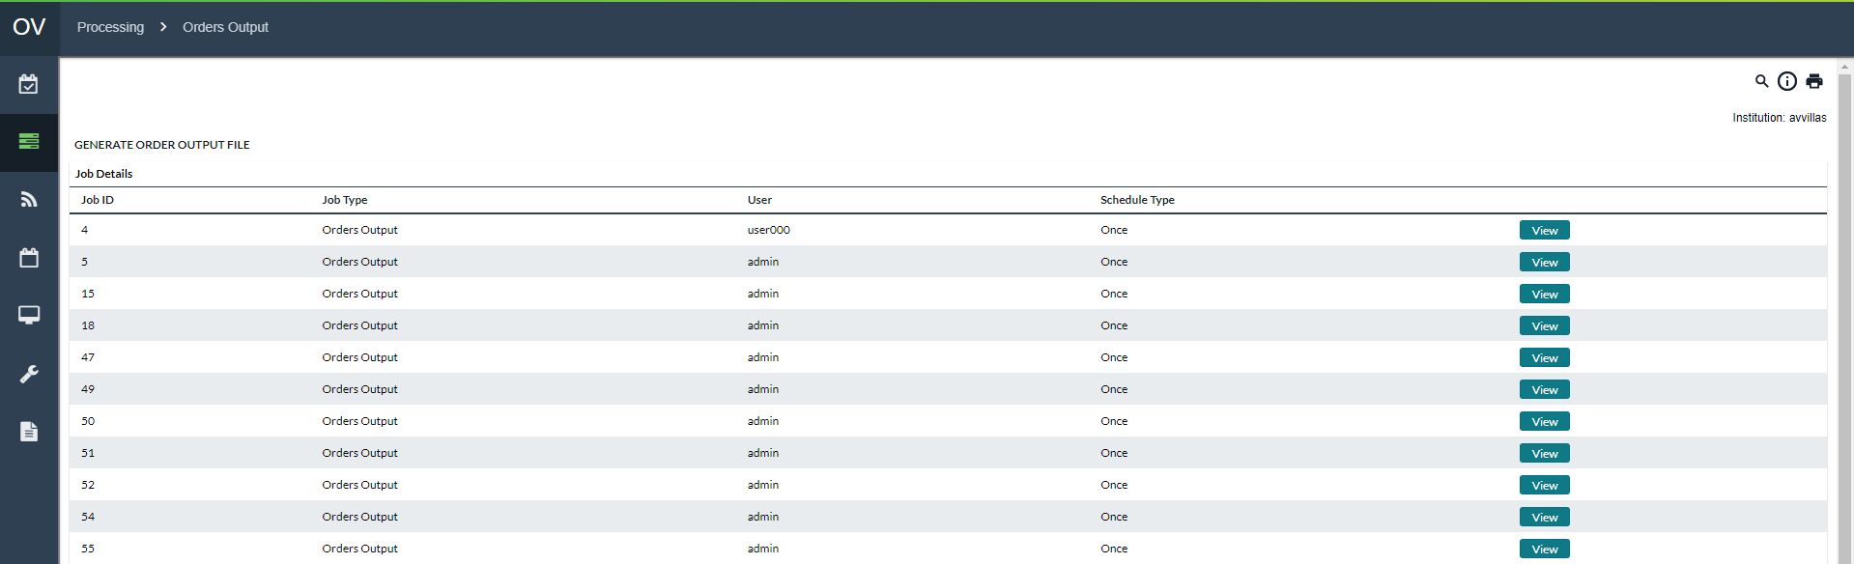

Table 54: Orders Output Description

| Field | Description |
| --- | --- |
| **Job Id** | A number indicating the Identifier for the Recommendation profile. This number is automatically assigned at the time of creation. |
| **Job Type** | Describes the type of profile that is created |
| **User** | Indicates the user name of the person who created the Job profile |
| **Schedule Type** | Indicates the type of profile that is being created. This is used for informational purposed to identify to users how the profile is to be used. This helps to prevent the deletion of system profiles that are used for batch processes. |
| **View Button** | Allows the user to view or edit the Order Output profile as well as run the process. |
| **New Button** | Used to create a new recommendation profile. |
| **Cancel Button** | Cancels the process and returns to the previous menu. |
| **Start Date** | The starting date of the order output file |
| **End Date** | The ending date of the order output file |
| **Order Output File** | The name of the file that will be generated after the completion of the Order Output Process. |
| **Save Button** | Saves the currently selected Order Output profile |
| **Save&Run Button** | Saves the currently selected Order Output profile and starts the job. |
| **Delete Button** | Deletes the currently selected Order Output profile.  **Note:** This does not delete any order output; only the profile is deleted. Also, if the profile is deleted, it cannot be used by any batch processes, so it is important to be sure that the batch processes are not dependent on an Orders Output profile before deleting. |

Return To: Processing Tab

### Processing→CI Constraints

The Custodial Inventory Constraints is a process that is normally run weekly to indicate the limits of each Custodial Inventory Cashpoint based on the balances of its parent Vault Cashpoint.

Figure 33: CI Constraints Page

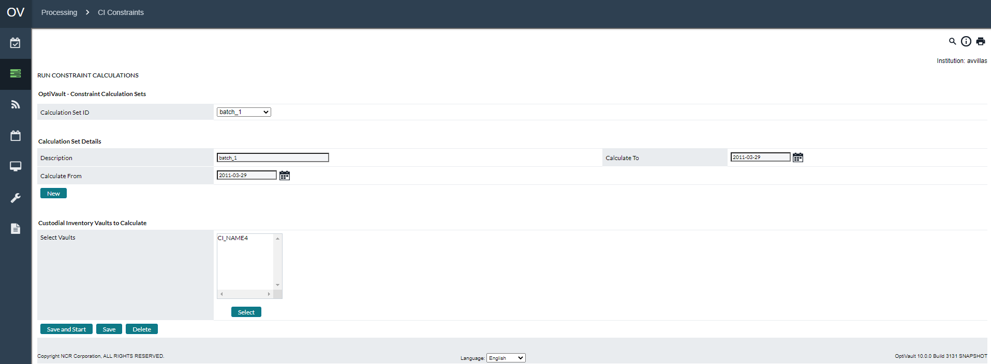

Table 55: CI Constraints Description

| Field | Description |
| --- | --- |
| **Calculation Set ID** | A unique identifier that is used to save and identify the Custodial Inventory Constraint Calculation profile |
| **New Button** | Creates a new Custodial Inventory Constraint Calculation profile. |
| **Description** | Description used to identify the Custodial Inventory Constraint Calculation profile. |
| **Calculate From** | Sets the starting date of the Custodial Inventory Calculation. |
| **Calculate To** | Sets the ending date of the Custodial Inventory Calculation. |
| **Select Vaults** | Allows the analyst to select the vaults for which vaults will be run. |
| **Save and Start** | Saves the changes made to the currently selected profile and runs the Custodial Inventory Constraint Calculation process using the currently selected parameters. |
| **Save Button** | Saves the parameters for the currently selected Custodial Inventory Constraint Calculation profile. |
| **Delete Button** | Deletes the currently selected profile from the system. The user should be prompted to confirm the deletion before it is permanently deleted from the system. The deletion does not delete the Custodial Inventory constraints that have already been performed, only the profile is deleted. |

Return To: Processing Tab

### Processing→Cost Calculation

OptiVault takes the cost of cash (both holding and transportation) into consideration when deciding the amount and frequency of deliveries. To measure the performance of the Cashpoints, OptiVault needs to have the costs calculated for each day of historical data.

There are two different types of costs that can be calculated in OptiVault. Each of them is calculated in the same way, but they are used in different ways.

* **Actual Costs -** Used in reports to show the daily, weekly, or monthly costs for holding and delivering cash or used to compare against Projected Costs.
* **Projected Costs –** Calculated and used as a benchmark for comparison against Actual Costs. Normally, users calculate projected costs at the beginning of the month. The projected costs are based on the current information that is on the horizon. The software stores the calculations so a comparison can be made on a daily basis to see the actual costs versus the projected costs.

The following sections will explain the Cost options and methods in more detail:

* Cost Calculation→Actual Costs/Projected Costs
* Cost Calculation→Cost Options Page

Return To: Processing Tab

#### Cost Calculation→Actual Costs/Projected Costs

Figure 34: Actual Costs Page

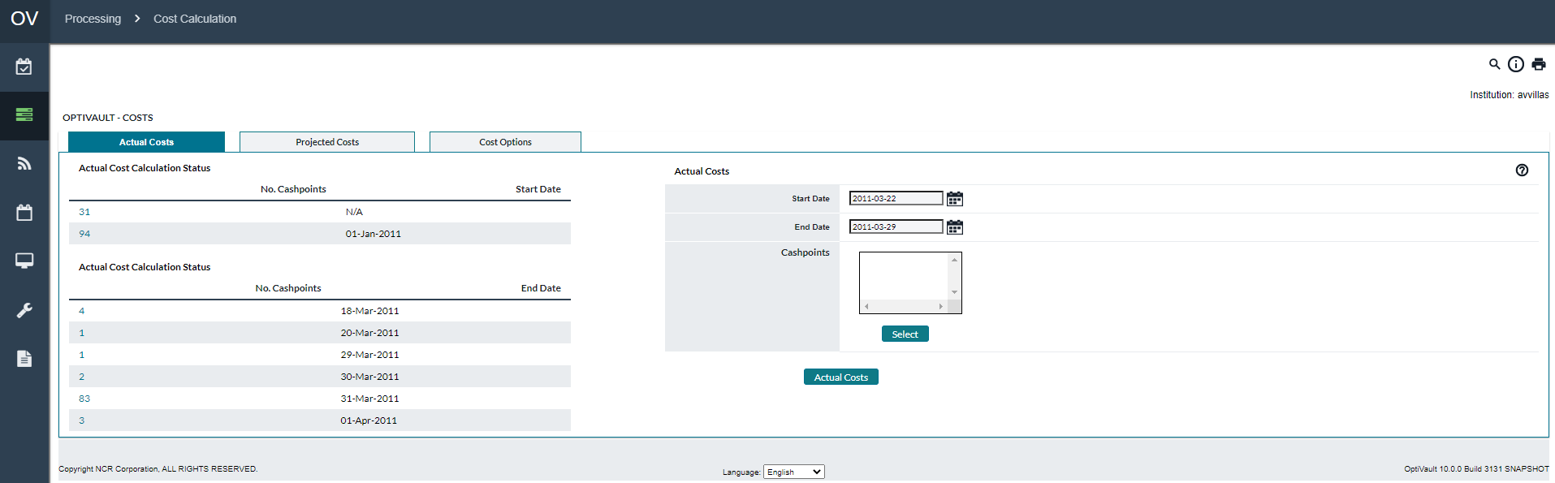

Figure 35: Projected Costs Page

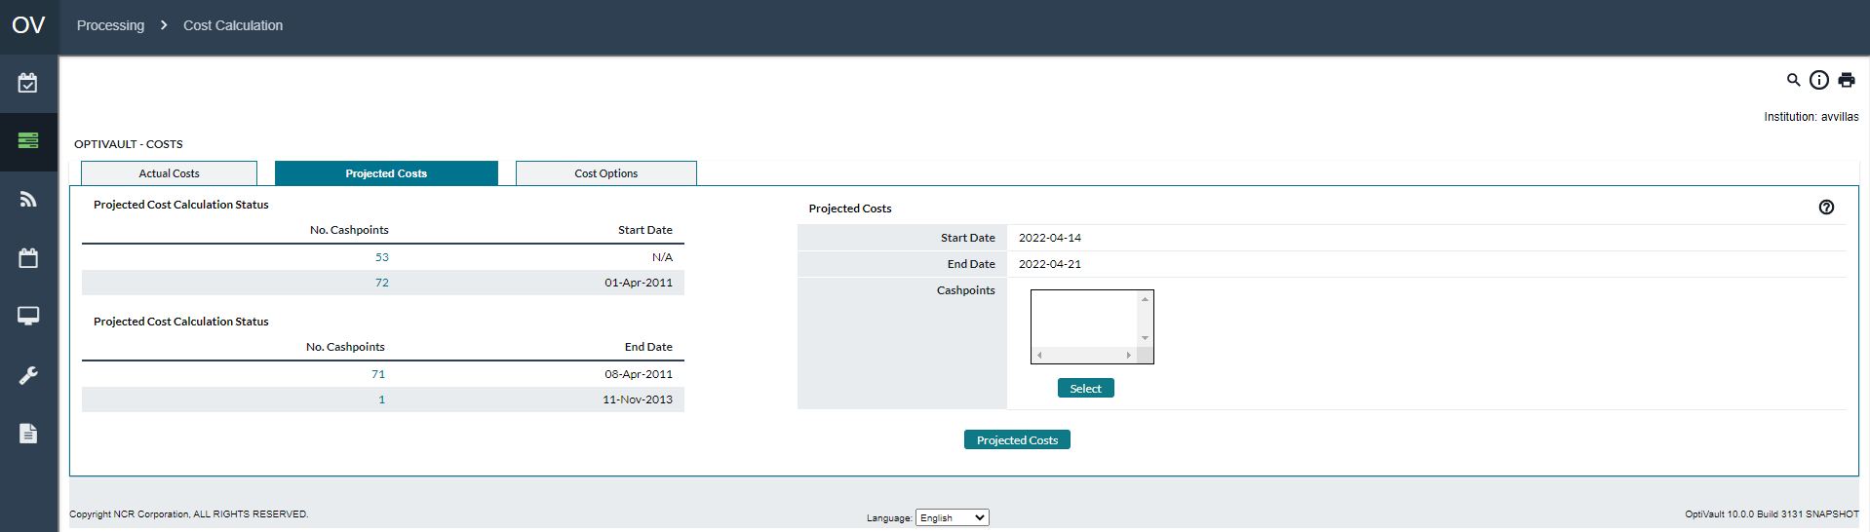

Table 56:Actual/Projected Cost Calculation Description

| Fields | Description |
| --- | --- |
| **Actual/Projected Cost Calculation Statuses** | On the left side of all the Cost Calculation pages is a status summary that shows the starting and ending dates for the cost calculations. There may be different entries on this page depending on the Cashpoints that were processed and when it was completed. Clicking on any of the hyperlinks will lead the user to a report detailing each Cashpoint and the starting and ending dates for the cost calculations. |
| **Start Date** | The day that Cost Calculation will begin |
| **End Date** | The last day Costs will be calculated. |
| **Select** | Allows the analyst to select Cashpoints to be used for the Cost Calculation. For more information on selecting Cashpoints, See: Cashpoint Selector |
| **Actual/Projected Cost Calculation Button** | Calculates the cost specific to the Cost Calculation model for the Cost Options that have been defined. For more information on the Cost Options see: Cost Calculation→Cost Options Page |

Return To: Processing→Cost Calculation

#### Cost Calculation→Cost Options Page

Several different cost elements make up the overall costs for a Cashpoint. The user can choose which costs to calculate on the Costs Options page. The different cost elements are explained in detail below.

Figure 36: Cost Options Page

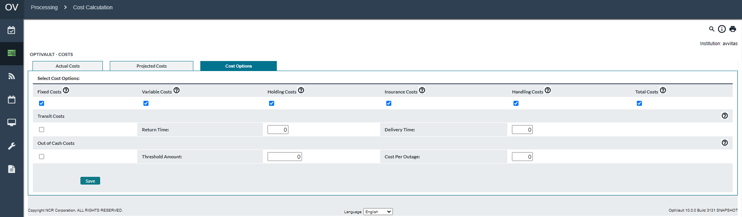

Table 57: Cost Options Description

| Cost | Description |
| --- | --- |
| **Fixed Costs** | Fixed cost per delivery regardless of the amount of cash being transported.  Fixed costs are assigned at the Cashpoint level. See: Cashpoint→Advanced→Costs. |
| **Variable Costs** | Variable costs are based on the amount of cash being transported. In some cases, variable costs may be on a sliding scale or range. For example, the carrier is charging 0.003 EUR for 1 EUR transported when the delivery is between 0 -20,000 EUR and 0.0025 EUR for 1 EUR transported when the delivery is between 20,001-40,000 EUR.  Variable costs (or cost per unit/per $ costs) are set and assigned at the Cashpoint level.  See: The service Cost panel described in the section Cashpoint→Advanced→Costs. |
| **Holding Costs** | Costs associated with holding cash (for instance, lost potential savings from interest rates).  Holdings costs are based on Overnight Earning Rates defined at the Currency level refer to [SystemàCurrencies/Denominations](#_System(Currencies/Denominations) |
| **Insurance Costs** | The currency insurance rate is the rate charged to insure funds kept in Cashpoints (0, 7, 15, etc.). This is an annual rate and is typically covered by the FDIC in the U.S. market. Insurance Costs are defined at the Cashpoint level refer to Cashpoint→Advanced→CostsCashpoint→Advanced→Costs. |
| **Handling Costs** | Total internal costs associated with the processing/handling of cash delivery. This may include the value of employees’ time required during the delivery, and any other overhead or administrative costs.  Handling Costs are defined at the Cashpoint level and refer to Cashpoint→Advanced→Costs. |
| **Total Costs** | If this option is selected, the report will calculate and display the sum of all checked cost components. |
| **Transit Costs** | Costs associated with cash not being used while in transit.  **Return Time** – indicate number of days the residual cash is in transit.  **Delivery Time** – indicate number of days the delivery is in transit. |
| **Out of Cash Costs** | Costs associated with out-of-cash situations.  **Threshold amount** – indicate an amount below which the Cashpoint is considered out-of-cash.  **Cost per outage** – indicate the cost set by the institution for cash outage (i.e. penalty, admin fee, etc.). |
| **Save Button** | Saves the settings for use in all Cost Calculations. |

Return To: Processing→Cost Calculation

### Processing→Custom Jobs

The Custom Job page is used to manually launch processes that have been developed as a custom integration for a particular client installation. For more information on this functionality, please see the installation guide or contact NCR Cash Management Support.

To invoke a Custom Job, click on the link for the custom job to be run.

# Network Tab

The Network Tab is where the Network structure is defined. On this tab, users can search for Cashpoints; navigate to different pages or reports; define the network structure and defaults or assign parameters to Cashpoints.

The following is a summary of the information that will be covered along with hyperlinks to each topic:

* Network→Cashpoints
* Network→Create New
* Network→Mass Assign
* Network→Carrier
* Network→Groups
* Network→Sorters
* Network→Cross Shipping
* Network→Trading Market

Return To: Introduction to the Interface

### Network→Cashpoints

The Cashpoints page shows the user a tree view of the funding chain for the active Cashpoints assigned to the user. The list can be expanded to show the child Cashpoints assigned to the parents.

Figure 37: Cashpoints Page

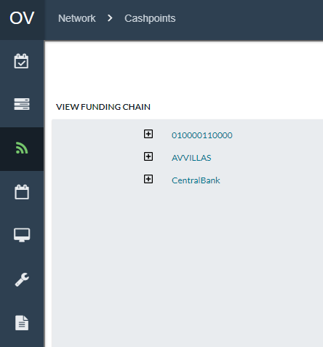

Return To: Network Tab

### Network→Create New

Allows the analyst to create new Vault, Commercial, Custodial Inventory, and External Funding source Cashpoints.

Figure 38: Create New Page

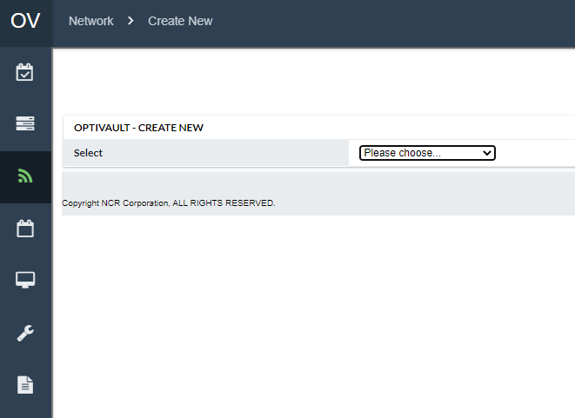

Table 58: Create New Description

| Fields | Description |
| --- | --- |
| **Select** | Selects from a list the type of Cashpoint to create. Once the selection is made, the user will be directed to the appropriate Cashpoint creation page. From the individual creation page, the user must enter a Cashpoint ID and click the Create button to create the Cashpoint. All parameters for the Cashpoint must then be set at the Cashpoint level.  The available selections are:   * Vault * Commercial * Custodial Inventory * External Funding Source |
| **Cashpoint ID** | A unique alpha-numeric identifier that uniquely defines the Cashpoint in the system. |
| **Create Button** | Creates the new Cashpoint for the Cashpoint type selected and the Cashpoint ID defined |
| **Cancel Button** | Cancels the creation process and returns to the previous menu. |

Return To: Network Tab

### Network→Mass Assign

The Mass Assign function allows users to quickly set parameters for Vault Cashpoints for one or many Cashpoints.

Figure 39: Mass Assign Page

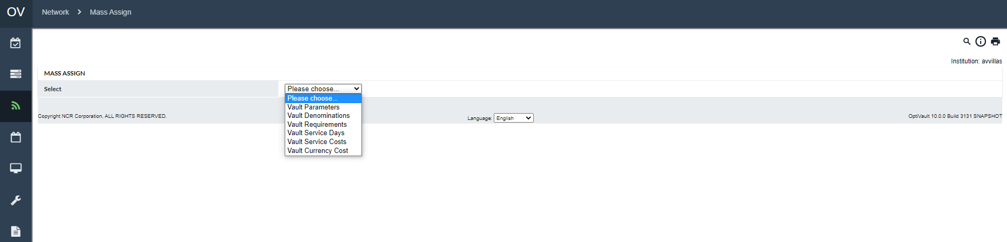

Table 59: Mass Assign Description

| Fields | Description |
| --- | --- |
| **Vault Parameters** | The following parameters can be Mass Assigned on this page:   * Default Funding Source * Maximum Number of Pallets * Bulk Order Reduction * Aggregate Emergencies Indicator * Clearance Time * Packaging Time   For more detail on these parameters see: Vault Parameters**.** |
| **Vault Denominations** | The following can be Mass assigned on this page:   * Denominations that have been defined in the system for Unknown, Fit, Normal, or Soiled notes. * Minimum Delivery Amount * Minimum Return Amount * Minimum Unplanned Delivery Amount   For more detail on these parameters see: Cashpoint→Basic→Denominations |
| **Vault Requirements** | Vault Requirements can be set by denomination only, therefore each denomination will need to be selected individually to set the requirements. Additionally, Vault Requirements can be removed from Vault Cashpoints by selecting the link at the bottom of the page.  The following Requirements can be set on the page:   * Minimum Operating Balance * E-Cash Holding Amount * % of Withdrawals to Cover * % of Deposits Available for Withdrawal * % of Deposits Held Until the End of the Day * Day of the Week * Specific Date * % Adjustment to Forecasted Demand * % Adjustment to Forecasted Deposits * % Adjustment to Requirements * Exception Threshold/Balance Buffer   For more detail on these parameters see: Cashpoint→Basic→Requirements |
| **Vault Service Days** | The following Service Day parameters can be set on this page:   * Normal Delivery Days * Normal Return Days * Unplanned Delivery Days * Normal Delivery Lead Time * Normal Return Lead Time * Emergency Lead Time * Delivery Cycle and Start Date * Return Cycle and Start Date   For more detail on these parameters see: Cashpoint→Basic→Service Days |
| **Vault Service Costs** | The following Costs can be set on this page for Deliveries, Returns, Combine, or Unplanned orders:   * Fixed Costs * Per Unit Costs * Per $ Cost   For more detail on these parameters see: Cashpoint→Advanced→Costs |
| **Vault Currency Costs** | The following costs can be set on this page for the different currencies that are being used in OptiVault   * Maximum Holding Amount * Currency Insurance Rate * Delivery Handling Cost * Return Handling Cost |
| **Next Button** | Once the parameters have been selected, clicking on the next button allows the user to enter any additional information and select the Cashpoint that will be updated with the selected parameters.  **NOTE:** There is no way to undo the changes that have been made through the Mass Assign function. Be certain that the correct Cashpoints and parameters are selected before completing the assignment. |

### Network→Carrier

The Carrier page allows users to set up and maintain carriers that will be used to transport cash to the Cashpoints.

Figure 40: Carrier Page

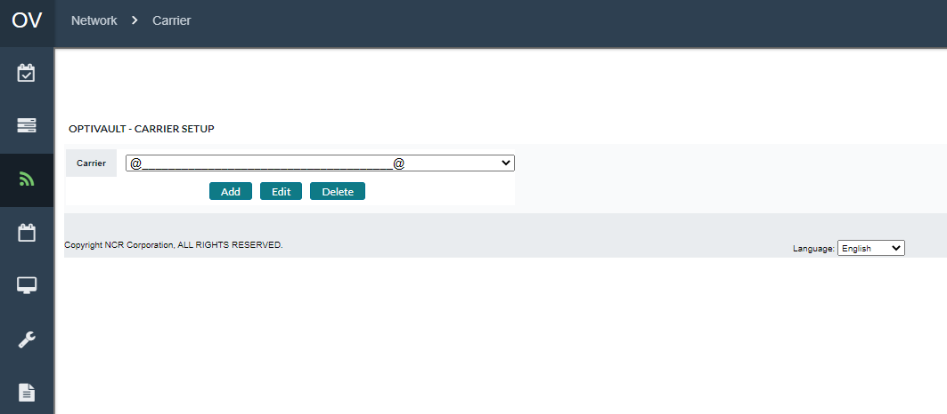

Table 60: Carrier Description

| Fields | Description |
| --- | --- |
| **Servicer** | A list of the currently defined Carriers defined in the system. |
| **Add Button** | Adds a new carrier to the system |
| **Edit Button** | Edits the currently selected Servicer. |
| **Delete Button** | Deletes the currently selected servicer.  **Note:** The depot can be deleted. |
| **Depot ID** | A unique alpha-numeric identifier used to identify the depot in the system |
| **Holiday Shift** | Defines how holidays are shifted when there is a scheduled holiday for a Cashpoint.  The available options are:   * **Later –** Shifts the scheduled delivery days after the holiday * **Before –** Shifts the scheduled delivery days before the holiday * **No Shift –** No shifts are made on to the service days * **Ignore –** The deliveries that fall on the holiday are ignored. |
| **Depot Name** | Name of the depot. This field normally shows up in reports instead of the Depot ID. |
| **Address Line 1** | Address of the carrier |
| **Address Line 2** | Address of the carrier |
| **City** | City of the carrier |
| **State/Province** | State/Province of the carrier |
| **Zip/Postal Coe** | Zip/Postal code of the carrier |
| **Contact Name** | Contact name of the carrier |
| **Email** | Email address of the carrier |
| **Phone** | Phone number of the carrier |
| **Fax** | Fax Number of the carrier |
| **Business Days** | Business days of the carrier. When selected, the corresponding days are available for delivery, return, and unplanned deliveries. |
| **Delivery Days** | Days that the carrier is able to deliver cash. |
| **Return Days** | Days that the carrier is able to accept returns of cash. |
| **Unplanned Delivery Days** | Days that the carrier is able to deliver emergency cash. |
| **Save Button.** | Saves the currently selected carrier profile |
| **Cancel Button** | Cancels the changes made to the carrier and exits to the previous menu. |

Return To: Network Tab

### Network→Groups

Allows analysts to create groups that can be used to quickly populate Cashpoint selections.

Figure 41: Group Page

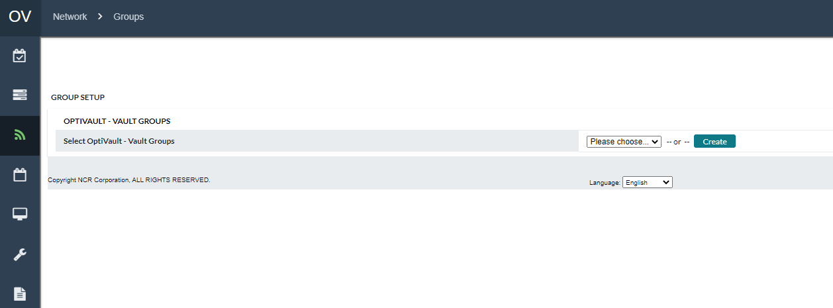

Table 61:groups Description

| Fields | Description |
| --- | --- |
| **Group Selector** | A dropdown list with the groups currently defined in the system. |
| **Group ID** | The unique alpha-numeric identifier for the Group |
| **Group Name** | Used to describe the group in more detail than the Group ID. |
| **Select Cashpoints to Add** | Displays a list of Cashpoints to add to the group. This is populated by clicking the **‘Select’** button and selecting Cashpoints from the Cashpoint selector. |
| **Cashpoint** | Cashpoint ID of the Cashpoint in the group. |
| **CP Type** | The Cashpoint Type of the corresponding Cashpoint ID. |
| **Save Button** | Saves the currently selected Group profile. |
| **Delete Button** | Deletes the Group ID from the system. The user will be prompted to confirm the deletion before it is permanently deleted from the system.  **Note**: Only the Group ID is deleted not the Cashpoints associated with it. |
| **Remove Button** | Removes the Cashpoints that are selected by the checkmark to the left of the Cashpoint ID in the Cashpoints list. |

Return To: Network Tab

### Network→Sorters

The Sorters page is used to define the Sorters that will be used by Vault Cashpoints. The definition is used to define the name and the number of notes per hour for the corresponding Sorter.

Figure 42: Sorters Page

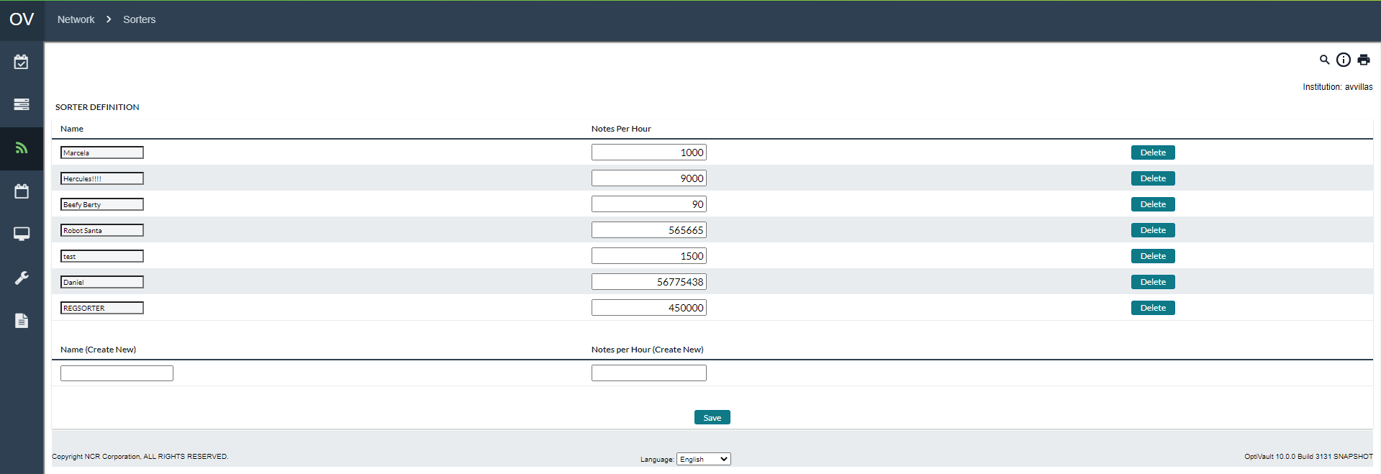

Table 62: Sorters Description

| Fields | Description |
| --- | --- |
| **Name** | A unique alpha-numeric identifier is used to identify the Sorter in the system. |
| **Notes Per Hour** | Defines the number of notes that can be processed by the sorter in an hour. |
| **Save Button** | Saves any changes made to the list of currently defined sorters |
| **Delete Button** | Deletes the corresponding Sorter from the system.  **Note** It is not possible to delete a sorter unless it is not assigned to a Vault. |

Return To: Network Tab

### Network→Cross Shipping

The Cross Shipping page is used to define the Cross Shipping parameters for determining when Cross Shipping penalties apply.

Table 63: Cross Shipping Description

| Fields | Description |
| --- | --- |
| **Type** | Defines the type of Cross Action to be taken. This is used in conjunction with the **‘Select’** Button to enter the appropriate sub-menu.  The available options are:   * **Zones –** Allows the user to define the zones that will be used to assign to the Cashpoints. * **Cross Shipping Penalty –** Determines the number of notes and the costs associated with constitute a Cross Shipping Penalty. |
| **Select Button** | Used to navigate to the sub-menu that is selected in the Type list. |
| **Unit Size (in notes)** | The number of notes and the cost for cross-shipping penalties. For example, if 1000 per was entered as the Unit Size and 5 was the Penalty Amount, this means that for every 1000 notes that is cross shipped, 5 dollars is charged. |
| **Penalty Amount** | The amount (in whole local currency) that is charged for each violation of the Unit Size. For example, if 1000 per was entered as the Unit Size and 5 was the Penalty Amount, this means that for every 1000 notes that is cross shipped, 5 dollars is charged. |
| **Save Button** | Saves the current Cross Shipping Penalty Cost Definition. |
| **Name** | Name of the Zone |
| **Description** | Description of the Zone |
| **Delete Button** | Deletes the corresponding Zone |
| **Save Button** | Saves the current list of Zones. |

Return To: Network Tab

### Network→Trading Market

Trading Markets are an additional licensed OptiVault feature. Vaults in the same Trading Market can share cash between themselves with reduced costs. The OptiVault Optimization process will use the Trading Market relationships to match excess cash in one vault with a corresponding need in another vault. Recommendations will be made to move cash between vaults and have reduced cost rather than recommend to deliver from the Default Funding Source.

The Trading Market page under Network facilitates the creation of the various markets to which Vaults may be assigned.

Figure 43: Network Trading Markets Page

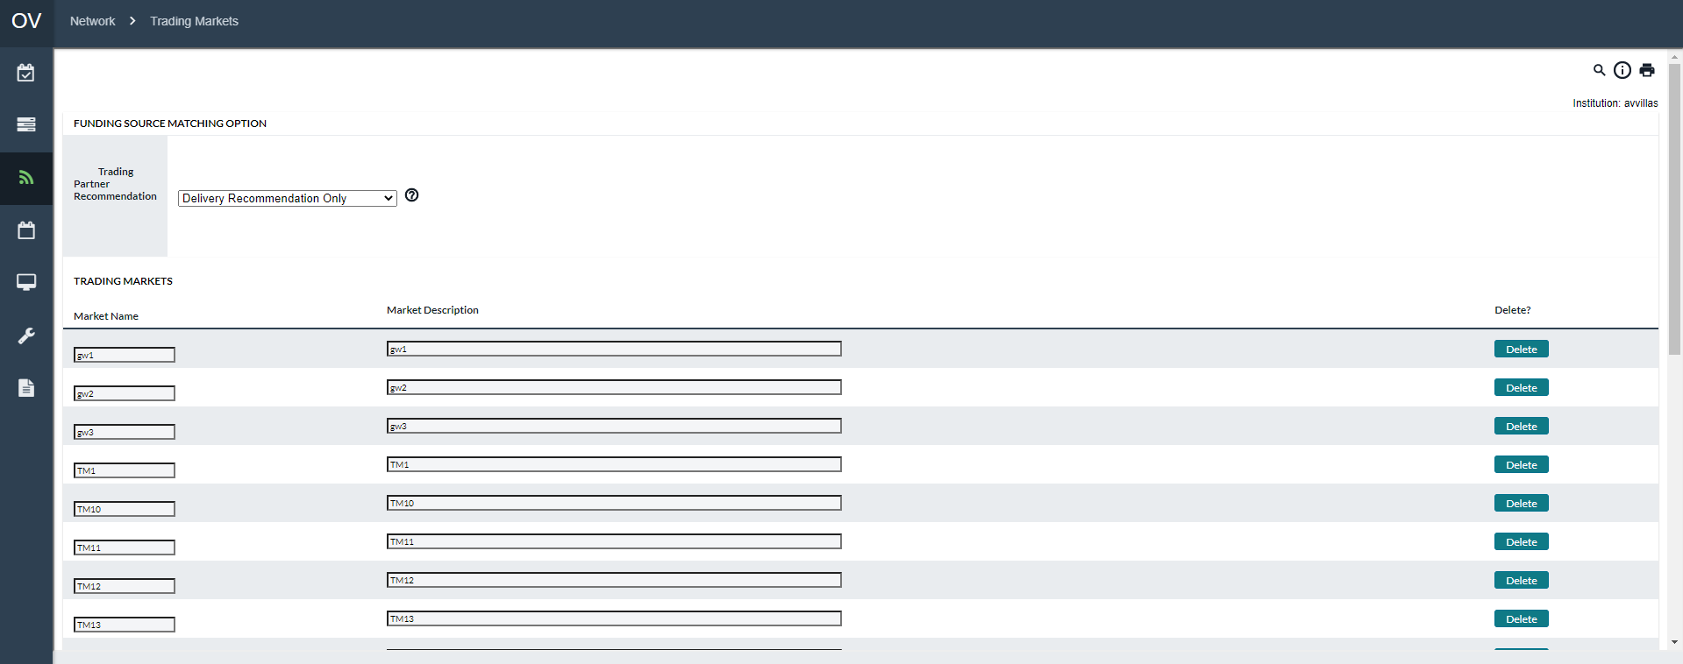

Table 64: Trading Market Field Descriptions

| Fields | Description |
| --- | --- |
| **Trading Partner Recommendations** | Pre-defined Dropdown selector allowing users to select what type of Trading Market is being created. This selection will determine what exchanges may be considered when OptiVault is running the Optimization process   * Delivery and Return Recommendations * Delivery Recommendations * Return Recommendations |
| **Market Name** | Users can define what each Trading Market will be called in the system. This is a fixed-length field. |
| **Market Description** | Open-length field where users can provide more information defining the Trading Market |

Return To: Network Tab

# Events Tab

Events can be national or local holidays as well as non-holiday occurrences. Events are important because they typically impact the demand for cash in Cashpoint, although the actual impact could have a similar effect or be quite different from one Cashpoint type to another.

The following is a summary of the information that will be covered along with hyperlinks to each topic:

* Events→Calendar Page
* Events→Event Collisions
* Calendars→Cashpoints
* Events→Events Page
* Events→Add/Edit Event

Return To: Introduction to the Interface

### Events→Calendar Page

Calendars are used in OptiVault to group similar Holidays and Events that relate to a group of Cashpoints. These Calendars can then be assigned to Cashpoints which will use the Events to make appropriate adjustments during the Forecast process.

Figure 44: Calendar Page

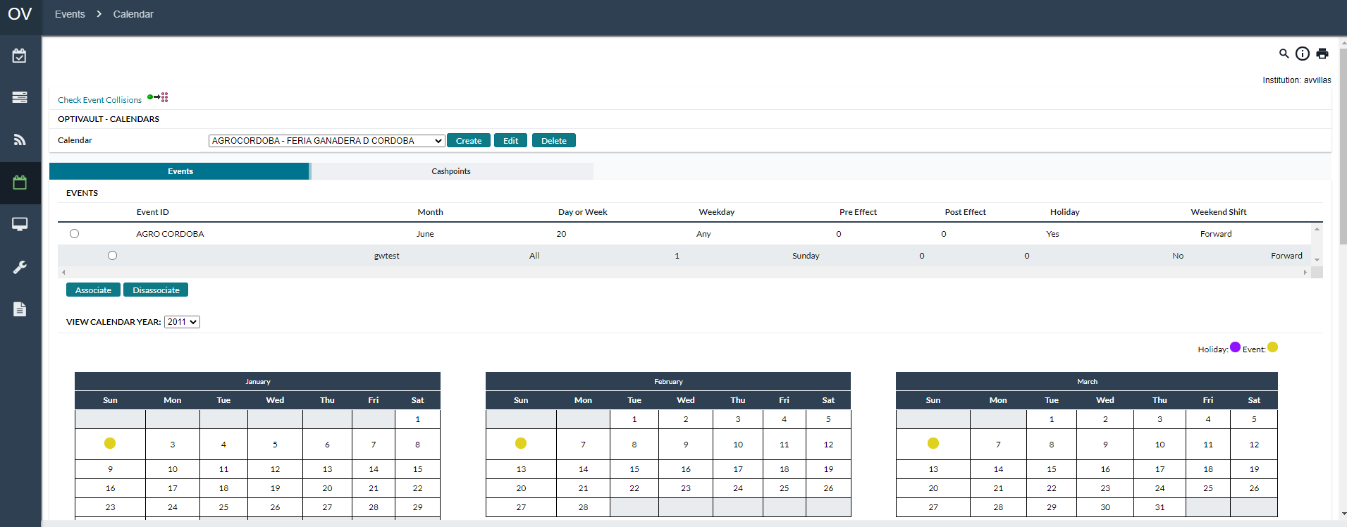

Table 65: Calendar Description

| Fields | Description |
| --- | --- |
| **Create Button** | Allows the user to create a new Calendar by setting a Calendar ID and Description. Once created, the Calendar can have Events and Cashpoints assigned to it. |
| **Associate** | Allows the user to associate Events to the current calendar. |
| **Disassociate** | Allows users to select Events from the Calendar list and remove them from the current Calendar. |
| **Cashpoints Tab** | Allows users to review, add, or remove Cashpoints from the calendar. See: Calendars→Cashpoints |
| **View Year** | This section of the Calendar Page shows a graphical view of the current Events assigned to this Calendar. This is for informational purposes only |
| **Check Event Collisions Link** | Allows the user to check if any Cashpoints assigned to the currently selected Calendar have collisions with another Calendar or Event. See: Events→Event Collisions |

Return To: Events Tab

### Events→Event Collisions

Event collisions might occur when the pre and post-days of two events fall within the same days. Pre and post-days are the days that impact the demand before and after the event. The overlapping events can impact the output of recommendations and forecast processes. When event collisions occur, the system has to decide which event to associate with the demand.

To ensure the correct and effective process of recommendations and forecasts, the event collisions must be corrected by making sure that the pre and post-effect days do not overlap. First, check event collisions as described below and second, update the pre and post-effect of the events under the Events tab.

When event collisions occur, OptiVault will first take into consideration those events that have a priority against other events. The priorities are determined by the following general rules:

* Holiday events are always considered first, then non-holiday events.
* Events are considered before pre/post effects of events, except for when holiday pre/post effects collide with a non-holiday event.

Figure 45: Event Collisions Page

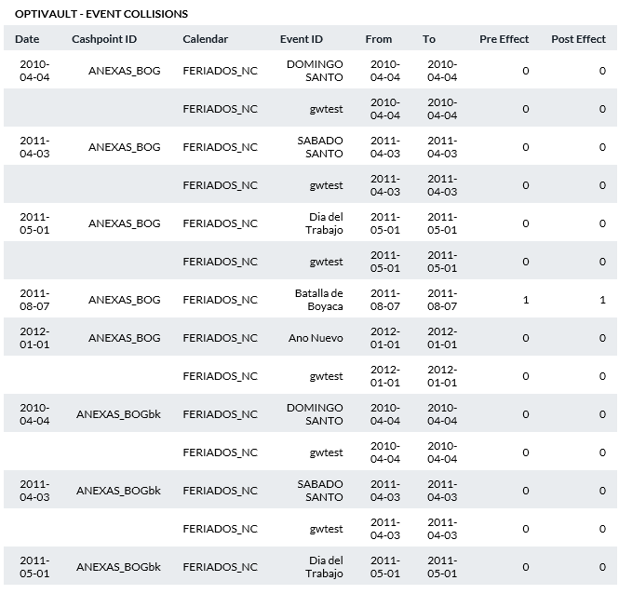

Table 66: Event Collisions Description

| Field | Description |
| --- | --- |
| Date | Date of the event. |
| Cashpoint ID | Unique alpha-numeric identification of the Cashpoint. |
| Calendar | Displays the name of the calendar this event belongs to. |
| Event ID | Unique alphanumeric code identifying this event. |
| From/To | The time period of the event: start and end dates. |
| Pre-Effect | The number of days that are impacted prior to this event. For example, demand may be impacted by Christmas for several days before December 25. |
| Post Effect | The number of days impacted after the event. |

Return To: Events Tab

#### Calendars→Cashpoints

Figure 46: Calendar Cashpoints Page

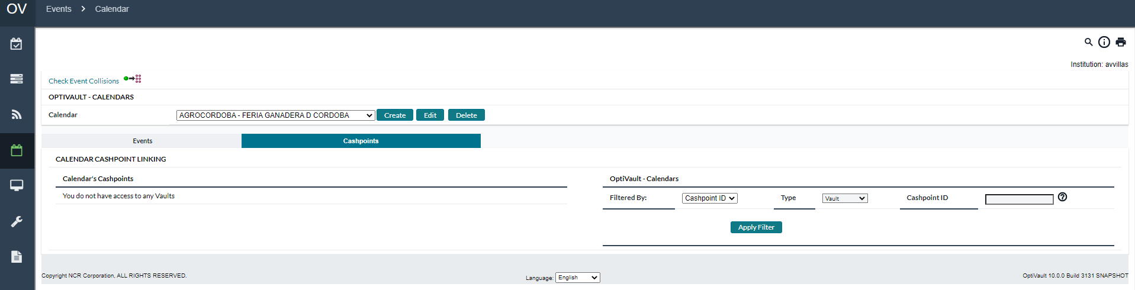

Table 67: Calendar Cashpoints Page

| Fields | Description |
| --- | --- |
| **Filtered By** | Allows the user to select how the search for Cashpoints will be filtered  The options for this are:   * Cashpoint ID * Type |
| **Type** | Allows the user to select how the search for Cashpoints will be filtered  The options for this are:   * Vault * Commercial * Custodial Inventory * External Funding Source |
| **Cashpoint ID** | Allows the user to type the Cashpoint ID to search for when the results are filtered. This is only available when Cashpoint ID is selected in the Filtered By section. |
| **Apply Filter** | Runs the search and returns the results based on the Search Criteria defined |
| **Select All button** | Selects all Cashpoints in the list related to the button’s position. |
| **Remove button** | Removes Cashpoints from the calendar |
| **Add Button** | Adds Cashpoints to the calendar |
| **<< < > >> buttons** | Allows the users to scroll back and forth through the pages of Cashpoints. |

Return To: Events Tab

### Events→Events Page

Events are defined in OptiVault to bring special attention to certain days such as paydays or holidays. The Events are assigned to Calendars that are then assigned to Cashpoints for use in the Forecasting and Recommendation processes.

Figure 47: Events Page

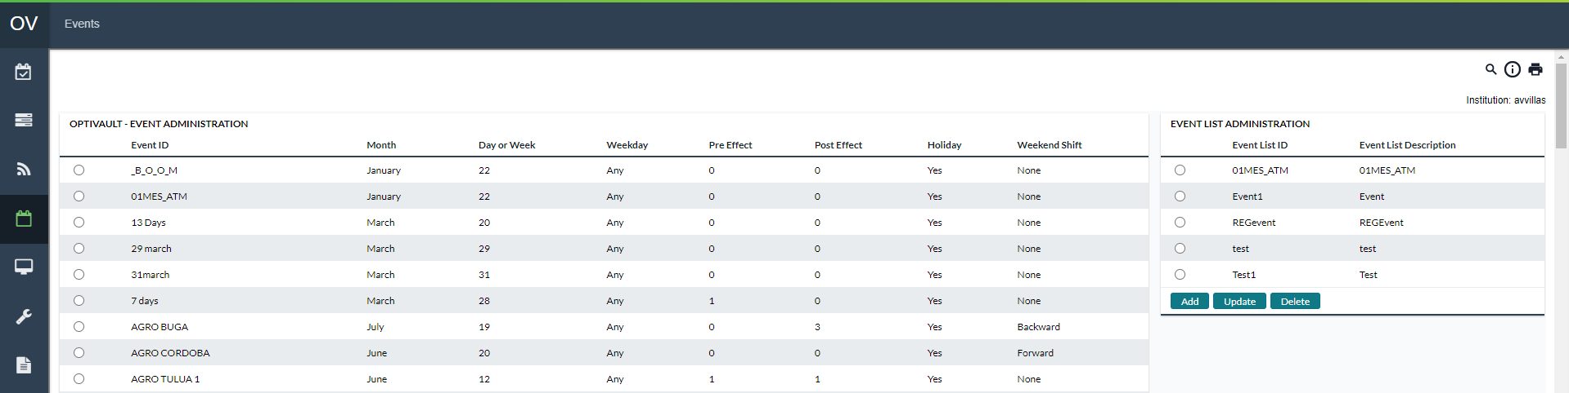

Table 68: Events Page Description

| Fields | Description |
| --- | --- |
| **Add Button** | Allows the user to create a new Event. |
| **Update Button** | The user can select one of the events from the event list and click the Update button the change dates or Event definitions. |
| **Delete Button** | The user can select one of the events from the event list and click the Delete button to delete it from the system.  **Note:** Events cannot be deleted if they are assigned to a Calendar. |

Return To: Events Tab

#### Events→Add/Edit Event

The Add/Edit Event Page allows the user to define new or modify existing Events.

Figure 48: Add/Edit Event Page

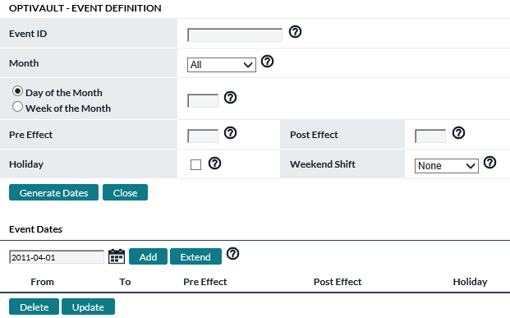

Table 69: Add/Edit Event Description

| Fields | Description |
| --- | --- |
| **Event ID** | Unique alpha-numeric code that identifies the Event. |
| **Month** | Specify the month in which this event occurs. If the event occurs every month, select **“All”.** |
| **Day of Month** | Enter the number of the day of the month on which this event occurs.  **Note**: The event must always fall on the same day of the month each year. If the day varies from one month/year to the next, then do not use this field. Instead, use the next field called **“Week of Month”** (see below). |
| **Week of Month** | The week of the month on which the event occurs (i.e., enter “1” if the event always falls in the first week of the month, “2” if the event always falls in the second week of the month, “5” for last week of month). If a value in this field is entered, you must also specify a day of the week on which the event occurs (see below). This feature will help to define those events that do not occur on the same day each year; for instance, Mother’s Day will occur second Sunday of May each year. |
| **Day of Week** | If the Week of the month is selected, a new field **Day of Week** will occur. Click on the **Down** arrow and select the day of the week on which this event falls. |
| **Pre-effect / Post-effect** | The anticipated “ripple effect” from a major event or holiday on cash demand. This is the anticipated days both before (pre-effect) and after (post-effect) that an event will have on cash demand. For example, a major holiday like December 25 (Christmas) will likely have significant effects both before and after the actual holiday. Enter the actual number of days when the “ripple effect” is expected to extend out from the event. |
| **Holiday** | Optional selection. Click in the check box next to holiday to indicate that an event is also a holiday.  **Note**: An event is not necessarily a holiday. For example, an event could be payday every other Wednesday. A holiday is a national or regional event that could affect the delivery of cash to a Cashpoint if the carrier does not deliver on that holiday. In this case, if the check box is selected, OptiVault will plan for this contingency and forecast for cash to be delivered before the holiday, if necessary. |
| **Weekend Shift** | Click the **Down** arrow to select the expected shift in cash demand when an event falls on the weekend (Saturday or Sunday). The possible choices are:  **Backward:** shifts demand to the Friday before the weekend.  **Forward:** shifts demand to the following Monday.  **None:** indicates no anticipated shift in demand and keeps the original event date.  **Note**: this field is only active when the Day of Month field is populated with a value greater than zero (0). |
| **Generate Dates Button** | Generates Event Dates based on the definition of the Event (present year plus 2 years in the past and 2 years into the future). The dates can then be selected and individually updated if needed. |
| **Add Button** | Allows Users to manually enter dates. This is an alternative to Generating dates. |
| **Generate From** | Works similarly to **“Generate Dates”** except that this function will ONLY generate out into the future from a selected starting point. This helps keep existing dates from being overwritten during an Event refresh or update. |
| **Update Button** | Updates the select date. |
| **Delete Button** | Deletes the selected date. |

Return To: Events Tab

# Settings Tab

The Settings Tab contains tools normally used by administrators to set up the system or perform maintenance functions.

The following is a summary of the information that will be covered along with hyperlinks to each topic:

* Settings→Institution
* Settings→Override Reasons
* Settings→Privileges
* Settings→Currencies/Denominations
* Settings→Currencies/Denominations
* Settings→Order Settings
* Settings→Calendar Refresh

Return To: Introduction to the Interface

### Settings→Institution

The Institution page allows the OptiVault analyst set up parameters that affect all Cashpoints.

Figure 49: Institution Page

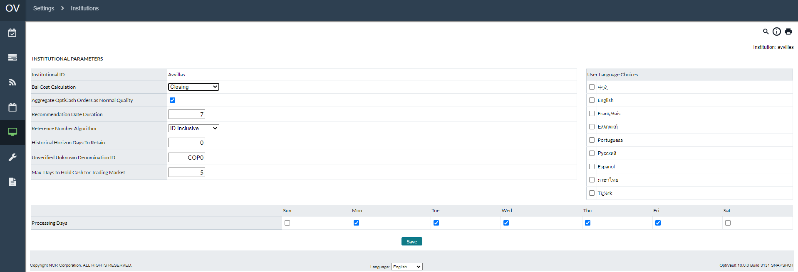

Table 70: Institution Page Description

| Fields | Description |
| --- | --- |
| **Balance Cost Calculation** | This option determines how the balance cost calculation is performed. The options available are:  **Closing –** Balance cost is calculated each day based on the closing balance of the Cashpoint.  **Average –** Balance cost is calculated based on the average holding balance of the Cashpoint. |
| **Aggregate OptiCash Orders as Normal Quality** | Change First Level Aggregation so that all orders coming in from OptiCash are considered Normal quality. |
| **Recommendation Date Duration** | The value of this field sets the default recommendation length. Each time the recommendation process is run, the recommendations will automatically produce a number of days forward into the future based on this setting. |
| **Reference Number Algorithm** | Choose the format for reference numbers created by OptiVault to uniquely identify orders and recommendations. The options are:  **ID Inclusive –** Reference includes the cashpoint ID as well as the randomized numeric value **Incremental –** Reference is numeric values that increase by 1 each time a new reference ID is created. |
| **Historical Horizon Days To Retain** | The value of this field controls the number of days of history that are retained for Horizon Days. |
| **Unverified Unknown Denomination ID** | System wide setting to determine what Denomination ID will be used to define currency that is of both unknown quality and unknown denomination. |
| **User Language Choices** | Administrators can narrow the choices for language selection. For example, if only language files for English and Russian are available, but selecting those on this screen, the user Language dropdowns will be limited to those options. |
| **Processing Days** | The Processing days are the days that the institution will be processing recommendations. These are days that the analysts will work to process recommendations and place orders. |
| **Max. Days to Hold Cash for Trading Market** | In funding source optimization, excess cash at one vault location can be held over 1 or more days to serve needs at another location in the same trading market. This setting limits the longest amount of time cash can be held in this way. |

Return To: Settings Tab

### Settings→Override Reasons

The Override Reasons are used to specify the reasons that a recommendation was not followed. When a recommendation is overridden, these reasons can be used by the analysts to understand why the recommendations were not followed and to make changes to parameters to improve the Cashpoint’s performance to better accommodate the Cashpoint’s needs. Furthermore, if no changes are needed, the analyst can use the information to justify that the recommendations were correct.

Figure 50: Override Reasons Page

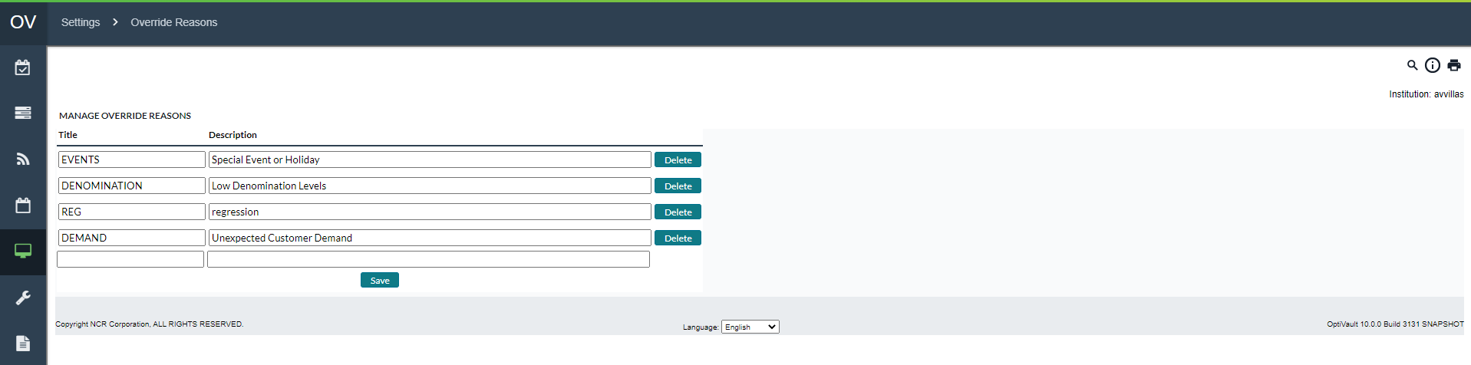

Table 71: Override Reasons Description

| Fields | Description |
| --- | --- |
| **Title** | The title is a 12-character alpha-numeric field that is used as a general reference to the reason description |
| **Description** | An alpha-numeric field of 80 characters is used as the description of the Override Reason used to explain the Title field. |
| **Delete Button** | Deletes the entry adjacent to the button. The user will be prompted to confirm the deletion before it is made permanent. |
| **Save Button** | Saves any changes made to the entries on the page or adds a new entry if the last empty cells are filled in with information. |

Return To: Settings Tab

### Settings→Privileges

The Privileges pages allow the administrator to set up users and user groups. Users can access the system only if they are a member of a Business Unit. The Business Units have Users assigned to them as well as Cashpoints and Rights.

The following is a summary of the information that will be covered along with hyperlinks to each topic:

* Privileges→Users
* [PrivilegesàBusiness Unit](#_Privileges(Business_Units)s

Figure 51: Privileges Page

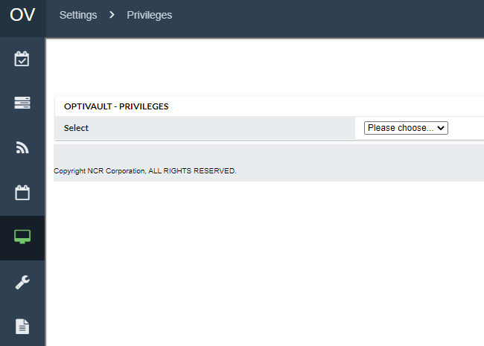

Return To: Settings Tab

#### Privileges→Users

To access OptiVault, users must have a User ID and password pre-defined by a system administrator.

Figure 52: New User Page

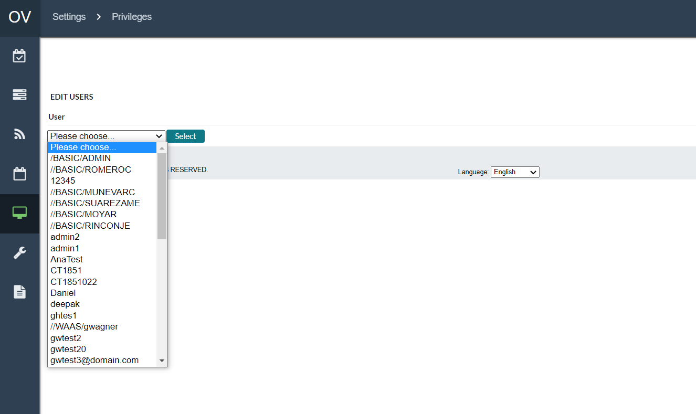

Table 72: User Description

| Field | | Description | |
| --- | --- | --- | --- |
|  | |  | |
|  |  | |
|  | |  | |
| **External Authentication User** | | EPSS Username | |
| **Max Order Amount** | | The maximum amount that this user will be able to put in an order.  Note: This amount is in the system’s primary currency. | |
| **Email Address** | | Email address for this user. | |

Return To: Settings→Privileges

#### Privileges→Business Units

‘  
  
Note: In OptiVault, the tasks 'View and Edit Members' and 'View and Edit Rights' in Business Units have been relocated from System > Privileges > Administer Business Users to the EPSS Screen.

In EPSS users can assign groups by navigating to User Management

Figure 53: Business Units Page

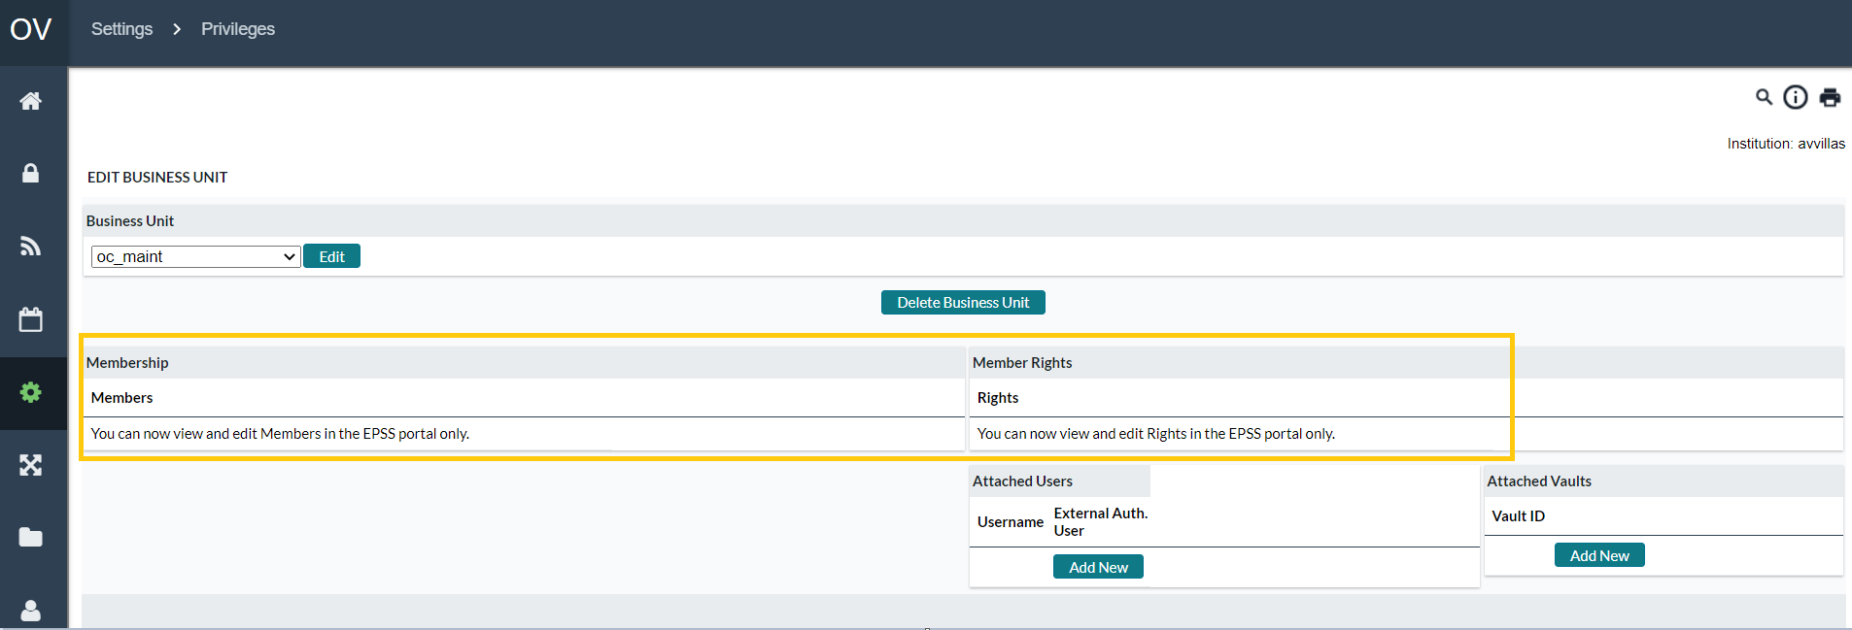

Table 73: Business Unit Details Window

| Tabs | Description |
| --- | --- |
| **Membership** | Members are users in the Business Unit that have all the privileges that are assigned to that unit in the Rights section.  To remove/add members to a group, follow the button functions described in the next table.  Note: Members can now be assigned to Business units (Security groups) through EPSS |
| **Attached Users** | Attached Users are people who can administer the group without necessarily being a Member of the group. For instance, a user will not have the rights to see vault information but will have permission to assign other users to groups, create new users, etc. Being an attached user means that the user has administrative rights over the group and any users or rights within it.  **Note:** When user access and maintenance is managed by an administrator, who has the right of “Administer System”, it is not necessary to assign users since administrators will be able to access all users and business units. |
| **Attached Vaults** | Members of the group, who have rights to view, edit and administer certain Cashpoints, will have those Cashpoints assigned to them under the Attached Vaults section. |
| **Rights** | **Note: Rights (Now configured as “Roles” in EPSS) Can be assigned to security groups in EPSS** |

Table 74: Button Functions

| Function | Description |
| --- | --- |
| **Add New Button** | Adds a New Member, User, Vault, or Right to the Group. For adding Members, Users, or Vaults, click the button labelled ‘Add New’. The analyst will then be prompted with a window that will allow them to search and select the desired items to add to the group.  For Rights, the user should select the appropriate right and then click the **‘Add New’** Button to add the right to the Group. |
| **Remove Bottom** | Removes the Member, User, Vault, or Right from the Group. Click the button next to the Group object that is to be deleted. The analyst will be prompted to confirm the deletion before it is made permanent. |
| **Delete Business Unit Button** | Deletes the Group from the system. Clicking this button will not delete the users or the Cashpoints, but the group that is associated with the Group ID. |

Return To: Settings→Privileges

### Settings→Currencies/Denominations

The Currencies/Denomination Tab allows the user to define the currencies and denominations that users will assign to vaults so they are ordered and managed. The user has the option to configure Currencies, Denominations, and Foreign Exchange Rates by selecting the appropriate function from the dropdown box.

#### Settings→Currencies/Denominations→Currencies

OptiVault is a multi-currency system. It allows the users to create different currencies and denominations for each one of the currencies so it can be managed for OptiVault at the Vault level. The currencies page allows the setup of each unique currency to be utilized.

Figure 54: Currency Page

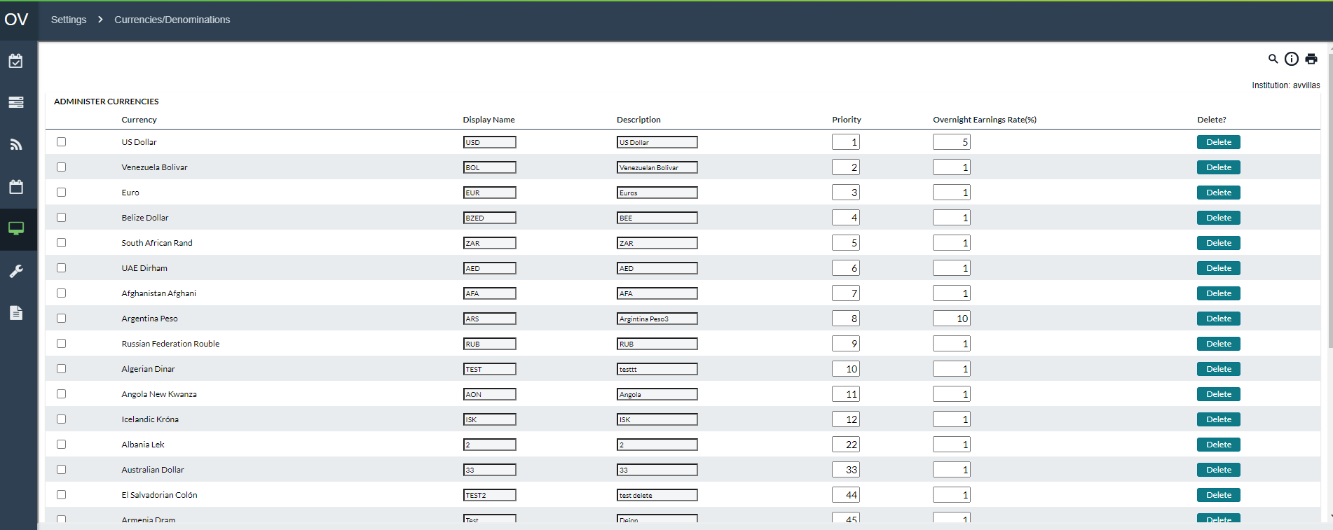

Table 75: Currencies Description

| Field | Description |
| --- | --- |
| **Currency** | Full name of each Currency |
| **Display Name** | The display name will be used on all screens. |
| **Description** | Description of the currency. |
| **Priority** | A unique priority for the currency. The priority of the currencies defines the master/slave relationship for the currencies dispensed at the Cashpoint. The priority of the currency decreases as the numeric value of the priority increases. So, priority value of 1 is the highest and will be defined for the master currency. For any given Cashpoint’s recommendation process, its master currency drives the optimization/delivery parameters (refer to the example below for more on multi-currency synchronization). |
| **Overnight Earnings Rate (%)** | The rate of return available funds will earn or the opportunity cost of maintaining excess cash in the branch or ATM. This should be an annualized rate. |
| **Delete** | Allows the user to delete individual currencies from usage in OptiVault |

#### Settings→Currencies/Denominations→Denominations

Denominations are the breakdown of a currency in notes and coins that are individually forecasted, recommended, and ordered through the OptiVault system. Denominations are set up to be an identifier for each type of currency note and coin.

Figure 55: Denominations Page

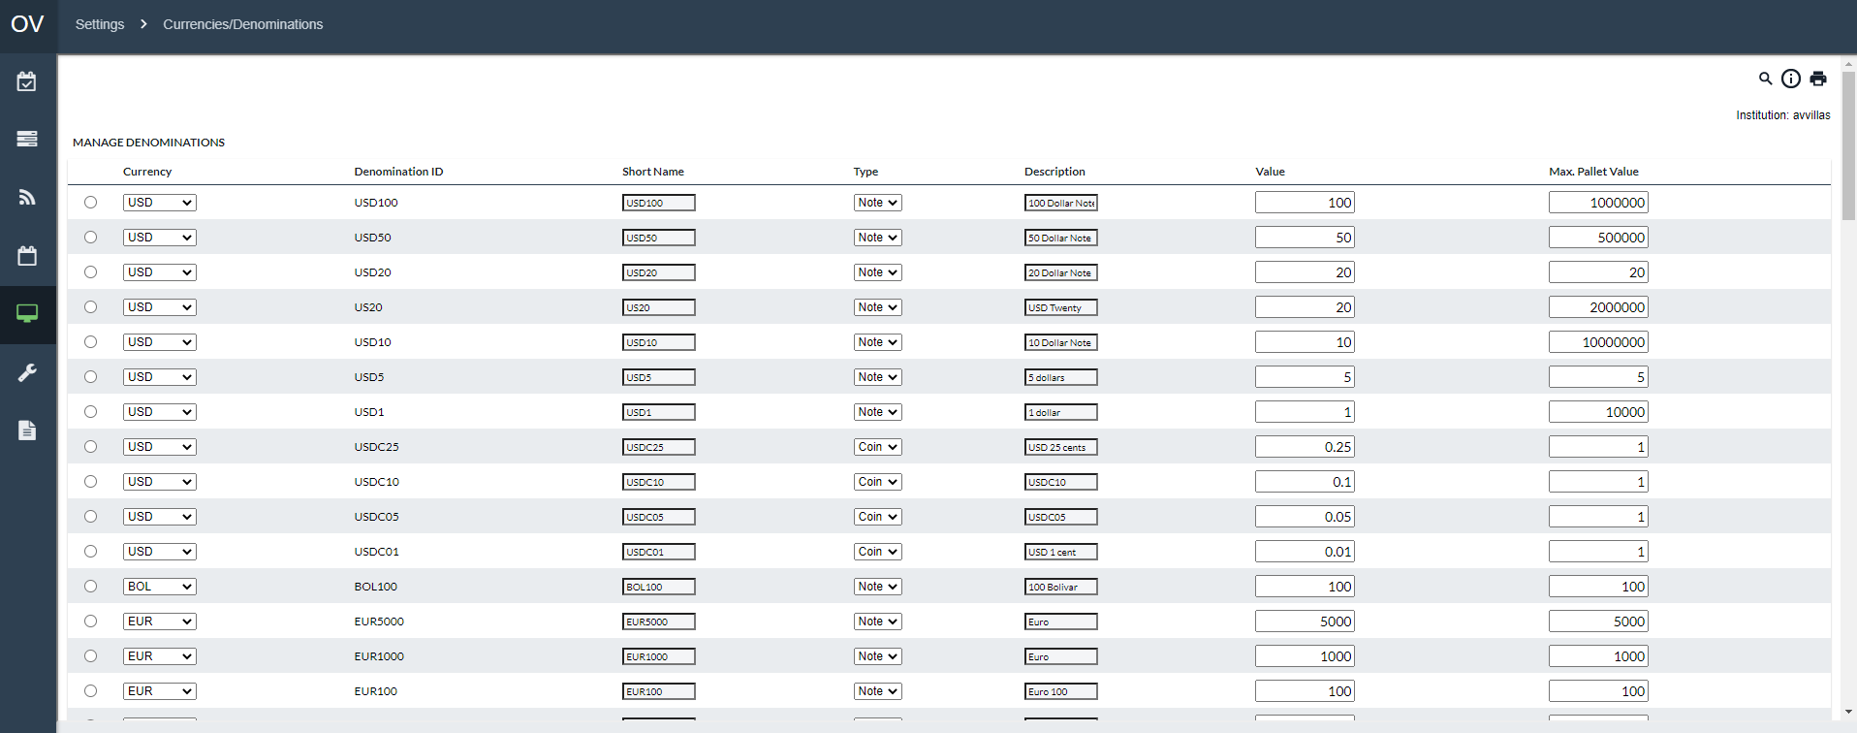

Table 76: Denomination Description

| Fields | Description |
| --- | --- |
| **Denomination ID** | The denomination ID is a 12-character alphanumeric field that is used to identify the denomination throughout the application. |
| **Short Name** | The short name is used as an abbreviated reference for the denomination that is used in reports to refer to the denomination ID |
| **Type** | Describes the type of denomination. The available types are:   * **Note –** Paper currency * **Coin –** Metal currency |
| **Description** | Describes the denomination in more detail. Used only for informational purposes |
| **Value** | The single note or coin value of the denomination. For instance, if the denomination was USD $100 then the value would be 100 |
| **Large Order Unit Size** | The size of a large order bundle. |
| **Small Order Unit Size** | The size of a small order bundle. |
| **Max Pallet Value** | This field represents the amount (in value, not the number of notes/coins) of a denomination that can fit on a pallet. This is used in conjunction with the Max Number of Pallets parameter defined on the Cashpoint’s parameter page. |
| **Add Button** | Adds a new denomination to the system. All the fields need to be specified correctly before the user can successfully add a new denomination to the system |
| **Update Button** | Updates the selected entry with any changes that were made. The user has to select the radio button to the left of the Denomination entry to update that single entry. |
| **Delete Button** | Deletes the selected entry from the system. The user has to select the radio button to the left of the Denomination entry to delete that single entry. The user will be prompted to confirm the deletion before it is permanently deleted from the system. |

Return To: Settings Tab

#### Settings→Currencies/Denominations→Exchange Rate

When working in a Multi-Currency environment, it is necessary for the recommendation process to consider the exchange rate between different currencies to make accurate decisions on which currencies to prioritize and optimize as well as calculate costs. The Currency Exchange Rate can be set daily if necessary.

**Note**: If exchange rates are changed for days in the past, it is best to re-calculate Actual Costs to ensure the figures are correct.

Figure 56: Exchange Rate Page

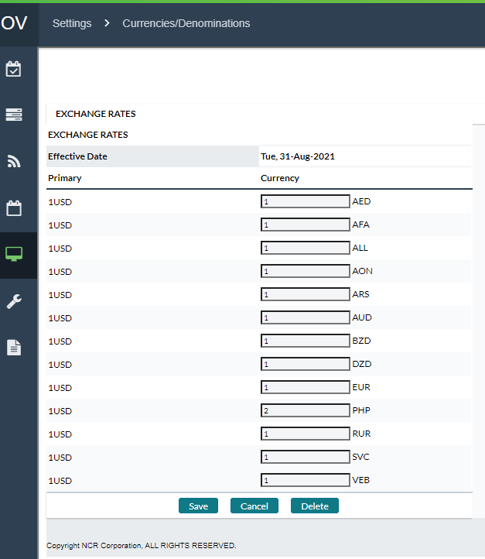

### Settings→Order Settings

The following is a summary of the information that will be covered along with hyperlinks to each topic:

* Events→Calendar Page SettingsàOrder Workflow Definition
* Events→Calendar Page SettingsàCustom Field Definition
* Events→Calendar Page SettingsàCustom Field to Order Linkage

#### Settings→Order Settings→Order Workflow Definition

Order Workflow functionality tracks the status of orders from creation to fulfilment and confirmation. If Order Workflow is not licensed, standard OptiVault Order Workflow will apply and access to the Workflow Editor will be disabled.

An Order Workflow consists of States that an order can be in at a given time, and Tasks or actions that can be performed from a given State. In the example diagram below, black text in bubbles are States, while red text next to arrows represents Tasks. For instance, Orders can be ‘Ordered’ by Branch users but a regional supervisor has to **‘Approve’** the order before it goes on to be transmitted to the carrier.

Figure 59: Example of an Order Workflow

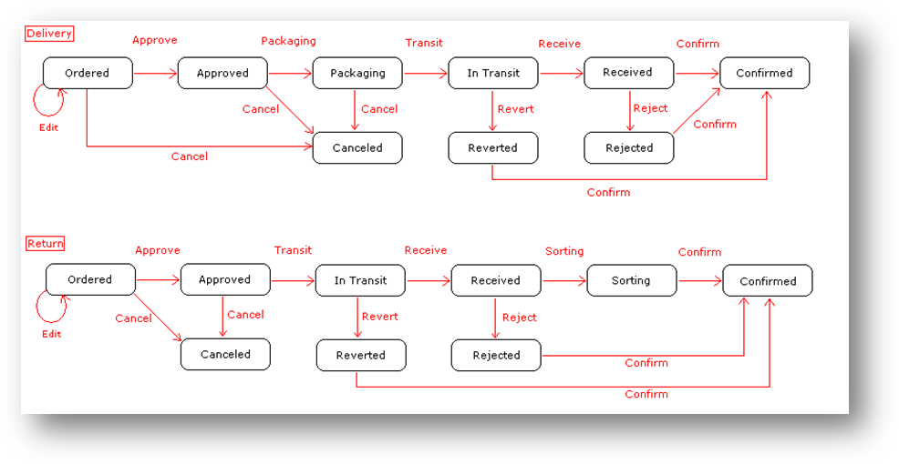

[Return to:](#_System(Order_Settings)  Settings→Order Settings

Figure 60: Order Workflow Page

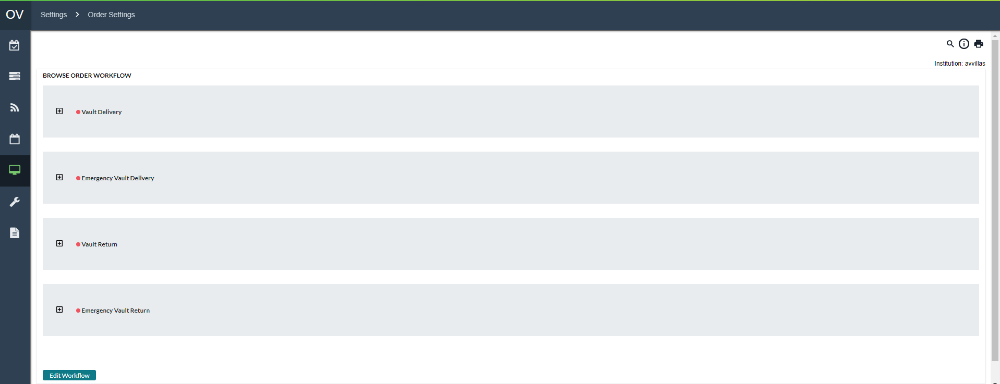

Table 80: Order Workflow Description

| Fields | Description |
| --- | --- |
| **Browse Order Workflow** | * **Order Types –** Each order type is listed in the Order Workflow list. Clicking on the **‘+’** icon will expand the States, Tasks, and New States for each order type. * **States –** Describes the current State of the order. This means that when the order is in a particular state, the Tasks and New States are available below the specified state. Clicking on the **‘+’** icon for a State will expand the available Tasks and New States assigned to the workflow. * **Tasks –** Tasks are the actions that can be taken for the order at a particular state. The Task selected will move the order into the associated **‘New State’** * **New States –** This is the State that the order will be in once the Task has been selected during the order workflow. |
| **Edit Workflow Button** | Clicking on this button will enter a new page where the user can select the order type from a list to be edited. This process can be simplified by expanding desired order type from the list and clicking on one of the states listed. |

[Return to:](#_System(Order_Settings) Settings→Order Settings

##### Order Workflow Editing

Orders workflow can be edited by selecting one of the **‘Order States’** from the Browse Order Workflow page or by clicking on the **‘Edit Workflow’** button and selecting the appropriate order type.

Figure 61: Order Workflow Editing Page

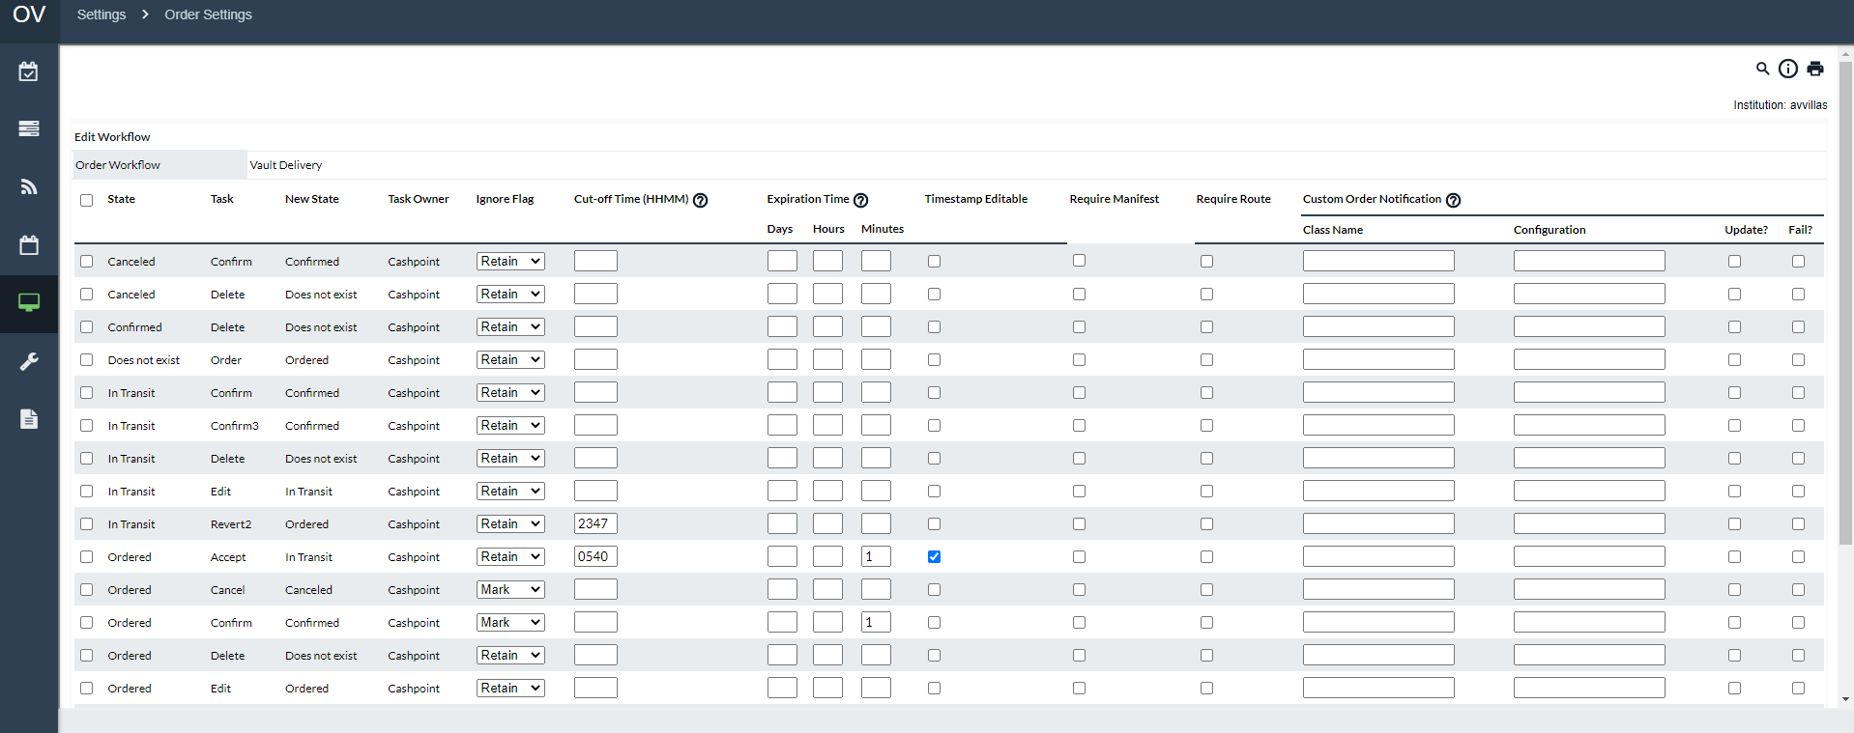

Table 81: Order Workflow Editing Description

| Fields | Description |
| --- | --- |
| **Checkbox** | Allows the user to select the item for which the Update or Delete buttons will apply |
| **Update button** | Saves any changes made to the selected item(s) in the list. |
| **Delete button** | Deletes any item(s) selected in the list.  **NOTE**: The State **‘Does not exist’** cannot be deleted as this is a default system State. |
| **Add Task to Workflow button** | Allows the Analyst to Add an Order Task to the Order Workflow. |
| **State** | Indicates the current State of the order; this means that when an order for the associated order type is this state, then the adjoining **‘Task**’ and resulting ‘**New State’** will be available (depending on permissions). |
| **Task** | The Task is what will be displayed to the user in the form of a button on the Order Page. The Tasks available for the assignment are:   * **Accept, Accept2, Accept3 –** Accepts the Order * **Approve, Approve2, Approve3 –** Approves the Order * **Cancel, Cancel2, Cancel3 –** Cancels the Order * **Confirm, Confirm2, Confirm3 –** Confirms the Order * **Delete, Delete2, Delete3** – Allows the Order to be deleted * **Edit, Edit2, Edit3 –** Allows for the editing of an order * **Order –** Analysts place the order * **Reject, Reject2, Reject3 –** Rejects the Order * **Revert, Revert2, Revert3 –** Reverts the Order   Those tasks that have more than one entry i.e., Approve, Approve2, Approve3 are provided to give flexibility around permissions as well as cut-off times for certain functions. This is also because it may be the case that multiple people will have to Approve an order before it goes to the next State.  Some of the tasks have several new States that can be assigned to them; for example, Approving an order can lead to Approved, In Transit, Ordered, etc. Other states such as Delete have only one option which is **“Does Not Exist”**  **NOTE**: Certain Tasks have an effect other than changing the State of the order these include:   * **Delete –** Deletes the order * **Cancel, Reject, and Revert -** Orders that pass through any one of these tasks are considered undeliverable. This means that Recommendations will assume the cash has not arrived, and the same for Pre-Emptive Alerts and Recommendation Compliance Reports. * **Edit tasks -**  allow users to change certain fields regarding an Order (denominations, amounts, etc.) * **Order -** A special task referring to the creation of Orders. * **Transmit -** Transmit tasks represent the Orders Output function. The Orders Output will include only those orders currently in a State for which a Transmit task is defined starting in that State. |
| **New State** | This is the State the Order will be in after the user accomplishes the **‘Task’** (in other words clicks on the ‘**Task’** button in the Order)  Depending on the Task that is selected, only applicable States will be available The following is a list of the states that are available for each Task   * Accept, Accept2, Accept3 = Ordered, Approved, Confirmed, Packaging, In Transit, Delivered, Accepted, Reverted, or Canceled * Approve, Approve2, Approve3 = Ordered, Approved, Confirmed, Packaging, In Transit, Delivered, Accepted, Reverted, or Canceled * Cancel, Cancel2, Cancel3 = Ordered, Approved, Confirmed, Packaging, In Transit, Delivered, Accepted, Reverted, or Canceled * Confirm, Confirm2, Confirm3 = Ordered, Approved, Confirmed, Packaging, In Transit, Delivered, Accepted, Reverted, or Canceled * Delete, Delete2, Delete3 = Does Not Exist * Edit, Edit2, Edit3 = Ordered, Approved, Confirmed, Packaging, In Transit, Delivered, Accepted, Reverted, or Canceled * Order = Ordered, Approved, Confirmed, Packaging, In Transit, Delivered, Accepted, Reverted, or Canceled * Reject, Reject2, Reject3 = Canceled * Revert, Revert2, Revert3 = Canceled |
| **Task Owner** | Workflow Administration Users select either “Cashpoint” or **“Funding Source” Selecting “Cashpoint”** means that the branch receiving the cash must complete that Workflow Task. Selecting **“Funding Source”** means that the sending branch must complete it. |
| **Ignore Flag** | Users select between **“Mark”, “Unmark”,** and **“Retain”**  **Mark**: Tells OptiCash that the Order will not arrive if the associated Task occurs  **Unmark:** Tells OptiCash to again consider the Order to be received or going to be received if it was Marked not to arrive in the prior State  **Retain**: Tells OptiCash to keep whatever **“Ignore Flag”** status was in place with the prior order State |
| **Cut Off Time** | The time in ‘HHMM’ format that the user has to accomplish the Task. After this time has elapsed, the branch user will no longer have the ability to perform the task. |
| **Expiration Time** | The amount of time that the task is valid. This means the user has a soft cut-off time. They are still able to process the orders, but any expired tasks performed will be flagged to the OptiCash Analyst.  Tasks can be processed in days, hours, and minutes with any combination in between (i.e., 2 days and 1 minute) |
| **Timestamp Editable** | Indicates whether the timestamp recorded when this particular Task is executed can be changed afterwards. For example, if a cash delivery arrives at 10:00, but the staff takes the action of **“Receive”** at 13:00, then editing “13:00” to “10:00” would be appropriate. |
| **Require Manifest** | Indicates if the system should require that an order manifest exist before this Task can be executed. |
| **Require Route** | Indicates if the system should require that a Route Plan exist for this order before this Task can be executed. |

[Return to:](#_System(Order_Settings) Settings→Order Settings

#### Settings→Order Settings→Custom Field Definition

Order Custom Fields can be used in many different ways to allow analysts to collect data for the orders that are not available on the standard order pages.

Ten custom fields are available and can be activated or deactivated as necessary for one type of cashpoint or all cashpoint types.

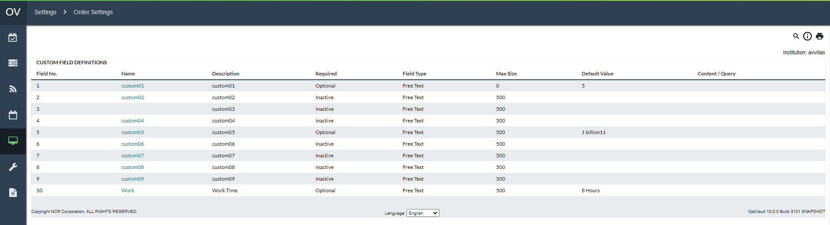

Table 82: Order Custom Field Definitions Description

| Fields | Description |
| --- | --- |
| **Field Number** | Indicates the Order Custom Field ID |
| **Name** | Indicates the Name of the Order Custom Field. This will be displayed to the user on the order pages. |
| **Description** | Describes the Order Custom Field is for. This field will not be displayed on the order pages. |
| **Required** | Indicates the status of the Order Custom Field:   * **Inactive –** Not in service for any cashpoints * **Optional –** This is an optional field that does not have to be specified * **Required –** Requires that the value be specified to complete the order |
| **Field Type** | Indicates the type of Custom Field being specified:   * **Free Text –** Provides a field for users to type any information necessary to communicate to the analyst. This text field allows any information to be displayed up to the maximum size specified. * **Pre-set List –** Displays a list that users can choose from. This list is defined in the Content/Query field as a comma-separated list. * **SQL Query –** Displays a list of information (similar to Pre-set List but automatically populated from an SQL query.) Queries can only be set up by an administrator. |
| **Max Size** | Indicates the maximum size of the field for Free Text fields |
| **Default Value** | Indicates the information that should be in the field by default. |
| **Content / Query** | Indicates the content (comma-separated list) or SQL query that is to be used to populate the options. |
| **Editing Values** | Clicking on any of the Custom Field Name hyperlinks will take the user to the editing page to allow for the editing of the custom field. |
| **Save button** | Saves changes made during editing. |
| **Cancel button** | Cancels any changes made to the Order Custom Fields |

[Return to:](#_System(Order_Settings) Settings→Order Settings

#### Settings→Order Settings→Custom Field to Order Linkage

In order to allow Order Custom Fields to apply to a particular type of order and/or cashpoint type, the Order Custom Fields can be associated with the applicable cashpoint and order types.

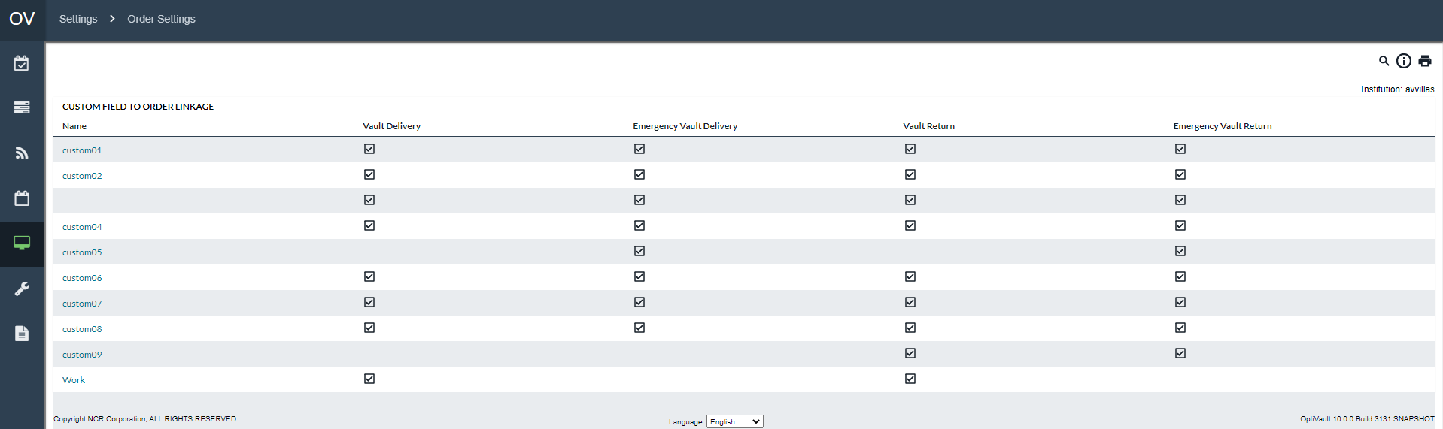

Table 83: Custom Field To Order Description

| Fields | Description |
| --- | --- |
| **Name** | Indicates the Name of the Order Custom Field as defined on the Order Custom Field Definition Page |
| **Save button** | Saves changes made during the editing process |
| **Cancel button** | Cancels any changes made during the editing process |
| **Editing Linkage** | To edit the linkage for an Order Custom Field, click on the Name hyperlink to access the parameters. |

### Settings→Calendar Refresh

When OptiVault is used in conjunction with OptiCash, it is possible to use the calendar information set up in OptiCash within OptiVault. The Calendar Refresh function allows this synchronization to take place. This will update the calendar information in OptiVault with the information saved in OptiCash.

The Cashpoint synchronization is a one-way sync from OptiCash to OptiVault. This means that any changes in OptiCash will be updated in OptiCash but not the reverse.

Figure 62: Calendar Refresh Page

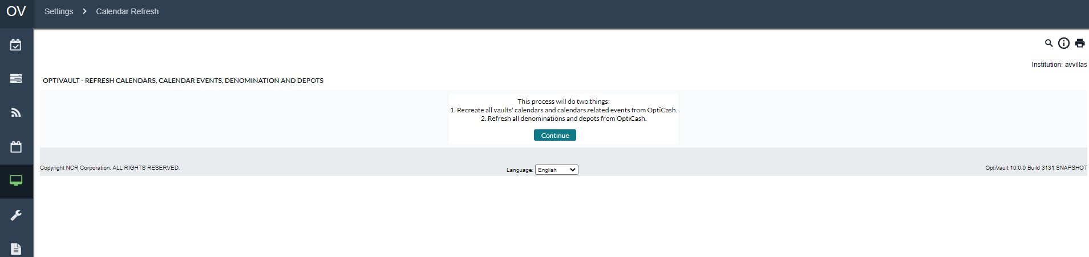

Table 85: Calendar Refresh Description

| Field | Description |
| --- | --- |
| **Continue Button** | Begins the Calendar Refresh. There is no prompting of the user to confirm this action please ensure that this function should be performed before clicking this button. This process may take several minutes to complete. Once the page has been refreshed, the process has been completed and a report will be displayed highlighting the information that was changed. |
| **Vault ID** | The Vault is associated with a calendar that has changed |
| **Calendar ID** | The ID of the calendar that is assigned to the vault. |
| **Events Created** | A number signifying how many event days were created for the associated Cashpoint and calendar. |

Return To: Settings Tab

# Maintenance Tab

The Maintenance Page allows users to perform system maintenance functions for OptiVault and Cashpoints. The user must select the desired option from the dropdown list to access the maintenance option. Most tasks should only be performed by system administrators or a user who is experienced in the system operations.

* Keep in mind that changes made to data in OptiVault are permanent and cannot be undone once they are committed.

The following is a summary of the information that will be covered along with hyperlinks to each topic:

* Maintenance→Copy Vault/Copy Commercial
* Maintenance→Purge Data
* Cashpoint Maintenance→Rename Cashpoint

Return To: Introduction to the Interface

#### Maintenance→Copy Vault/Copy Commercial

The Copy Cashpoint function allows the user to copy a vault's history, parameters, and all other information into a new Vault. This allows users to quickly create Cashpoints that have similar settings. After the copy process has been completed, the Cashpoint will have all the same parameters and history as the original therefore it is best to edit the parameters and other definition information at the Cashpoint level.

Table 77: Copy Cashpoint Description

| Field | Description |
| --- | --- |
| **Select Button** | After selecting a Cashpoint from the dropdown List-box, the Select button prompts the user with a new page that will allow the renaming of the Cashpoint ID. |
| **Copy Button** | Executes the Copy Vault process. |
| **To** | The Vault ID of the new vault. The Vault ID is a 12-character alpha-numeric field that is used to identify the Cashpoint in the system. |

Return To: Maintenance Tab

#### Maintenance→Purge Data

The Purge Data function is used to permanently delete data from the OptiVault database. Data can be selectively deleted from the following categories: History, Forecast, Recommendations, and Orders.

Some examples of when data may need to be purged from the OptiVault database would include:

* The wrong days were loaded in the daily files, in which case, indicate the time period that needs to be purged and re-load the fixed daily files.
* Purging the forecast table of all data before regenerating the forecast. Therefore, it will reduce the time required to regenerate the forecast.
* Purging data accumulated during several years of operations.

|  |  |
| --- | --- |
| Description: MCj04338830000[1] | **Caution**: Purging will cause data to be permanently deleted from the OptiVault database. Once deleted, this data cannot be recovered unless a backup copy of the database is existing. |

Figure 57: Purge Data Page

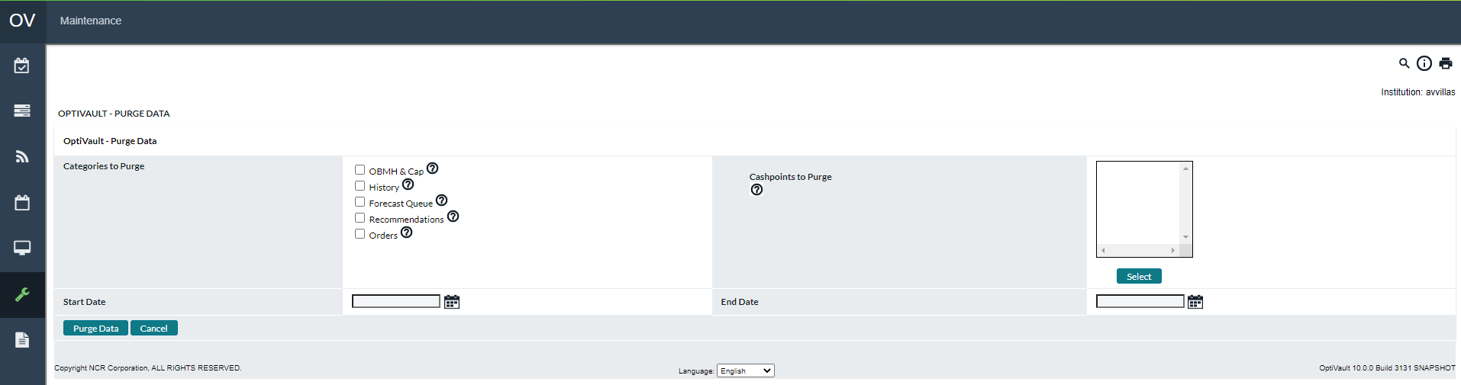

Table 78: Purge Data Description

| Field | Description |
| --- | --- |
| **OBMH & Cap** | Deletes the OBMH & Cap data from the system for the Cashpoints selected. |
| **History** | To delete historical data, check the box; indicate **“From”** and **“To”** Dates for the purge and select Cashpoints for which the history data will be purged by clicking on the Select button.  Date Selection (recommendation only): Generally, users should purge history greater than two full years plus the current year. For example, if today is July 16, 2004, the user can drop all history data prior to 01-Jan-2002. Then in January 2005, the users can drop all data prior to 01-Jan-2003. Repeat each January advancing by one year. The forecast engine uses twenty-four months of historical data. |
| **Forecast Queue** | Check the box to purge any Cashpoints currently existing in the forecast queue. This option will ignore the Cashpoints selected and the 'Start Date' and 'End Date' options. The forecast queue can be accessed at *Processing > Processing Status > Forecast*. If there is a message **“No processes running at this time”** this indicates there are no forecasts that have been generated. The forecast queue holds all forecast processes and releases it once the process has been completed. Occasionally, several users will generate a forecast simultaneously causing the process to hang up; therefore, no forecast process will generate until the forecast queue is purged. |
| **Recommendations** | To purge recommendations, check the box; indicate **“From”** and **“To”** Dates for the recommendations to be purged and select Cashpoints by clicking on the Select button.  **Note:** Purging old recommendations will automatically purge old horizon for the same time frame selected for recommendations.  **CAUTION:** Some users may run variance reports for periods greater than the past sixty days. The users should only purge data that the business will not use.  Date Selection (recommendation only): generally, users should purge recommendations greater than three full months plus the current month. For example, if today is July 16, 2005, drop all data prior to 01-April-2005. Repeat each month advancing by one month.  If users are running semi-annual/annual variance, they should select the dates accordingly.  **NOTE:** Recommendations are purged by the Due Date, not the Recommendation Date. |
| **Orders** | To purge orders, check the box, indicate “**From”** and **“To”** dates for the orders to be purged and select the Cashpoints by clicking on the Select button. |
| **Start Date** | The starting date of the purge period. Used only for History and Recommendations |
| **End Date** | The ending date of the purge period. Used only for History and Recommendations. |
| **Purge Data Button** | Deletes the data based on the items that are checked in the **‘Categories to Purge’** section of the page and the Cashpoints selected. |
| **Cancel Button** | Makes no changes in the system and exits the purge page. |

|  |  |
| --- | --- |
|  | **Note:** The above recommendations for data selections are only provided as suggestions; however, each institution needs to determine how much data it would like to have available. Prior to purging data, the database should be backed up. |

Return To: Maintenance Tab

#### Cashpoint Maintenance→Rename Cashpoint

The Cashpoint maintenance also allows renaming Cashpoints if the user needs to do so. Remember that at this level, only the Cashpoint ID can be renamed. Renaming other definition settings such as Cashpoint name, address, etc. is possible at the Cashpoint level in the Cashpoint definition window, under the Basic tab.

Figure 58: Rename Cashpoint Page

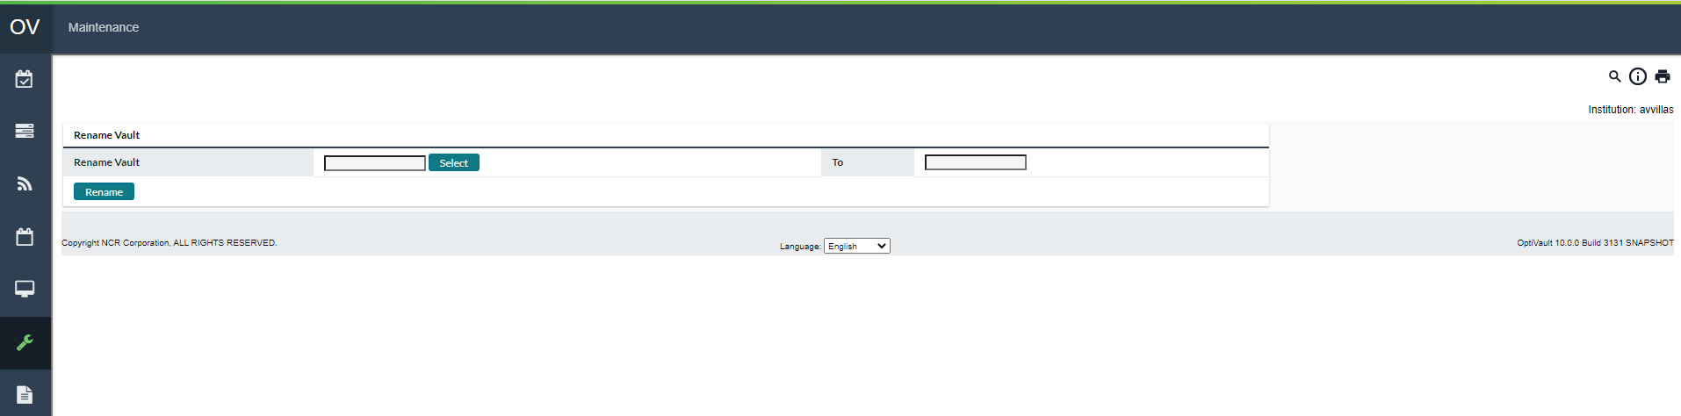

Table 79: Rename Cashpoint Description

| Field | Description |
| --- | --- |
| **Select Button** | After selecting a Cashpoint from the dropdown Listbox, the Select button prompts the user with a new page that will allow the renaming of the Cashpoint ID. |
| **Cancel Button** | Exits the Rename function without making any changes. |
| **Save Button** | Executes the renaming process. |
| **Set as Default Cashpoint** | Sets the currently selected Cashpoint as the default Cashpoint for all functions so the analyst does not have to select it from a list. |

Return To: Maintenance Tab















### Maintenance→Cashpoint Synchronization

When OptiVault is used in conjunction with OptiCash, the Cashpoints can be synchronized between OptiCash and OptiVault to keep the data up-to-date.

The Cashpoint synchronization is a one-way sync from OptiCash to OptiVault. This means that any changes in OptiCash will be updated in OptiCash but not the reverse. There are 3 categories of synchronization:

* Inserted Cashpoints
* Deleted Cashpoints
* Updated Cashpoints

Table 84: Cashpoint Synchronization Description

| Field | Description |
| --- | --- |
| **Continue Button** | Compares the OptiCash and OptiVault databases and displays the three categories of changes that will be:   * Insert * Delete * Update   The user will need to click on the link under each category (displayed as the number of records to change) to proceed with committing the changes. |
| **Total Insert** | Signifies the new Cashpoints that will be inserted into OptiVault. Click on the link to see the Cashpoints that will be inserted.  Click on the **‘Save’** button at the bottom of the page to save the Cashpoints |
| **Total Delete** | Signifies the old Cashpoints that will be deleted from OptiVault. Click on the link to see the Cashpoints that will be deleted.  Click on the **‘Save’** button at the bottom of the page to permanently delete the Cashpoints from OptiVault. The user will be prompted to confirm the deletion before it is executed. |
| **Total Update** | Signifies the Cashpoint information that will be updated in OptiVault based on changes made in OptiCash. Click on the link to see the Cashpoints that will be updated.  Click on the **‘Save’** button at the bottom of the page to update the Cashpoints in OptiVault. |
| **Save Button** | Saves the information in the system |
| **Cancel Button** | Cancels the function without making any changes. |



Return To: Maintenance Tab

### Maintenance→Audit Log Browser

OptiVault has the ability to track user activity in the system. The Audit Browser allows the OptiVault user to view the transactions that took place in the system as well as filter down the results to find a specific transaction.

The Audit Log Browser begins with a filter page that allows the user to filter the results of the Audit Log to quickly find the desired information.

Figure 63: Audit Log Browser Search Page

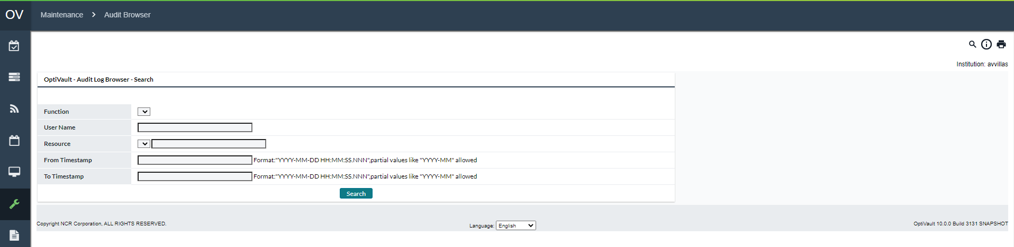

Table 86: Audit Log Browser Search Description

| Field | Description |
| --- | --- |
| **Function** | A list that is populated by the current Functions that have already been performed in the Audit Log. If the Function is not listed, it has not yet been performed. |
| **User Name** | The User Name of the person who performed the action. The search is case-sensitive, but partial word and wildcard searches are possible. |
| **Resource** | A list that is populated by the current system resources that have been accessed in the Audit Log. If the Resource is not listed, it has not yet been accessed. |
| **From/To Timestamp** | Date and time that the action was performed The user is able to enter the date, the date/time, or leave the field blank. Leaving the field blank will return all rows. For instance, if the user wanted all records after June 1, 2009, the user would enter 2009-06-01 in the From field and leave the To field blank.  The entry must conform to the correct format of YYYY-MM-DD HH:MM:SS:NNN  YYYY = Year (4 digits)  MM = Month (2 digits)  DD = Day (2 digits)  HH = Hour (2 digits)  MM = Minute (2 digits)  SS = Second (2 digits)  NNN = Nanoseconds (3 digits)  Example: June 1, 2009, at 3:15 pm would be 2009-06-01 15:15:00:0000 |

Figure 64: Audit Log Browser Search Results Page

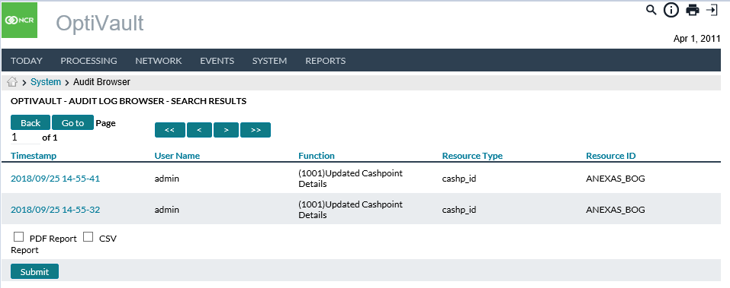

Table 87: Audit Log Browser Search Results Description

| Field | Description |
| --- | --- |
| **Go To Button** | Navigates to the page number specified in the Page field |
| **Page** | Indicates the current page currently being viewed out of the total number of pages. Changing the page number and selecting the **‘Go To’** button navigate directly to that page. |
| **Navigation (<< < > >>)** | Navigates forward or backwards to a particular page.  **<<**  First Page  **<** Back one page  **>** Forward one page  **>>** Last Page |
| **Timestamp** | Date and time stamp for the Audit Log entry. Clicking on the column header will resort to the list (ascending or descending depending on the current view).  Clicking on a Timestamp hyperlink will bring the user to the Transaction detail report. See: |
| **User Name** | User name of the person who performed the action. Clicking on the column header will resort to the list (ascending or descending depending on the current view). |
| **Function** | The function that was performed for the specific Audit Log entry. Clicking on the column header will resort to the list (ascending or descending depending on the current view). |
| **Resource Type** | The Resource type that was accessed. Clicking on the column header will resort to the list (ascending or descending depending on the current view). |
| **Resource ID** | The Resource ID that is associated with the Resource type. Clicking on the column header will resort to the list (ascending or descending depending on the current view). |

The Transaction Detail report shows more in-depth information about some transactions that are performed on the system. The Transaction detail is accessed by clicking on the Timestamp hyperlink from the Audit Log Browser Results. Not all transactions will have transaction details associated with them.

Figure 65: Audit Log Browser Transaction Detail Page

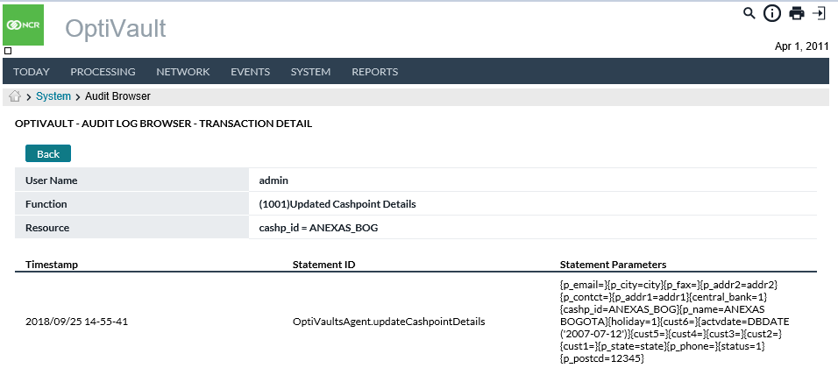

Table 88: Audit Log Browser Transaction Detail Description

| Field | Description |
| --- | --- |
| **User Name** | User name of the person who performed the action. |
| **Function** | The function that was performed for the specific Audit Log entry. |
| **Resource** | The Resource type that was accessed. |
| **Timestamp** | Date and time stamp for the Audit Log entry. |
| **Statement ID** | The action code that is associated with the database change. |
| **Statement Parameters** | Parameters executed at the database level. This will often include the most specific details on a particular action. **Example:** if a Cashpoint’s parameters are saved, this will list the new parameters submitted to the database.  **Note**: If the system administrator configures partial auditing, then Statement Parameters will be blank. |

Return To: Maintenance Tab

### Maintenance→View Logs

The View Logs function allows users to access system logs to help NCR troubleshoot problems. The users should only access this page when directed to do so by a system administrator or an NCR Support Representative.

Figure 66: Logs Page

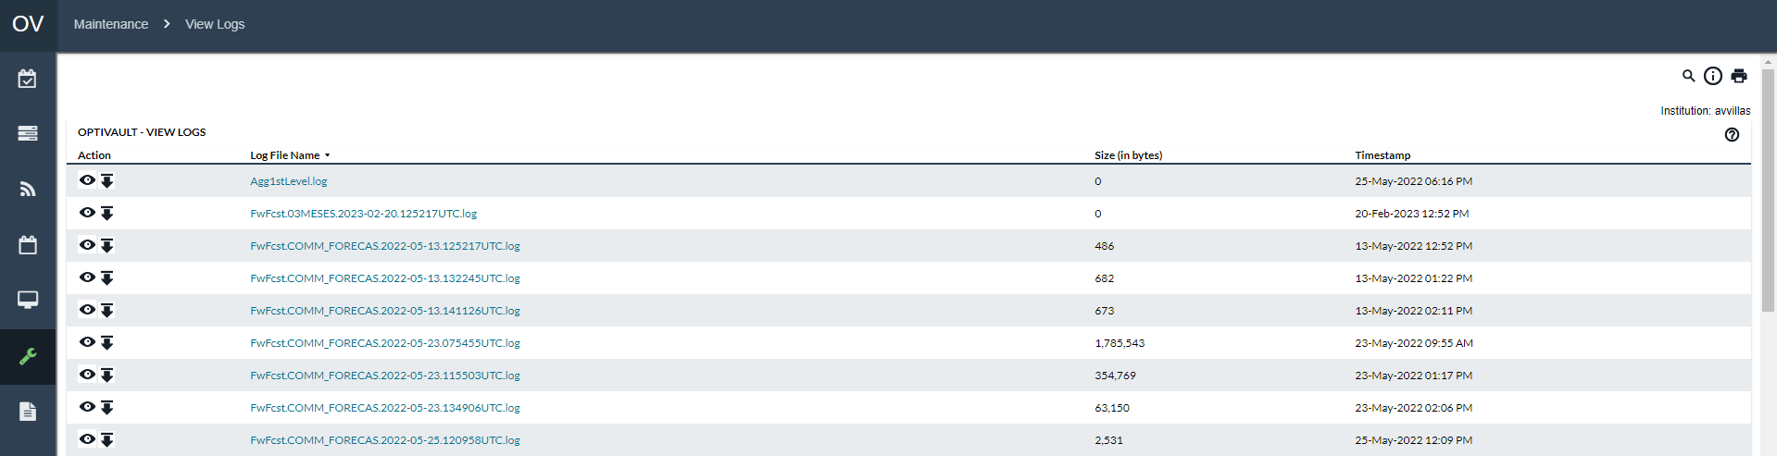

Table 89: Log Viewer Description

| Field | Description |
| --- | --- |
| **Actions** | Shows the available actions that are allowed for the given each Log File entry  - Allows the user to view the Log file in the web browser.  - Allows the user to download the Log file to the local computer which can then be opened by a text file editor.  **NOTE**: The size of the logs. Large files may take a long time to load in a web-browser or may not be visible in all text file editors. Check with your system administrator if you have questions about viewing large files. |
| **Log File Name** | Name of the log file that was generated. Clicking on the log file name will prompt the user to download it to the local computer to be viewed with a text file editor. |
| **Size** | Size of the file in bytes for each log file. |
| **Timestamp** | Timestamp of the Log file (generally this is the time the log was created, but it could also be the last time it was modified). |

Return To: Maintenance Tab

### Maintenance→About

This page gives a system summary to tell users the current version of both the software as well as the subcomponents used by the OptiVault system.

The user can see the current version and build of the application as well as access the NCR Support website. This page also displays the user’s last successful and failed login time.

This page is for informational purposes only.

Figure 67: About Page

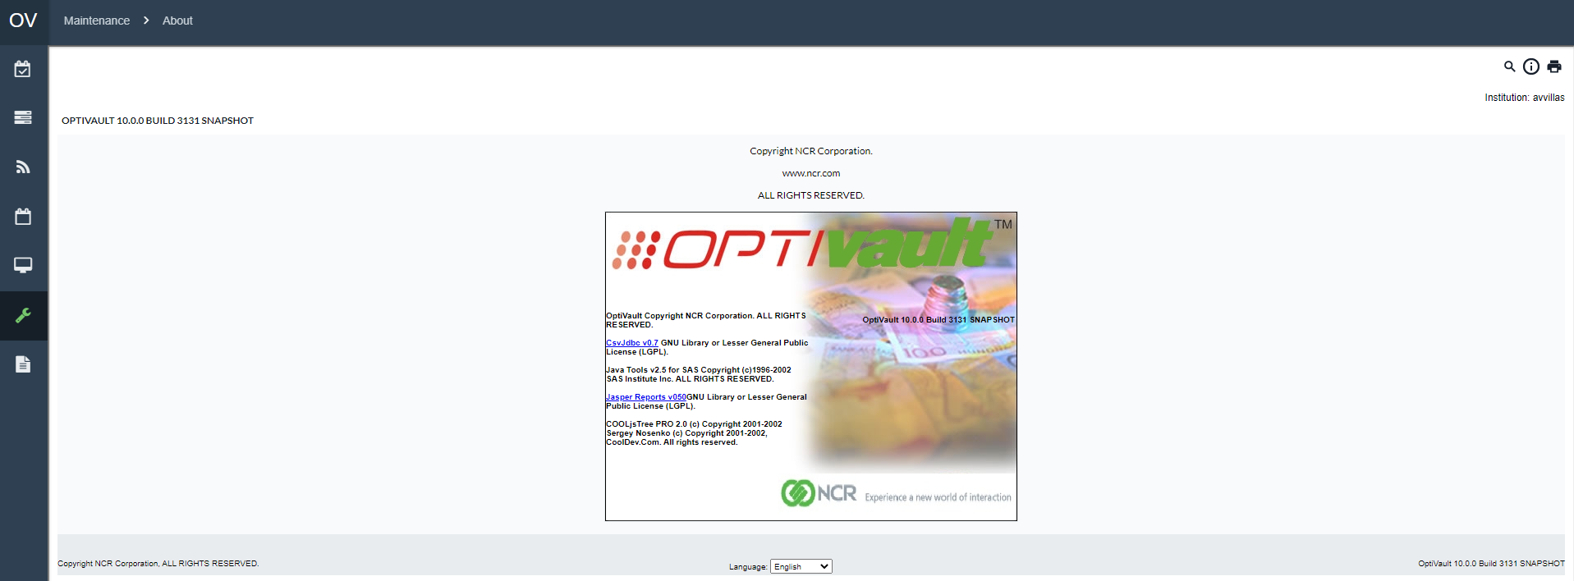

Return To: Maintenance Tab

# Reports Tab

OptiVault reporting functionality captures and presents information generated during normal processes.

The following is a summary of the information that will be covered along with hyperlinks to each topic:

* Reports Overview
* Report Basicsz
* Processing Reports
* History Reports
* Planning Reports
* Management Information Reports
* Cashpoint Reports

Return To: Introduction to the Interface

### Reports Overview

The reports are broken into 4 sections and are summarized in the table below.

Table 90: Report Summary

|  |  |
| --- | --- |
| Report Name | Report Output |
| Processing Reports | |
| Aggregation Results | Displays the results of the aggregation processing during the recommendation process |
| Aggregation Summary Results | Shows a summary of the results of the Aggregation process |
| Recommendation Results | Displays the results from the previous recommendation process run. |
| Recommendation Validation Results | Shows a summary of the results of the Recommendation Validation Process |
| Commercial Consolidation Results | Displays the results from the previous commercial consolidation process run. |
| History Reports | |
| Commercial History | Displays the commercial history of the selected Cashpoint |
| Custodial Inventory History Report | Reports the historical balances and transactions for the Custodial Inventory for the selected dates. |
| Vault Orders | Displays a report of the vault orders for the Cashpoints and dates selected. |
| Vault Recommendations | Displays a report of the vault recommendations for the Cashpoints and the dates selected. |
| Vault Variance | Displays the differences between the recommended and ordered amounts as well as the forecast and actual values for each selected Cashpoint, and denomination for the selected time period. |
| CI Position (History) | Reports the details of the Custodial Inventory History breaking down the orders by denomination and quality. |
| Provisional Credit Report | Provides a report for the Provisional Credits entered for the selected vaults and dates selected. |
| Planning Reports | |
| Forecast Results | Shows an overview of the Forecast process for all Cashpoints. |
| Forecast Health Report | Displays an overview of the forecast quality for all denominations and qualities for the selected Cashpoints. |
| Vault Forecast Details | Displays the daily details of the forecast for the denominations and qualities selected. |
| Commercial Forecast Details | Displays the daily details of the forecast for the denominations and qualities selected. |
| Horizons | Displays the horizon information for the selected vault |
| Horizons with CI | Displays the horizon information for the selected vault along with Custodial Inventory information. |
| OptiCash Aggregation Details | Shows the results of the aggregation process for the selected Cashpoints and dates. |
| CI CAP/OBMH Report | Reports the Custodial Inventory Capacity amounts for the On Book Minimum Holding for each of the selected Cashpoints and dates selected. |
| CI Position (Forecasted) | Displays the denomination details of the Custodial Inventory forecast calculations for the selected Cashpoints and dates. |
| Management Information Reports | |
| Costs (Actuals vs. Projected) | Reports the cost comparisons between the actual and projected costs. |
| Costs (Actual) | Reports the actual costs that were calculated on historical data |
| Cross-Shipping Alerts | Displays the Cross-Shipping alerts for the selected vaults. |
| Cashpoint Reports | |
| Vault Horizon Report | Displays the horizon information for the selected vault |
| Vault History Report | Displays the history report for the selected vault |
| Vault Forecast Report | Displays the Forecast Report for the selected vault |
| Commercial History Report | Displays the commercial history of the selected Cashpoint |
| Commercial Forecast Report | Displays the commercial forecast for the selected Cashpoint. |

Return To: Reports Tab

### Report Basics

All reports work in the same manner in OptiVault but provide different information for the user. In each case, the user has to select Cashpoints, Options, and Report Types and Submit the request to view the report. The basic report elements will be described in this section.

Figure 68: Report Generation Page

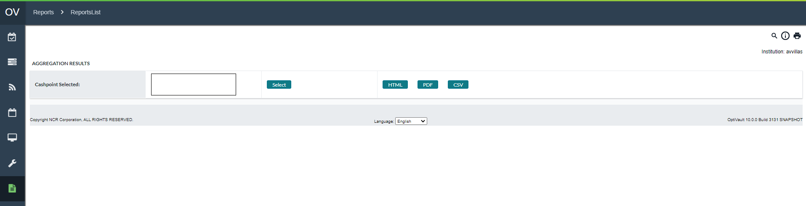

Table 91: Report Description

| Field | | Description | |
| --- | --- | --- | --- |
| **Select Button** | | Allows the user to choose Cashpoints to be included in the report. For more information on Cashpoint Selection, see: General OptiVault Pages Cashpoint Selector | |
| **Cashpoints Selected** | | A list of the Cashpoints that were selected for the specific report is listed in the box labelled **“Cashpoints Selected”** | |
| **Submit Button** | | Processes the report request using the options and Cashpoints selected. | |
| **HTML Button** | | Processes the report into an HTML report to be used in an external reporting tool | |
| **View Button** | | Processes the report request using the options and Cashpoints | |
| **Export Button** | | Exports the report into a CSV report to be used in an external reporting tool | |
|  | **Note:** If the CSV format is selected in the output options, by default the report will be saved in your ‘**dynreports’** folder (where the web application server is located). However, you can also click on the hyperlink ‘Save CSV (for import)’ to save the file to the desired location. | |

|  |  |
| --- | --- |
|  | **Note:** When running a network level report that will return a large amount of data, an error message may be received caused by memory shortage. In order to avoid this, reduce the selection of Cashpoints (for instance, if all active Cashpoints have been selected, try to select only half of the Cashpoints) or the time period (select 30 days instead of 90 days). If the error message is still displayed, the users who have administrative rights can change the Java settings in your web application server management console. Java settings must be changed by setting max heap size following specific web application instructions. After this, the server must be rebooted. |

Return To: Reports Tab

### Processing Reports

The processing reports are a summary of the Aggregation, Recommendation, and Commercial Consolidation processes.

The following is a summary of the information that will be covered along with hyperlinks to each topic:

* Aggregation Results
* Aggregation Summary Results
* Recommendation Results
* Recommendation Validation Results
* Commercial Consolidation Results
* Vault Parameters
* Vault Service Days
* Vault Service Schedule
* Vault Denominations
* Vault Service Cost
* Vault Requirements

Return To: Reports Tab

#### Aggregation Results

The Aggregation Results report is a summary of the results from each Cashpoint that aggregated data from OptiCash during the recommendation process.

Table 92: Aggregation Results Report Description

| Field | Description |
| --- | --- |
| **Generate Start Date** | Beginning date of the report. |
| **Generate End Date** | Ending Date of the report |
| **Vault ID** | The unique identifier of the vault was processed for commercial consolidation. |
| **Commercial ID** | The unique identifier of the Commercial Cashpoint was processed for commercial consolidation. |
| **Denomination** | The Denomination Description of the vault that was processed for recommendation |
| **Quality** | The quality of the denomination that was processed for recommendation |
| **Start Date** | Beginning date of the report |
| **End Date** | Ending date of the report |
| **Process Status** | Reports the success or failure of the consolidation process. |

Return To: Processing Reports

#### Aggregation Summary Results

The Aggregation Results report is a summary of the results from each Cashpoint that aggregated data from OptiCash during the recommendation process. This report is displayed as PDF or optionally in CSV format.

Table 93: Aggregation Results Report Description

| Field | Description |
| --- | --- |
| **Vault** | The unique identifier of the vault was processed for commercial consolidation. |
| **Result** | The summary result of the Vault Aggregation Process |
| **Count** | The number of Cashpoints that relate to the results and Vault ID |
| **Open In New Window Link** | Clicking on the link displays the report in a new window as opposed to in the OptiVault Report Window. |

Return To: Processing Reports

#### Recommendation Results

The Recommendation Results report is a summary of the results of each Cashpoint’s recommendation process run. There are no options that need to be selected prior to running this report. After the report has been displayed, the user will have the option to create a PDF or CSV report by clicking the option checkmarks at the bottom of the page. This report is displayed as PDF or optionally in CSV format.

Table 94: Recommendation Results Report Description

| Recommendation Last Run Results | |
| --- | --- |
| Field | Description |
| **Vault ID** | The unique identifier of the vault that was processed for recommendation |
| **Denomination** | The Denomination Description of the vault that was processed for recommendation |
| **Quality** | The quality of the denomination that was processed for recommendation |
| **Date Last Run** | The date that the recommendation process was the last run for the vault |
| **Result** | The result of the last recommendation run. |

Return To: Processing Reports

#### Recommendation Validation Results

This report shows the results of the validation process that is run before the recommendation process is run.

Table 95: Recommendation Validation Results Report Description

| Recommendation Last Run Results | |
| --- | --- |
| Field | Description |
| **Vault ID** | The unique identifier of the vault that was processed for recommendation |
| **Denomination** | The Denomination Description of the vault that was processed for recommendation |
| **Quality** | The quality of the denomination that was processed for recommendation |
| **Date** | The date that the recommendation process was the last run for the vault |
| **Error** | The error that occurred during the validation process |
| **Affected Date** | History day that relates to the error |
| **Breach Amount** | When an amount is exceeded, such as maximum capacity, the Breach Amount shows the amount of the violation. |

Return To: Processing Reports

#### Commercial Consolidation Results

This report summarizes the consolidation of Commercial Customer Cashpoints to see if any problems occurred in the consolidation process. After the report has been displayed, the user will have the option to create a PDF or CSV report by clicking the option checkmarks at the bottom of the page.

Table 96: Commercial Consolidation Results Description

| Field | Description |
| --- | --- |
| **Generate Date** | Date the report was generated. |
| **Vault ID** | The unique identifier of the vault that was processed for recommendation |
| **Commercial ID** | The Cashpoint ID of the commercial Cashpoint that relates to the report |
| **Denomination Short Name** | The denomination name being reported |
| **Quality** | The quality of the denomination being reported |
| **Start Date** | The starting date of the consolidation process |
| **End Date** | The ending date of the consolidation process |
| **Process Status** | The results of the consolidation process. |

Return To: Processing Reports

#### Vault Parameters

This Report details all parameters assigned to a vault.

Table 97: Vault Parameters Description

| Field | Description |
| --- | --- |
| **Vault** | The Cashpoint ID for the Cashpoint for which parameters are being displayed. |
| **Maximum Number of Pallets** | The Maximum number of Pallets that can be held in the Cashpoint at any given time |
| **Packaging Time** | The time (in days) that it takes for the orders to be packaged before they are sent to the Cashpoint. |
| **Clearance Time** | The time (in days) that it takes for returns from child Cashpoints to be received at processed upcoming demand. |
| **Bulk Order Reduction** | The setting that determines when orders will be available to be used for child Cashpoint demand |
| **Aggregate Emergencies Indicator** | Indicates if Emergencies from child Cashpoints will be aggregated during the recommendation process. |

Return To: Processing Reports

#### Vault Service Days

This report displays the service days that are assigned to Cashpoints and the parameters that affect deliveries and returns.

Table 98: Vault Service Days Description

| Field | Description |
| --- | --- |
| **Vault** | The Cashpoint ID for Cashpoint for which Service days are being displayed |
| **Business Days** | The days of the week that the Cashpoint is open for business |
| **End of Day Return Time** | Indicates if returns are processed at the end of the day. |
| **Required Service Days** | Indicates days that service (Delivery or Return) is required |
| **Optional Service Days** | Indicates days that service (Delivery or Return) is optional |
| **Lead Time** | The days prior to delivery that the orders must be placed |
| **Cycle** | Indicates the frequency of visits to the Cashpoint. |
| **Start Date** | Indicates the starting date for cycles that are not based on a weekly basis. |

Return To: Processing Reports

#### Vault Service Schedule

This report displays the current service schedule based on the last recommendation process. The recommendation process runs on a daily basis and as a result, the service days are determined based on the Service Days parameters and any holiday or service shifts.

Table 99: Vault Service Schedule Description

| Field | Description |
| --- | --- |
| **Start Date** | The starting date of the report |
| **End Date** | The ending date of the report |
| **Vault** | The Cashpoint ID for which Service Schedules will be displayed |
| **Vault Type** | The Cashpoint type that relates to the Vault |
| **Service Day** | Indicates the date for which details are being provided |
| **Delivery Order Day** | Indicates if the date is a delivery order day |
| **Return Order Day** | Indicates if the date is a return order day |
| **Delivery Order Date** | Indicates the date that orders must be placed to be delivered on the Delivery Day |
| **Return Order Date** | Indicates the date that orders must be placed to be returned on the Return Day |
| **Unplanned Order Day** | Indicates if the date is an unplanned delivery day |
| **Unplanned Order Date** | Indicates the date that unplanned orders must be placed to be delivered on the Unplanned Delivery Day |
| **Delivery** | Indicates if Delivery is Optional or Mandatory on this date. |
| **Return** | Indicates if Returns are Optional or Mandatory on this date |
| **Business Day** | Indicates if the date is a Business Day |
| **Holiday** | Indicates if the date is a holiday |
| **Exception** | Indicates if there is a service exception on this date. |

Return To: Processing Reports

#### Vault Denominations

This report displays all the details on the denominations assigned to Cashpoints.

Table 100: Vault Denominations Description

| Field | Description |
| --- | --- |
| **Cashpoint** | The Cashpoint ID for which denomination details are being provided |
| **Denomination** | The Denomination ID |
| **Quality** | The Quality ID that relates to the Denomination ID |
| **Denomination Description** | The description of the denomination |
| **Maximum Balance** | The maximum balance that can be held for the denomination |
| **Min Delivery** | The minimum amount that can be delivered to the Cashpoint |
| **Min Returns** | The minimum amount that can be returned from the cashpoint |
| **Min Unplanned Delivery** | The Minimum amount of unplanned deliveries that can be delivered to the  Cashpoint |
| **Order Unit** | The bundle size of the order for the denomination |
| **Recommend?** | Indications if the denomination should be Recommended for ordering during the Recommendation Process |
| **Cross Shipping?** | Indicates if Cross-Shipping penalties apply to the denomination and quality |
| **Include in Sorting?** | Indicates if the denomination is included in the sorting process. |

Return To: Processing Reports

#### Vault Service Cost

This report displays the service costs assigned to Cashpoints.

Table 101: Vault Service Cost Description

| Field | Description |
| --- | --- |
| **Vault** | The Cashpoint ID for which Service Cost details are being displayed |
| **Cashpoint Type** | The type of Cashpoint being reported |
| **Cashpoint Name** | The name of the Cashpoint |
| **Carrier** | The Name of the Default Carrier that provides service to the cashpoint |
| **Services** | The Types of services that are being reported |
| **Currency** | Currency that the delivery/service costs are associated with |
| **Max Holding Amt** | The Maximum Holding Amount for the entire Cashpoint. This is not to be confused with the holding amount for each denomination. The Maximum Holding Amount is the amount that can be held at any given time regardless of the maximum capacity of the individual denominations |
| **Currency Insurance Rate** | The Currency Insurance Rate Assigned to the Cashpoint |
| **Handling Cost** | Displays the Handling Cost |
| **Fixed Cost** | Displays the Fixed Cost that is charged for the specified service |
| **Per Defined Unit** | Displays the amount charged per unit of currency |
| **Unit Size** | Displays the unit size that relates to the Per Defined Unit |
| **Per Unit of Currency** | Displays the amount that is charged for each 1 unit of currency |
| **Amount Range** | Displays the range for which the amount that is charged Per Unit of Currency applies |

Return To: Processing Reports

#### Vault Requirements

This report displays the Vault Requirements assigned to Cashpoints for each denomination, quality, and day of the week.

Table 102: Vault Requirements Description

| Field | Description |
| --- | --- |
| **Day** | Displays the day of the week for which requirements apply. This will display All Day for standard parameters or the particular day of the week for specific requirements. |
| **Denomination** | The denomination ID being reported |
| **Quality** | The quality of the note relating to the denomination ID |
| **Cycle** | The delivery cycle that applies to the denomination ID |
| **Specific Date** | Indicates a specific date (if applicable) for which the requirements apply. |
| **Minimum Operating Balance** | Indicates the Minimum Holding Amount that should always be held for the denomination and quality |
| **E-Cash Holding Amount** | Indicates the amount of Emergency cash that should always be held for the denomination and quality. |
| **% of Withdrawals to Cover** | Indicates the percentage of withdrawals to cover the denomination and quality |
| **% of Deposits Available for Withdrawal** | Indicates the percentage of deposits available for withdrawal for the denomination and quality |
| **% of Deposits Held Until the End of the Day** | Indicates the percentage of deposits held until the end of the day for the denomination and quality |
| **% Adjustment to Forecasted Demand** | Indicates the adjustment to the forecasted demand for the denomination and quality |
| **% Adjustment to Forecasted Deposits** | Indicates the adjustment to the forecasted deposits for the denomination and quality |
| **% Adjustment to Total Requirements** | Indicates the adjustment to total requirements for the denomination and quality |
| **Exception Threshold /Balance Buffer Amount** | Indicates the amount of the Exception Threshold. If no amount is indicated, then a percentage is used. |
| **Exception Threshold / Balance Buffer Percentage** | Indicates the percentage of holdings that is applicable as the Exception Threshold. If no percentage is indicated, then an Exception Amount is applicable. |

Return To: Processing Reports

### History Reports

The following is a summary of the information that will be covered along with hyperlinks to each topic:

* Vault History
* Commercial History
* Custodial Inventory History
* Vault Orders
* Vault Recommendations
* Vault Variance
* Custodial Inventory (CI) Position (History)
* Provisional Credit Report
* Vault Transaction History
* Vault Transaction Summary - Averages
* Vault Recommendations, Orders, and Shipments

Return To: Reports Tab

#### Vault History

The Commercial History Report shows the analyst the historical data that has been loaded into the system for the selected Commercial Cashpoint. The analyst has the ability to exclude data from the forecast from this page.

Table 103: Commercial History Description

| Field | Description |
| --- | --- |
| **Denom.** | Allows the analyst to select the denomination(s) that will be shown in the report |
| **Qual.** | Quality of the denomination(s) that will be shown in the report. |
| **Start Date** | Starting date of the report |
| **End Date** | Ending date of the report |
| **Date** | Date of the reporting day |
| **Currency** | OptiVault short name of the currency to which the reported denominations are a part of |
| **Denomination** | Denomination and quality relating to the date of the report |
| **Deposits** | Deposits into the Vault for the quality and denomination of the report |
| **Withdrawals** | Withdrawals from the Vault for the quality and denomination of the report |
| **Exclude Flag** | Indicates that the record is excluded from the history. |

Return To: History Reports

#### Commercial History

The Commercial History Report shows the analyst the historical data that has been loaded into the system for the selected Commercial Cashpoint. The analyst has the ability to exclude data from the forecast from this page.

Table 104 : Commercial History Description

| Field | Description |
| --- | --- |
| **Denom.** | Allows the analyst to select the denomination(s) that will be shown in the report |
| **Qual.** | Quality of the denomination(s) that will be shown in the report. |
| **Start Date** | Starting date of the report |
| **End Date** | Ending date of the report |
| **Date** | Date of the reporting day |
| **Currency** | OptiVault short name of the currency to which the reported denominations are a part of |
| **Denomination** | Denomination and quality relating to the date of the report |
| **Deposits** | Deposits into the Vault for the quality and denomination of the report |
| **Withdrawals** | Withdrawals from the Vault for the quality and denomination of the report |
| **Exclude Flag** | Indicates that the record is excluded from the history. |

#### Custodial Inventory History

This report shows the Custodial Inventory History for a single Custodial Inventory Cashpoint. The user must first select the Cashpoint for which the report will be run, then the user can select the options and run the report.

Table 105: Custodial Inventory Report Description

| Field | Description |
| --- | --- |
| **Start Date** | Starting date of the report |
| **End Date** | Ending date of the report |
| **Denom.** | Denomination to be included in the report. The user can select all denominations or a single denomination with this option. |
| **Qual** | Quality of the denomination(s) that will be shown in the report. |
| **Denomination** | The description of the denomination in the Custodial Inventory Cashpoint |
| **Opening Balance** | The Opening Balance of the Custodial Inventory Cashpoint |
| **Cash In** | Cash Transferred into the Custodial Inventory Cashpoint. |
| **Cash out** | Cash Transferred out of the Custodial Inventory Cashpoint |
| **Closing Balance** | The Closing Balance of the Custodial Inventory Cashpoint |

Return To: History Reports

#### Vault Orders

The Vault Order report allows the OptiVault analyst to list all orders that have been generated for a specific vault or all the vaults assigned to a user. Fields in this report are automatically populated from committed recommendations or manual orders placed by the analyst.

Table 106: Vault Orders Report Description

| Field | Description |
| --- | --- |
| **Vault ID** | The unique identifier for the Cashpoint |
| **Funding Source** | The Cashpoint ID of the vault that will supply the cash to the vault |
| **Report Sorted by** | Determines the way the report is displayed.  The available options are:   * Due Date * Order Date |
| **Start Date** | Starting date of the report |
| **End Date** | Ending date of the report |
| **Action** | The type of service that will be performed for the corresponding Cashpoint |
| **Conf #** | The confirmation number of the order |
| **Order Date** | The date the order was placed |
| **Order Src.** | The status of the order source. |
| **Denom.** | Denomination ID of the order |
| **Amount** | The amount of the order |

Return To: History Reports

#### Vault Recommendations

The vault Recommendations report allows the analyst to list all recommendations that have been generated for a specific vault or all vaults assigned to the user. The recommendation process automatically populates the tables related to the recommendations. There is no other way in OptiVault to create a recommendation. In situations where no recommendations are created, the user will be able to create a manual order, if necessary, but this new record will be treated as an order, not a recommendation.

Table 107: Vault Recommendations Report Description

| Field | Description |
| --- | --- |
| **Vault ID** | The unique identifier for the Cashpoint |
| **Start Date** | Starting date of the report |
| **End Date** | Ending date of the report |
| **Action** | The type of service that will be performed for the corresponding Cashpoint |
| **Due Date** | The date the recommendation is scheduled to be completed if the order is completed |
| **Funding Source** | The funding Cashpoint ID for the recommendation. |
| **Denomination** | Denomination ID of the order |
| **Amount** | The amount of the order |
| **Total Amount** | A summary record is shown at the end of each Cashpoint’s recommendations to show the total amount of the orders. |

Return To: History Reports

#### Vault Variance

This report helps control the difference between what has been recommended and the orders that have been placed. This report will also monitor the difference between the forecast(aggregation) versus the actual data.

**Note**: The report will allow the user to filter the difference based on the percentage(%) between recommendations and orders to make the report easier to handle when dealing with large amounts of data.

Table 108: Vault Variance Report Description

| Field | Description |
| --- | --- |
| **Vault ID** | The unique identifier for the Cashpoint |
| **Start Date** | Starting date of the report |
| **End Date** | Ending date of the report |
| **Schedule** | The type of schedule related to the order.  The available types are:   * Planned * Unplanned |
| **Action** | The type of service that will be performed for the corresponding Cashpoint  The available actions are:   * Delivery * Return |
| **Funding Source** | The Cashpoint ID of the vault that will supply the cash to the Cashpoint |
| **Min Variance Percent** | Allows the report to be filtered by selecting the minimum variance percentage. Valid entries should be 0 to 100 |
| **Max Variance Percent** | Allows the report to be filtered by selecting the maximum variance percent. Valid entries should be 0 to 100. |
| **Denom.** | Represents the vault-denomination value. |
| **Date** | Date when the recommendations were placed. |
| **Recommended Order** | Recommendation generated by OptiVault. |
| **Ordered** | Actual order committed by the user. |
| **History** | The historical order committed by the user. This number is directly taken from the Vault History Report. |
| **Difference** | Variation between the recommended order vs. the actual order. The calculation is: [(Recommended Order - Actual Order)]/[Recommended Order]. |
| **Diff. Percentage** | % Representation of the difference between recommendations and Actual Orders. |
| **Forecast Demand** | Predicted demand. Demand = Deposits (aggregated Returns) – Withdrawals (aggregated Deliveries) |
| **Actual Demand** | Actual demand. Demand = Deposits (Actual aggregated Returns) – Withdrawals (Actual aggregated Deliveries) |
| **Difference** | Variation between the Forecasted Demand Vs the Actual Net Demand. The calculation is: [(Recommended Order - Actual Order)]/[Recommended Order]. |
| **Diff. Percentage** | Variation, in percentages, between the Forecasted Demand Vs the Actual Net Demand. |

Return To: History Reports

#### Custodial Inventory (CI) Position (History)

Custodial Inventory can be thought of as a holding area of cash that a center may use to keep cash off-book (meaning it does not show up in the official cash center balances). There are rules that limit how much cash can be put into the Custodial Inventory and how much the center must have in its balance before it can be put cash into the Custodial Inventory. Because of this, it is important that the Custodial Inventory be controlled by OptiCash to ensure the best possible optimization.

Table 109: CI Position History Report Description

| Field | Description |
| --- | --- |
| **Vault ID** | The unique identifier for the Cashpoint |
| **Report Date** | The date for which the report will be ran |
| **Denominations** | The denominations for which balances will be reported |

Return To: History Reports

#### Provisional Credit Report

Provisional Credits are entered at the Cashpoint level and used when there are funds within the Vault that were not reported in the balances. These credits are used to add to the vault’s overall balances to ensure the correct calculations are made for the Custodial Inventory calculations.

Table 110: Provisional Credit Report Description

| Field | Description |
| --- | --- |
| **Vault ID** | The unique identifier for the Cashpoint |
| **Start Date** | The starting date of the report |
| **End Date** | The ending date of the report |
| **Date** | Date of the Provisional Credit entry |
| **Amount** | The amount of the provisional credit |

Return To: History Reports

#### Vault Transaction History

This report is used to give a daily summary of transaction history between Cashpoints.

Table 111: Vault Transaction History Description

| Field | Description |
| --- | --- |
| **Date** | The date of the reported cash transactions |
| **Cash In** | The total amount of cash that came into the Cashpoint |
| **Cash Out** | The total amount of cash that left the Cashpoint to service child Cashpoint demand |
| **Fed In** | The total amount of cash that was brought into the Cashpoint from the Fed |
| **Fed Out** | The total amount of cash that was sent back to the Fed from the Cashpoint |

Return To: History Reports

#### Vault Transaction Summary - Averages

This report gives an average, minimum and maximum of the cash transactions that occurred during a selected period.

Table 112: Vault Transaction Summary Description

| Field | Description |
| --- | --- |
| **Denomination** | The denomination ID being reported |
| **Cash In** | Cash that is coming into the Cashpoints from child Cashpoints |
| **Cash Out** | Cash going out to service the demand for child Cashpoints |
| **Fed In** | Cash coming into the Cashpoint from the Fed |
| **Fed Out** | Cash going out to the Fed from the Cashpoint |
| **Minimum** | The minimum amount of cash transactions for the period selected |
| **Maximum** | The maximum amount of cash transactions for the period selected |
| **Average** | The average amount of cash transactions for the period selected |

Return To: History Reports

#### Vault Recommendations, Orders, and Shipments

This report gives a summary of the orders and shipments that were recommended as well as ordered for a specific period.

Table 113: Vault Recommendations, Orders, and Shipments Description

| Field | Description |
| --- | --- |
| **Orders Count** | The total number of orders placed during the period selected was broken down by the different funding sources |
| **Orders Amount** | The total amount ordered during the period selected is broken down by the different funding sources. |
| **Shipments Count** | The total number of shipments during the period selected was broken down by the different funding sources |
| **Shipments Amount** | The total amount shipped during the period selected was broken down by the different funding sources |
| **Active Vaults** | Total number of Vaults active during the period selected. |

Return To: History Reports

### Planning Reports

The following is a summary of the information that will be covered along with hyperlinks to each topic:

* Forecast Results
* Forecast Health
* Vault Forecast Details
* Vault Forecast Summary
* Commercial Forecast Details
* Commercial Forecast Summary
* Horizons
* Horizons With CI
* OptiCash Aggregation Details
* Custodial Inventory Cap/On Book Minimum (CI CAP/OBMH) Report
* Custodial Inventory (CI) Position (Forecasted)

Return To: Reports Tab

#### Forecast Results

This report shows the forecast for all Cashpoints assigned to the user. There are no parameters to enter for this report. Clicking on the link from the reports table will automatically produce and display the report. Additionally, this report does not have the option to output as a PDF or CSV file.

Table 114: Forecast Results Report Description

| Field | Description |
| --- | --- |
| **Cashpoint ID** | The unique identifier for the Cashpoint |
| **Cashpoint Type** | Type of Cashpoint relating to the Cashpoint ID |
| **Status** | The status of the Forecast |
| **Process Executed On** | The date corresponding to the last time the forecast process was run for the Cashpoint. |
| **Forecast Exists Through** | The last day for which forecast records exist |
| **Forecast From** | Starting day of the forecast |
| **Forecast To** | Ending day of the forecast |
| **History From** | Starting day of the history used to forecast the Cashpoint |
| **History To** | Ending day of the history used to forecast the Cashpoint |
| **Horizon ID** | The Forecast Horizon ID used to forecast the Cashpoint. |

Return To: Planning Reports

#### Forecast Health

This report is a summary of the Forecast Health for a specific Cashpoint or all Cashpoints assigned to the user.

Table 115: Forecast Health Report Description

| Field | Description |
| --- | --- |
| **Cash Point** | The unique identifier for the Cashpoint. The analyst has the option to report on a single Cashpoint or **‘All’** Cashpoints |
| **Min %** | Allows the report to be filtered by selecting the minimum variance percentage. Valid entries should be 0 to 100 |
| **Max %** | Allows the report to be filtered by selecting the maximum variance percent. Valid entries should be 0 to 100. |
| **Denomination** | The denomination and quality of the forecast relating to the Cashpoint |
| **Cashpoint Type** | Type of Cashpoint relating to the Cashpoint ID |
| **Action** | The type of forecast performed.  The available options will be:   * Withdrawals * Deposits * Net Demand |
| **Forecast Health** | A percentage ranging from 0 to 100 that represents the quality of the forecast with 0 being poor and 100 being perfect. |

Return To: Planning Reports

#### Vault Forecast Details

The Vault Forecast Details report gives the analyst the forecasted amounts for the selected Cashpoints and options.

Table 116: Vault Forecast Details Report Description

| Field | Description |
| --- | --- |
| **Vault ID** | The Cashpoint ID of the vault being displayed in the report |
| **Date** | Date of the forecast record |
| **Denomination** | Denomination ID for the associated date |
| **Quality** | Quality of the denomination for the associated date |
| **Cash In** | Forecast and Actual amounts for cash into the Cashpoint |
| **Cash Out** | Forecast and Actual amounts for cash out of the Cashpoint |
| **Net Demand** | Forecast and Actual amounts for the Net Demand of the Cashpoint |
| **Total** | The total amount of the day reported |
| **Average** | The average amount for each category on the day reported. |

Return To: Planning Reports

#### Vault Forecast Summary

This report gives a summary comparison of the forecast versus the actual cash transactions for the selected Cashpoints.

Table 117: Vault Forecast Summary Description

| Field | Description |
| --- | --- |
| **Forecast Type** | Allows the user to specify the type of Forecast to display. This can be one of the following options:   * **Total Vault Summary –** Summarizes all Forecast Type categories * **Branch Summary –** Summarizes all Branch Forecasts * **ATM Summary –** Summarizes all ATM Forecasts * **Vault Summary –** Summarizes all Vault Forecasts |
| **Cash In - Forecast** | Displays the amount of cash that was Forecasted to come into the Cashpoint from child Cashpoints. |
| **Cash In – Actual** | Displays the actual amount of cash that was brought into the Cashpoint from child Cashpoints |
| **Cash Out – Forecast** | Displays the amount of cash that was Forecasted to go out to child Cashpoints to service demand. |
| **Cash Out – Actual** | Displays the actual amount of cash that was sent to child Cashpoints to service demand |
| **Net Demand – Forecast** | Displays the forecasted amount of cash Net Demand |
| **Net Demand - Actual** | Displays the actual amount of cash Net Demand. |

Return To: Planning Reports

#### Commercial Forecast Details

The Commercial Forecast Details report gives the analyst the forecasted amounts for the selected Cashpoints and options.

Table 118: Commercial Forecast Details Report Description

| Field | Description |
| --- | --- |
| **Vault ID** | The Cashpoint ID of the vault being displayed in the report |
| **Date** | Date of the forecast record |
| **Denomination** | Denomination ID for the associated date |
| **Quality** | Quality of the denomination for the associated date |
| **Cash In** | Forecast and Actual amounts for cash into the Cashpoint |
| **Cash Out** | Forecast and Actual amounts for cash out of the Cashpoint |
| **Net Demand** | Forecast and Actual amounts for the Net Demand of the Cashpoint |
| **Total** | The total amount of the day reported |
| **Average** | The average amount for each category on the day reported. |

Return To: Planning Reports

#### Commercial Forecast Summary

Table 119: Commercial Forecast Summary Description

| Field | Description |
| --- | --- |
| **Deposit - Forecast** | Displays the total and average of the denomination that was forecasted to be deposited during the selected period |
| **Deposit – Actual** | Displays the total and average actual amount of the denomination that was deposited during the selected period |
| **Withdrawals – Forecast** | Displays the total and average of the denomination that was forecasted to be withdrawn during the selected period |
| **Withdrawals – Actual** | Displays the total and average actual amount that was withdrawn during the selected period |
| **Net Demand – Forecast** | Displays the total and average Net Demand of the denomination that was forecasted during the selected period |
| **Net Demand - Actual** | Displays the total and average actual Net Demand that was reported during the selected period. |

Return To: Planning Reports

#### Horizons

The Vault Horizon Report shows the analyst the currently planned horizon for the vault based on the last recommendation process run. This information is used to view the potential balances and deliveries for the upcoming 45 days to help the analyst view the future needs of the vault and the expected deliveries.

Table 120: Vault Horizon Description

| Field | Description |
| --- | --- |
| **Start Date** | Starting date of the report |
| **End Date** | Ending date of the report |
| **Display CI** | When selected displays the Custodial Inventory entries along with the Cashpoint’s Horizon |
| **Submit Button** | Submits the report to be displayed based on the selected options. |
| **Currency** | OptiVault short name of the currency to which the reported denominations are a part of |
| **Denom.** | Vault Denomination |
| **Opening Bal.** | Vault Opening Balance on the given date |
| **Normal Del.** | Normal Deliveries to the Vault from all funding sources EXCEPT OptiCash Cashpoints. |
| **CI Norm.Del.** | Normal Deliveries to the Vault from Custodial Inventory. |
| **Normal Ret.** | Normal Returns from the Vault to all funding sources EXCEPT OptiCash Cashpoints. |
| **CI Norm.Ret.** | Normal Returns from the Vault to Custodial Inventory. |
| **Unpl. Del.** | Emergency Deliveries to the Vault from all funding sources EXCEPT OptiCash Cashpoints. |
| **CI Unpl.Del.** | Emergency Deliveries to the Vault from Custodial Inventory. |
| **Unpl. Ret.** | Emergency Returns from the Vault to all funding sources EXCEPT OptiCash Cashpoints. |
| **CI Unpl.Ret.** | Emergency Returns from the Vault to Custodial Inventory. |
| **Agg. Ret.** | Aggregate Returns to the Vault from the attached OptiCash Cashpoints |
| **Agg. Ord.** | Aggregate Orders from the Vault to attached OptiCash Cashpoints |
| **Tot. Net Dem.** | Net Demand on the Vault for the given date |
| **Closing Bal.** | Vault Closing Balance on the given date |
| **Reqd. Bal.** | Vault Required Balance on the given date |
| **Denom.** | Vault Denomination |
| **Opening Bal.** | Vault Opening Balance on the given date |
| **Normal Del.** | Normal Deliveries to the Vault from all funding sources EXCEPT OptiCash Cashpoints. |
| **CI Norm.Del.** | Normal Deliveries to the Vault from Custodial Inventory. |

Return To: Planning Reports

#### Horizons With CI

The Vault Horizon Report shows the analyst the currently planned horizon for the vault based on the last recommendation process run. This information is used to view the potential balances and deliveries for the upcoming 45 days to help the analyst view the future needs of the vault and the expected deliveries.

Table 121: Vault Horizon Description

| Field | Description |
| --- | --- |
| **Start Date** | Starting date of the report |
| **End Date** | Ending date of the report |
| **Display CI** | When selected displays the Custodial Inventory entries along with the Cashpoint’s Horizon |
| **Submit Button** | Submits the report to be displayed based on the selected options. |
| **Currency** | OptiVault short name of the currency to which the reported denominations are a part of |
| **Denom.** | Vault Denomination |
| **Opening Bal.** | Vault Opening Balance on the given date |
| **Normal Del.** | Normal Deliveries to the Vault from all funding sources EXCEPT OptiCash Cashpoints. |
| **CI Norm.Del.** | Normal Deliveries to the Vault from Custodial Inventory. |
| **Normal Ret.** | Normal Returns from the Vault to all funding sources EXCEPT OptiCash Cashpoints. |
| **CI Norm.Ret.** | Normal Returns from the Vault to Custodial Inventory. |
| **Unpl. Del.** | Emergency Deliveries to the Vault from all funding sources EXCEPT OptiCash Cashpoints. |
| **CI Unpl.Del.** | Emergency Deliveries to the Vault from Custodial Inventory. |
| **Unpl. Ret.** | Emergency Returns from the Vault to all funding sources EXCEPT OptiCash Cashpoints. |
| **CI Unpl.Ret.** | Emergency Returns from the Vault to Custodial Inventory. |
| **Agg. Ret.** | Aggregate Returns to the Vault from the attached OptiCash Cashpoints |
| **Agg. Ord.** | Aggregate Orders from the Vault to attached OptiCash Cashpoints |
| **Tot. Net Dem.** | Net Demand on the Vault for the given date |
| **Closing Bal.** | Vault Closing Balance on the given date |
| **Reqd. Bal.** | Vault Required Balance on the given date |
| **Denom.** | Vault Denomination |
| **Opening Bal.** | Vault Opening Balance on the given date |
| **Normal Del.** | Normal Deliveries to the Vault from all funding sources EXCEPT OptiCash Cashpoints. |
| **CI Norm.Del.** | Normal Deliveries to the Vault from Custodial Inventory. |

Return To: Planning Reports

#### OptiCash Aggregation Details

This report gives users a detailed breakdown of the aggregation that was performed from OptiCash into OptiVault for a single vault.

Table 122: OptiCash Aggregation Details Report Description

| Field | Description |
| --- | --- |
| **Vault ID** | The unique identifier for the Cashpoint |
| **Start Date** | The starting date of the report |
| **End Date** | The ending date of the report |
| **Qual** | Quality of the denominations that will be reported |
| **Date** | Date of the entry |
| **Cashpoint** | The Cashpoint ID of the Cashpoint being aggregated |
| **Denom** | Denomination being reported |
| **Forecasted ATM/Branch Return** | Aggregated return values from the ATM and Branch Cashpoints |
| **Actual ATM/Branch Return** | Actual return values from the ATM and Branch Cashpoints |
| **Forecast ATM/Branch Delivery** | Aggregated delivery values from the ATM and Branch Cashpoints |
| **Actual ATM/Branch Delivery** | Actual delivery values from the ATM and Branch Cashpoints |
| **Submit Button** | Generates the report based on the selected options. |

Return To: Planning Reports

#### Custodial Inventory Cap/On Book Minimum (CI CAP/OBMH) Report

The CI CAP/OBMH Report allows the analyst to view a combination of history and predicted horizon for Custodial Inventory Cashpoints and they are On Book Minimum Holding and Cap figures.

Table 123: CI CAP/OBMH Report Description

| Field | Description |
| --- | --- |
| **Start Date** | Starting date of the report |
| **End Date** | Ending date of the report |
| **View Button** | Submits the report to be displayed based on the Cashpoint IDs and dates selected. |
| **CI ID(s)** | Custodial Inventory Vault ID. |
| **Date** | Date to which the remaining balance columns apply. |
| **OBMH** | On Book Minimum Holdings |
| **Total Verified** | Balance of all verified vault cash |
| **Off-site Verified** | Total required off-site emergency cash |
| **On-site Verified** | All verified vault cash less off-site cash |
| **CI Denominations (Verified)** | Balance of verified CI denominations |
| **Off-site CI Verified** | Total required off-site emergency cash in CI denominations |
| **On-site CI Verified** | Verified CI less off-site CI cash |
| **CI Ratio** | The ratio of verified CI denominations to all verified on-site vault cash |
| **Unverified** | Unverified cash |
| **Fed Credit** | Fed Credit is calculated by applying the CI Ratio to unverified cash |
| **CI Credit** | Sum of verified CI denominations and the Fed Credit for unverified cash |
| **Actual CI** | Historically recorded Custodial Inventory closing balance |
| **CI Cap** | Custodial inventory calculated constraint |
| **Predicted** | Indicates if the balance information for this date is actual or forecasted. |
| **Total Credit** | Total credit towards CI Minimum Holdings less OBMH |
| **Remaining CI** | The CI Cap less the actual CI Balance |
| **Recommended** | Recommended transfer to or removal from Custodial inventory based on the Total Credit vs. the Remaining CI |

Return To: Planning Reports

#### Custodial Inventory (CI) Position (Forecasted)

This report is similar to the Custodial Inventory (CI) Position History Report but along with the actual historic data, the projected data is displayed with it. This allows the analyst to see what the projections were versus the actual data.

Table 124: CI Position Forecasted Report Description

| Field | Description |
| --- | --- |
| **Vault ID** | The unique identifier for the Cashpoint |
| **Start Date** | The starting date of the report |
| **End Date** | The ending date of the report |
| **Date** | Date of the Provisional Credit entry |
| **Amount** | The amount of the provisional credit |
| **Submit Button** | Generates the report based on the selected options. |

Return To: Planning Reports

#### Trading Market Order Matching

The report displays recommendations (delivery & return) arranged to facilitate the recognition of opportunities to serve a vault’s need with another vault’s excess.

The report can be filtered by Cashpoint ID, Date Range, Currency, and Orders or Recommendations.

Table 125: Trading Market Order Matching Field Descriptions

| Field | Description |
| --- | --- |
| **Vault ID** | Identifies the Vault with the Need for Cash |
| **Denomination** | Denomination Ordered or Recommended |
| **Quality** | Cash quality of the order being matched |
| **Source** | Cashpoint ID of the potential Trading Market Funding Source for the need |
| **Order Date / Due Date** | Dates the Order is placed in the system and the corresponding Due Date |
| **Emergency Delivery Amount (funding source)** | Amount of Cash if an Emergency Delivery |
| **Delivery Amount (funding source)** | Amount of Cash if a Normal Delivery |
| **Return Amount (funding source)** | Amount of Cash if a Normal Return |

Return To: Planning Reports

### Management Information Reports

The following is a summary of the information that will be covered along with hyperlinks to each topic:

* Costs (Actual Vs. Projected)
* Costs (Actual)
* Total Carrier
* History Vault Stock Holding
* Forecast Vault Stock Holding
* Commercial and Branch Historical
* ATM & Branch Demand
* Cross-Shipping Alerts

Return To: Reports Tab

#### Costs (Actual Vs. Projected)

This report allows the analyst to compare the Actual costs incurred versus the Projected costs that were calculated in the past. In this way, the analyst can use this data to help fine-tune the Cashpoints and help improve the performance and optimization of the network.

Table 126: Costs Actual vs. Projected Report Description

| Field | Description |
| --- | --- |
| **Select Button** | Allows the user to choose Cashpoints to be included in the report. For more information on Cashpoint Selection, Cashpoint Selector |
| **Start Date** | Starting date of the report |
| **End Date** | Ending date of the report |
| **Time Period** | Determines how the report is displayed and summarized.  The available options are:   * Daily * Monthly   Additionally, the type of summary can be displayed  The available summary options are:   * **Network Summary –** Summarizes the entire network based on the Cashpoints selected * **Detail –** Provides daily details for each Cashpoint and each day * **Depot Summary –** Summarizes the report by depot based on the Cashpoints and dates selected * **Cashpoint Summary –** Summarizes the report by Cashpoint based on the Cashpoints and dates selected |
| **Denomination** | Allows the analyst to select ‘All’ denominations or one particular denomination |
| **Quality** | Displays the quality of the denominations selected or ‘All’ Qualities. |
| **Currency** | OptiVault reflects the currency that the denomination(s) being reported is associated with |
| **Cashpoint ID** | Unique alphanumeric identification of the Cashpoint. |
| **Balance Cost** | Balance cost details will give an overview of costs associated with cash being held in a Cashpoint. Balance Costs are the sum of the following costs:  Balance Cost = Holding Cost + Insurance Cost + Out-of-Cash Cost  **Holding Costs** - costs associated with holding too much cash (for instance, lost potential savings from interest rates).  Holding Costs = (Closing Balance x Interest Rate %) / Number of Days in a Year x Days Cash is Held in Cashpoint  **Insurance Costs** are based on currency insurance rate that is charged to insure funds kept in Cashpoints.  Insurance Costs = (Closing Balance x Insurance Rate %) / Number of Days in a Year  **Out-of-Cash Costs**: any costs associated with out-of-cash indicated by the cost set by the institution such as penalty, admin fee, etc.  Out-of-Cash Costs = Cost per Outage Amount x Number of Outages\*,  \*where Outage is when Closing Balance is less than the threshold amount defined in *Processing tab à Cost Calculation à Cost Options*. |
| **Carrier Cost** | Carrier costs will display the costs associated with a delivery or return service, including handling, fixed and variable costs. These costs are defined at a Cashpoint level under the *Advanced tab à Costs*.  **Handling Costs**: Total internal costs associated with the processing/handling of cash delivery. This may include the value of employees’ time required during the delivery, and any other overhead or administrative costs (defined as Delivery and Return Handling Costs for branches, Replenishment Costs for ATMs).  **Fixed Costs**: cost per delivery regardless of the amount of cash being transported.  **Variable Costs**: costs based on the amount of cash being transported. In some cases, variable costs may be on a sliding scale or range (defined by the Range button).  Carrier Costs = (Handling Costs + Fixed Costs + Variable Costs) x Number of Deliveries |
| **Dead Money Cost** | Dead money costs are associated with transit costs, i.e., costs of ‘dead cash’ while being in transit.  Dead Money Costs = (Delivery Amount x Interest Rate %) / Number of Days in a Year x Delivery Time\* + (Return Amount x Interest Rate %) / Number of Days in a Year x Return Time\*  \*number of days for Return and Delivery Time defined in *Processing tab à Cost Calculation à Cost Options.* |
| **Total Cost** | Total costs will be the sum of all the costs in the above categories. |

Return To: Management Information Reports

#### Costs (Actual)

This report will show a breakdown of the actual costs incurred as calculated by OptiVault for one or a number of Cashpoints, denominations, and qualities.

Table 127: Costs Actual Report Description

| Field | Description |
| --- | --- |
| **Select Button** | Allows the user to choose Cashpoints to be included in the report. For more information on Cashpoint Selection, Cashpoint Selector |
| **Start Date** | Starting date of the report |
| **End Date** | Ending date of the report |
| **Time Period** | Determines how the report is displayed and summarized.  The available options are:   * Daily * Monthly   Additionally, the type of summary can be displayed  The available summary options are:   * **Network Summary –** Summarizes the entire network based on the Cashpoints selected * **Detail –** Provides daily details for each Cashpoint and each day * **Depot Summary –** Summarizes the report by depot based on the Cashpoints and dates selected * **Cashpoint Summary –** Summarizes the report by Cashpoint based on the Cashpoints and dates selected |
| **Denomination** | Allows the analyst to select ‘All’ denominations or one particular denomination |
| **Quality** | Displays the quality of the denominations selected or ‘All’ Qualities. |
| **Cashpoint ID** | Unique alpha-numeric identification of the Cashpoint. |
| **Currency** | OptiVault reflects the currency that the denomination(s) being reported is associated with |
| **Balance Cost** | Balance cost details will give an overview of costs associated with cash being held in a Cashpoint. Balance Costs are the sum of the following costs:  Balance Cost = Holding Cost + Insurance Cost + Out-of-Cash Cost  **Holding Costs** - costs associated with holding too much cash (for instance, lost potential savings from interest rates).  Holding Costs = (Closing Balance x Interest Rate %) / Number of Days in a Year x Days Cash is Held in Cashpoint  **Insurance Costs** are based on currency insurance rate that is charged to insure funds kept in Cashpoints.  Insurance Costs = (Closing Balance x Insurance Rate %) / Number of Days in a Year  **Out-of-Cash Costs**: any costs associated with out-of-cash indicated by the cost set by the institution such as penalty, admin fee, etc.  Out-of-Cash Costs = Cost per Outage Amount x Number of Outages\*,  \*where Outage is when Closing Balance is less than the threshold amount defined *in Processing tab à Cost Calculation à Cost Options.* |
| Carrier Cost | Carrier costs will display the costs associated with a delivery or return service, including handling, fixed and variable costs. These costs are defined at a Cashpoint level under the *Advanced tab à Costs*.  **Handling Costs**: Total internal costs associated with the processing/handling of cash delivery. This may include the value of employees’ time required during the delivery, and any other overhead or administrative costs (defined as Delivery and Return Handling Costs for branches, Replenishment Costs for ATMs).  **Fixed Costs**: cost per delivery regardless of the amount of cash being transported.  **Variable Costs**: costs based on the amount of cash being transported. In some cases, variable costs may be on a sliding scale or range (defined by the Range button).  Carrier Costs = (Handling Costs + Fixed Costs + Variable Costs) x Number of Deliveries |
| Dead Money Cost | Dead money costs are associated with transit costs, i.e., costs of **‘dead cash’** while being in transit.  Dead Money Costs = (Delivery Amount x Interest Rate %) / Number of Days in a Year x Delivery Time\* + (Return Amount x Interest Rate %) / Number of Days in a Year x Return Time\*  \*number of days for Return and Delivery Time defined in Processing tab à Cost Calculation à Cost Options. |
| Total Cost | Total costs will be the sum of all the costs in the above categories. |

Return To: Management Information Reports

#### Total Carrier

This report allows the analyst to view and compare a summary of balances and transactions by date for one or a number of Cashpoints as well as denominations and quality.

Table 128: Total Carrier Report Description

| Field | Description |
| --- | --- |
| **Start Date** | Starting date of the report |
| **End Date** | Ending date of the report |
| **Cash Point** | Cashpoints that will be selected for the report.  One or several Cashpoints may be selected. To select more than one Cashpoint, hold down the CTRL button while clicking the Cashpoints |
| **Denom** | Denominations that will be selected for the report.  One or several Denominations may be selected. To select more than one denomination, hold down the CTRL button while clicking the Denominations |
| **Qual** | Qualities that will be selected for the report.  One or several Denomination qualities may be selected. To select more than one quality, hold down the CTRL button while clicking the Quality. |
| **History Date** | Date in history for the Cashpoints selected |
| **Denomination** | Denomination and quality that is being reported |
| **Opening Balance** | Combined opening balance for the Cashpoints selected |
| **Normal Delivery** | Normal Deliveries for the Cashpoints selected |
| **Normal Return** | Normal Returns for the Cashpoints selected |
| **Emergency Del** | Emergency Deliveries for the Cashpoints selected |
| **Emergency Ret** | Normal Returns for the Cashpoints selected |
| **Agg. Ret** | Aggregated Returns for the Cashpoints selected |
| **Agg Ord** | Aggregated Orders for the Cashpoints selected |
| **Net Demand** | Total Net Demand for the Cashpoints selected |
| **Closing Balance** | Total closing balance for the Cashpoints selected |

Return To: Management Information Reports

#### History Vault Stock Holding

This report allows the analyst to view Historic holding amounts for one or a number of Cashpoints. The report displays a summary total of holdings by date and quality for all Cashpoints selected. This report is only available in PDF or CSV.

Table 129: History Vault Stock Holding Report Description

| Field | Description |
| --- | --- |
| **Start Date** | Starting date of the report |
| **End Date** | Ending date of the report |
| **Cash Point** | The Cashpoint ID that will be reported |
| **Balance Date** | Date of the reported entry |
| **Denomination** | Denomination and Quality on the reporting date |
| **Stock Holding** | The total holding amount is based on the Cashpoints selected. |

Return To: Management Information Reports

#### Forecast Vault Stock Holding

This report allows the analyst to view future forecasted Holding amounts for one or a number of Cashpoints. This report is only available in PDF or CSV.

Table 130: Forecast Vault Stock Holding Report Description

| Field | Description |
| --- | --- |
| **Start Date** | Starting date of the report |
| **End Date** | Ending date of the report |
| **Cash Point** | The Cashpoint ID that will be reported |
| **Balance Date** | Date of the reported entry |
| **Denomination** | Denomination and Quality on the reporting date |
| **Stock Holding** | The total holding amount is based on the Cashpoints selected. |

Return To: Management Information Reports

#### Commercial and Branch Historical

This report allows the analyst to view a summary of Historic Branch and Commercial Net Demand by month for one or a number of Cashpoints. This report is only available in PDF or CSV.

Table 131: Commercial and Branch Historical Report Description

| Field | Description |
| --- | --- |
| **Start Date** | Starting date of the report |
| **End Date** | Ending date of the report |
| **Cash Point** | The Cashpoint ID that will be reported |
| **Month and Year** | Month and year of the reported summary |
| **Denomination** | Denomination on the reporting month |
| **Deposits** | Total Deposits for the selected Cashpoints during the month and year reported |
| **Withdrawals** | Total Withdrawals for the selected Cashpoints during the month and year reported. |

Return To: Management Information Reports

#### ATM & Branch Demand

This report allows the analyst to view Historic ATM and Branch Orders for one or a number of Cashpoints summarized by month. This report is only available in PDF or CSV.

Table 132: ATM and Branch Demand Report Description

| Field | Description |
| --- | --- |
| **Start Date** | Starting date of the report |
| **End Date** | Ending date of the report |
| **Cash Point** | The Cashpoint ID that will be reported |
| **Month and Year** | Month and year of the reported summary |
| **Denomination** | Denomination on the reporting month |
| **ATM Orders** | Total ATM Orders for the selected Cashpoints during the month and year reported |
| **Branch Orders** | Total Branch Orders for the selected Cashpoints during the month and year reported. |

Return To: Management Information Reports

#### Cross-Shipping Alerts

When Cross-Shipping is used in OptiVault, the Cross-Shipping Alerts report will identify potential infractions that could result in higher costs.

Table 133: Cross-Shipping Alerts Report Description

| Field | Description |
| --- | --- |
| **Vault Id** | Represents the vault ID where ATMs and Branches are linked. |
| **Denom.** | Represents the vault denomination where a Cross-Shipping Infraction may occur. |
| **Qual.** | Represents the vault Quality where a Cross-Shipping Infraction may occur. |
| **Date** | Represents the actual date where a Cross-Shipping Infraction may occur. |
| **Alert** | This column will show a dynamic warning message depending on the action that the system took in lewd of Cross-Shipping Constraints.  The current return could result in a cross-ship because of a delivery in another quality  A Delivery has been merged with a previous return to avoid Cross-Shipping  A Return has been merged with a later delivery to avoid Cross-Shipping  The current return could incur a cross-shipping penalty |
| **Amount** | The amount adjusted to avoid Cross-Shipping Infraction or the amount that may cause a Cross-Shipping Infraction. |

Return To: Management Information Reports

### Cashpoint Reports

Some reports are only available at the Cashpoint level. These reports are specific to the Cashpoint and display information that is useful to the analyst to report or analysis.

The following Reports are available at the Cashpoint level:

* Vault Horizon Report
* Vault History Report
* Vault Forecast Report
* Commercial History Report
* Commercial Forecast Report

Return To: Reports Tab

#### Vault Horizon Report

The Vault Horizon Report shows the analyst the currently planned horizon for the vault based on the last recommendation process run. This information is used to view the potential balances and deliveries for the upcoming 45 days to help the analyst view the future needs of the vault and the expected deliveries.

Table 134: Vault Horizon Description

| Field | Description |
| --- | --- |
| **Start Date** | Starting date of the report |
| **End Date** | Ending date of the report |
| **Display CI** | When selected displays the Custodial Inventory entries along with the Cashpoint’s Horizon |
| **Submit Button** | Submits the report to be displayed based on the selected options. |
| **Currency** | Vault Currency |
| **Denom.** | Vault Denomination relating to the respective currencies |
| **Opening Bal.** | Vault Opening Balance on the given date |
| **Normal Del.** | Normal Deliveries to the Vault from all funding sources EXCEPT OptiCash Cashpoints. |
| **CI Norm.Del.** | Normal Deliveries to the Vault from Custodial Inventory. |
| **Normal Ret.** | Normal Returns from the Vault to all funding sources EXCEPT OptiCash Cashpoints. |
| **CI Norm.Ret.** | Normal Returns from the Vault to Custodial Inventory. |
| **Unpl. Del.** | Emergency Deliveries to the Vault from all funding sources EXCEPT OptiCash Cashpoints. |
| **CI Unpl.Del.** | Emergency Deliveries to the Vault from Custodial Inventory. |
| **Unpl. Ret.** | Emergency Returns from the Vault to all funding sources EXCEPT OptiCash Cashpoints. |
| **CI Unpl.Ret.** | Emergency Returns from the Vault to Custodial Inventory. |
| **Agg. Ret.** | Aggregate Returns to the Vault from the attached OptiCash Cashpoints |
| **Agg. Ord.** | Aggregate Orders from the Vault to attached OptiCash Cashpoints |
| **Tot. Net Dem.** | Net Demand on the Vault for the given date |
| **Closing Bal.** | Vault Closing Balance on the given date |
| **Reqd. Bal.** | Vault Required Balance on the given date |
| **Denom.** | Vault Denomination |
| **Opening Bal.** | Vault Opening Balance on the given date |
| **Normal Del.** | Normal Deliveries to the Vault from all funding sources EXCEPT OptiCash Cashpoints. |
| **CI Norm.Del.** | Normal Deliveries to the Vault from Custodial Inventory. |

Return To: Cashpoint Reports

#### Vault History Report

The Vault History report shows the analyst the historical data that has been loaded into the system for the selected vault. The analyst has the ability to exclude data from the forecast from this page.

Table 135: Vault History Description

| Field | Description |
| --- | --- |
| **Start Date** | Starting date of the report |
| **End Date** | Ending date of the report |
| **Submit Button** | Displays the report based on the dates selected |
| **Currency** | Shows the currency name being reported |
| **Denomination** | Denomination and quality of for the date selected |
| **Closing Balance** | The closing balance on the date reported |
| **Date** | Date of the reporting day |
| **Not Available** | The cash not available for distribution by the vault |
| **Total Cash In** | The total amount of cash coming into the vault is based on the different Funding source elements |
| **Total Cash Out** | The total amount of the cash going out to the funding sources. |
| **Branch Orders/Returns** | Total orders and returns to branches |
| **ATM Orders/Returns** | Total orders and returns to ATMs |
| **Central Bank Deliveries** | Total deliveries into the Vault from the central bank |
| **Central Bank Returns** | Total returns to the central bank from the vault |
| **Vault Deliveries** | Total deliveries from other vaults |
| **Vault Returns** | Total returns to other vaults |
| **Other Source Deliveries** | Total deliveries from External Sources |
| **Other Source Returns** | Total returns to External Sources |
| **Exclude Button** | Excludes the history record for the date and quality thereby excluding it from being used in the forecast  Upon clicking the Exclude Button, the analyst can choose to exclude Deposits, Withdrawals, or both from the popup window.  **Note:** The exclusion entries must be saved for them to take effect in the database. This is done by clicking the **‘Save’** button at the bottom of the page. |
| **Save Exclusion Entries Button** | Saves the exclusion settings for the history records displayed. |
| **View Button** | Displays the report based on the dates selected. |

Return To: Cashpoint Reports

#### Vault Forecast Report

The Vault Forecast Report allows the analyst to view the forecast results for a particular vault and time period. The analyst has many options as to the data that is viewed for dates, forecast type, denominations, and qualities.

Table 136: Vault Forecast Description

| Field | Description |
| --- | --- |
| **Forecast** | Allows the analyst to select the type of forecast values to display.  The available options are:   * **Total Vault Forecast –** Displays the total of all the forecast elements * **Branch Details –** Displays the details of the branch element of the forecast * **ATM Details –** Displays the details of the ATM element of the forecast * **Vault Details –** Displays the details of the Vault element of the forecast * **Commercial Details –** Displays the details of the Commercial element of the forecast |
| **Start Date** | Starting date of the report |
| **End Date** | Ending date of the report |
| **Denom** | Denomination ID that will be reported |
| **Qual** | Quality of the denomination that will be reported |
| **Date** | Date of the reporting forecast |
| **Denomination** | Denomination relating to the date of the report |
| **Cash In** | Shows the forecast and actual values of the forecast based on the type of forecast selected |
| **Cash Out** | Shows the forecast and actual values of the forecast based on the type of forecast selected |
| **Net Demand** | Shows the total net demand values of the forecast based on the type of forecast selected |
| **Submit Button** | Submits the report to be viewed based on the options selected. |

Return To: Cashpoint Reports

#### Commercial History Report

The Commercial History Report shows the analyst the historical data that has been loaded into the system for the selected Commercial Cashpoint. The analyst has the ability to exclude data from the forecast from this page.

Table 137: Commercial History Description

| Field | Description |
| --- | --- |
| **Start Date** | Starting date of the report |
| **End Date** | Ending date of the report |
| **Date** | Date of the reporting day |
| **Denomination** | Denomination and quality relating to the date of the report |
| **Deposits** | Deposits into the Vault for the quality and denomination of the report |
| **Withdrawals** | Withdrawals from the Vault for the quality and denomination of the report |
| **Exclude Button** | Excludes the history record for the date and quality thereby excluding it from being used in the forecast  Upon clicking the Exclude Button, the analyst can choose to exclude Deposits, Withdrawals, or both from the popup window.  **Note:** The exclusion entries must be saved for them to take effect in the database. This is done by clicking the **‘Save’** button at the bottom of the page. |
| **Save Button** | Saves the exclusion settings for the history records displayed. |
| **Submit Button** | Submits the report to be viewed based on the options selected. |

Return To: Cashpoint Reports

#### Commercial Forecast Report

The Commercial Forecast Report allows the analyst to view the forecast results for a particular vault and time period. The analyst has many options as to the data that is viewed for dates, forecast type, denominations, and qualities.

Table 138: Commercial Forecast Description

| Field | Description |
| --- | --- |
| **Start Date** | Starting date of the report |
| **End Date** | Ending date of the report |
| **Denom** | Denomination ID that will be reported |
| **Qual** | Quality of the denomination that will be reported |
| **Date** | Date of the reporting forecast |
| **Denomination** | Denomination relating to the date of the report |
| **Cash In** | Shows the forecast and actual values of the forecast based on the type of forecast selected |
| **Cash Out** | Shows the forecast and actual values of the forecast based on the type of forecast selected |
| **Net Demand** | Shows the total net demand values of the forecast based on the type of forecast selected |
| **Submit Button** | Submits the report to be viewed based on the options selected. |
| **Commercial Forecast Graph Link** | A hyperlink that navigates the user to the Forecast Graph page. |

Return To: Cashpoint Reports

# Table of Figures

[Figure 1: OptiVault Login Page 11](#_Toc128022110)

[Figure 2: Navigation Tabs 13](#_Toc128022111)

[Figure 3: Date Selector 15](#_Toc128022112)

[Figure 4: Cashpoint Search Page 16](#_Toc128022113)

[Figure 5: Cashpoint Selector Window 17](#_Toc128022114)

[Figure 6: Language selector 19](#_Toc128022115)

[Figure 7: Cashpoint Elements 21](#_Toc128022116)

[Figure 8: Vault Basic Definition Page 25](#_Toc128022117)

[Figure 9: Denomination Yield Page 44](#_Toc128022118)

[Figure 10: Edit Denomination Yield Page 45](#_Toc128022119)

[Figure 11: Vault Order 52](#_Toc128022120)

[Figure 12: Order Workflow Page 52](#_Toc128022121)

[Figure 13: Orders Overview Page 55](#_Toc128022122)

[Figure 14: Vault Recommendations Page 56](#_Toc128022123)

[Figure 15: Override Vault Recommendations Page 58](#_Toc128022124)

[Figure 16: Cashpoint manual Orders Page 59](#_Toc128022125)

[Figure 17: Cashpoint Order Confirmation Page 62](#_Toc128022126)

[Figure 18: Today -> Snapshot Page 71](#_Toc128022127)

[Figure 19: To Do List 74](#_Toc128022128)

[Figure 20: Today Vault Status Page 77](#_Toc128022129)

[Figure 21: Today Vault Orders Page 78](#_Toc128022130)

[Figure 22: Today Orders Workflow Page 80](#_Toc128022131)

[Figure 23: Process Status Page 82](#_Toc128022132)

[Figure 24: Load Balances Page 84](#_Toc128022133)

[Figure 25: Load Orders Page 85](#_Toc128022134)

[Figure 26: Run Recommendations Page 87](#_Toc128022135)

[Figure 27: Run Recommendation Validation Page 90](#_Toc128022136)

[Figure 28: Run Recommendation Output Page 91](#_Toc128022137)

[Figure 29: Run Forecast Page 92](#_Toc128022138)

[Figure 30: Run Commercial Consolidation Page 94](#_Toc128022139)

[Figure 31: Forecast Settings Page 96](#_Toc128022140)

[Figure 32: Orders Output Page 97](#_Toc128022141)

[Figure 33: CI Constraints Page 99](#_Toc128022142)

[Figure 34: Actual Costs Page 100](#_Toc128022143)

[Figure 35: Projected Costs Page 101](#_Toc128022144)

[Figure 36: Cost Options Page 102](#_Toc128022145)

[Figure 37: Cashpoints Page 105](#_Toc128022146)

[Figure 38: Create New Page 105](#_Toc128022147)

[Figure 39: Mass Assign Page 106](#_Toc128022148)

[Figure 40: Carrier Page 109](#_Toc128022149)

[Figure 41: Group Page 110](#_Toc128022150)

[Figure 42: Sorters Page 112](#_Toc128022151)

[Figure 43: Network Trading Markets Page 114](#_Toc128022152)

[Figure 44: Calendar Page 115](#_Toc128022153)

[Figure 45: Event Collisions Page 117](#_Toc128022154)

[Figure 46: Calendar Cashpoints Page 118](#_Toc128022155)

[Figure 47: Events Page 119](#_Toc128022156)

[Figure 48: Add/Edit Event Page 120](#_Toc128022157)

[Figure 49: Institution Page 123](#_Toc128022158)

[Figure 50: Override Reasons Page 125](#_Toc128022159)

[Figure 51: Privileges Page 126](#_Toc128022160)

[Figure 52: New User Page 127](#_Toc128022161)

[Figure 53: Business Units Page 128](#_Toc128022162)

[Figure 54: Currency Page 131](#_Toc128022163)

[Figure 55: Denominations Page 132](#_Toc128022164)

[Figure 56: Exchange Rate Page 133](#_Toc128022165)

[Figure 59: Example of an Order Workflow 134](#_Toc128022166)

[Figure 60: Order Workflow Page 135](#_Toc128022167)

[Figure 61: Order Workflow Editing Page 136](#_Toc128022168)

[Figure 62: Calendar Refresh Page 141](#_Toc128022169)

[Figure 57: Purge Data Page 144](#_Toc128022170)

[Figure 58: Rename Cashpoint Page 146](#_Toc128022171)

[Figure 63: Audit Log Browser Search Page 148](#_Toc128022172)

[Figure 64: Audit Log Browser Search Results Page 149](#_Toc128022173)

[Figure 65: Audit Log Browser Transaction Detail Page 151](#_Toc128022174)

[Figure 66: Logs Page 152](#_Toc128022175)

[Figure 67: About Page 153](#_Toc128022176)

[Figure 68: Report Generation Page 156](#_Toc128022177)

CXBanking, OptiVault, Reference Guide

Febuary 2023

NCR welcomes your feedback on this document. Your comments can be of great value in helping us improve our information products. Please contact us using the following address:

[email: xxxx@yyyy]

[web: <https://xxx.xxx.xxx>]